Agricultural Structures – Warehouses for the storage of bagged grains

Table of Contents
Foreword iii
AFRICAN STANDARD
1 Scope 1
2 Normative references 1
3 Terms and definitions 1
4 Location 2
5 Functional Requirements 3
5.1 Product sectionalism 3
5.2 Floor area requirement 3
5.2.1 Pallet dimension 3
Table 1 – Recommended dimension for pallet 3
Table 2 – Recommended stack heights 5
Table 3 – Recommended stacking density 5
6 Structural Requirements 6
7 Warehouse Management 8

Foreword

The African Organization for Standardization (ARSO) is an African intergovernmental organization established by the United Nations Economic Commission for Africa (UNECA) and the Organization of African Unity (AU) in 1977. One of the fundamental mandates of ARSO is to develop and harmonize African Standards (ARS) for the purpose of enhancing Africa’s internal trading capacity, increase Africa’s product and service competitiveness globally and uplift the welfare of African communities. The work of preparing African Standards is normally carried out through ARSO technical committees. Each Member State interested in a subject for which a technical committee has been established has the right to be represented on that committee. International organizations, Regional Economic Communities (RECs), governmental and non-governmental organizations, in liaison with ARSO, also take part in the work.

ARSO Standards are drafted in accordance with the rules given in the ISO/IEC Directives, Part 2.

The main task of technical committees is to prepare ARSO Standards. Draft ARSO Standards adopted by the technical committees are circulated to the member bodies for voting. Publication as an ARSO Standard requires approval by at least 75 % of the member bodies casting a vote.

Attention is drawn to the possibility that some of the elements of this document may be the subject of patent rights. ARSO shall not be held responsible for identifying any or all such patent rights.

This African Standard was prepared by the ARSO Technical Committee on Cerels, Pulses and Derived Products (ARSO/TC 12).

© African Organisation for Standardisation 2023 — All rights reserved*

ARSO Central Secretariat
International House 3rd Floor
P. O. Box 57363 — 00200 City Square
NAIROBI, KENYA

Tel. +254-20-2224561, +254-20-3311641, +254-20-3311608

E-mail: arso@arso-oran.org
Web: www.arso-oran.org

Copyright notice

This ARSO document is copyright-protected by ARSO. While the reproduction of this document by participants in the ARSO standards development process is permitted without prior permission from ARSO, neither this document nor any extract from it may be reproduced, stored or transmitted in any form for any other purpose without prior written permission from ARSO.

Requests for permission to reproduce this document for the purpose of selling it should be addressed as shown below or to ARSO’s member body in the country of the requester:

© African Organisation for Standardisation 2023 — All rights reserved

ARSO Central Secretariat
International House 3rd Floor
P.O. Box 57363 — 00200 City Square
NAIROBI, KENYA

Tel: +254-20-2224561, +254-20-3311641, +254-20-3311608

E-mail: arso@arso-oran.org
Web: www.arso-oran.org

Reproduction for sales purposes may be subject to royalty payments or a licensing agreement. Violators may be prosecuted.

AFRICAN STANDARD
Agricultural Structures – Warehouses for the storage of bagged cereals and pulses

1 Scope

This standard specifies the requirements for warehouses for bag type storage of cereals and pulses. It does not include storage for seeds.

2 Normative references

The following referenced documents are indispensable for the application of this document. For dated references, only the edition cited applies. For undated references, the latest edition of the referenced document (including any amendments) applies.

3 Terms and definitions

For the purpose of this standard the following terms and definitions shall apply.

3.1
aeration
movement of air through stored grains at low airflow rates for purposes other than drying, to maintain or improve its quality

3.2
bag type storage
storing of grains in bags usually made of jute, polyethylene, and other packaging materials.

3.3
dunnage
pallet
wooden or plastic (food grade) frames used on concrete floors for stacking bags to prevent direct contact between the grains and the floor

3.4
fumigation
process of using permitted fumigants to control insects in grains in a form of fumes

3.5
moisture content
amount of water in the grains, expressed as percentage

3.6
warehouse
building for storage of cereals and pulses meant for trade, exchange and food security programmes

Note: A typical warehouse is shown in Figure 1.
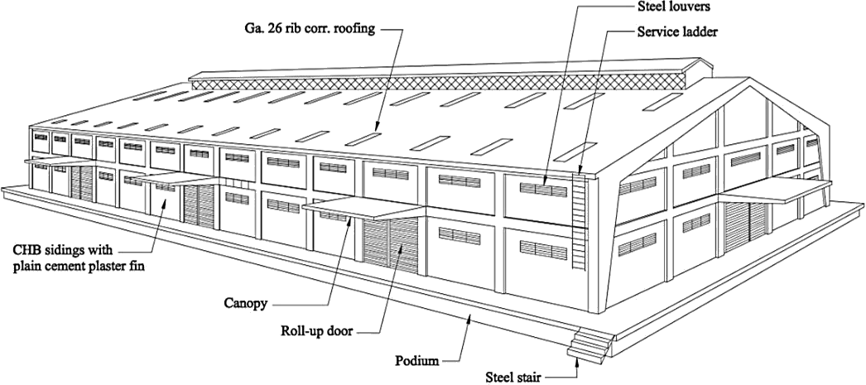

Figure 1 – Typical warehouse for bag type storage of grains

4 Location

The warehouse should be constructed away from sources of potential hazards that may affect the quality of produce and pose risk to the worker’s health and safety.

The warehouse should be located away from:
- environmentally polluted areas;
- sources of unsafe industrial activities that may impact on the safety/contaminate the stored grains;eg cement, tobacco, batteries;
- flood prone areas;
- fire hazard;
- zones that may encourage insect infestation and entry of stray animals; and
- places where waste either solid or liquid cannot be removed effectively.
The warehouse should be constructed where there is accessible road. It shall be accessible to relevant forms of transport system. There should be ample space to facilitate movement and manoeuvring of vehicles within the location.
The load-bearing capacity, resistance to compaction and drainage characteristics of soil in which the warehouse is to be constructed should be considered.
The location and distance of the warehouse from other farm structures or the production area should also be considered during construction.
The long axes of the warehouses should be oriented East-West or sited across the prevailing wind.

Warehouses shall not be located near busy public facilities such as schools, hospitals, etc. Surroundings in the vicinity shall conform to existing safety and sanitary measures.

The structure shall be built on a stable ground soil. Space shall be provided for future expansion.
Electricity, communication, water services and drainage shall all be available and reasonably economical.

Functional Requirements

5.1 Product sectionalism

Warehouse operations shall be identified and analysed as to space requirements of the commodity and the in-out flow of stocks from one operation to another and identify the proper places of every operation.

The internal layout of the depot shall be designed in accordance with the First in -First out method of holding inventory.
Quality and quantity of the stored grains should be monitored.

5.2 Floor area requirement

5.2.1 Pallet dimension

The recommended dimension for the pallet to be used is shown in Table 1.

Table 1 – Recommended dimension for pallet

Shape | Dimension
Square | 152 cm x 61 cm
Rectangular | 120±1cm x 100±1cm x 72±1cm
Square | 120±1cm x 120±1cm x 72±1cm

    - System of piling

      - Small scale storage

Bags of grain in each lot should be stacked in basic patterns of cluster formation (Figure 2) for easy inventory and quality maintenance/assessment.

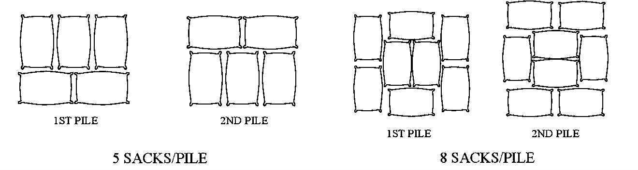
Figure 2 – System of piling for small scale

      - Large scale storage

5.2.2.2.1 Block stacking

In this type, six blocks are formed to make standard stack of 9.14m x 6m size. Each block is of the size 6m x 1.5m. In the block, one layer is put lengthwise and other breath-wise.

5.2.2.2.3 Chinese method

Bagged grains with 14% moisture content or lower could be piled in Chinese method. Sacks are piled side by side and one on top of the other for appropriate pest control measures (Figure 3).

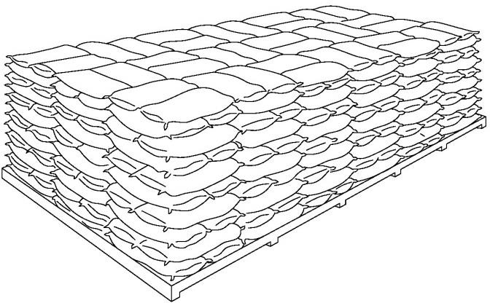

Figure 3 – Chinese piling

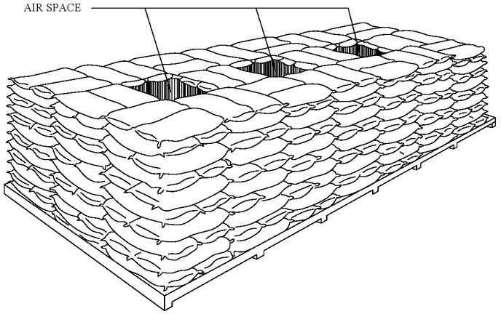

Figure 4 – Japanese piling

5.2.2.2.4 Japanese method

Bagged grains with moisture content 14.1% to 15% are to be piled in this method. This system of stacking provides ventilation space between bags and allows circulation of convective air currents that provide a medium for heat dissipation (Figure 4).

5.2.2.2.5 Criss-cross stacking

In this type bags are laid in complete length-wise or breath-wise tiers in alternate layers systematically. The first layer will have 11 bags in 9.14m direction with 11 such rows. The second layer of bags would be laid width-wise with 16 bags in 9.14m direction of stack with 7 such rows.

    - Stack height

      - The height of stacks shall not exceed the height of the walls and a space of at least 1 m shall be allowed between the tops of the stacks and roof frames.

      - Sacks made of woven polypropylene have a tendency to slide on each other, and therefore shall not be stacked more than 3 m high. Jute sacks bind together better, and maybe stacked up to 6 m above the floor.

      - Factors like nature of grain, size, weight, and shape and strength of grain bag to stand the height of stack have direct bearing on stack height. Table 2 shows the optimum stack heights recommended for grain storage.

Table 2 – Recommended stack heights

Type of grain | Maximum stack height inlayers | Stack height, m
Wheat, barley and corn | 18 | 4.57
Paddy | 16 | 6
Rice | 16 | 5.5

      - The size of the piles should conform with fumigating sheets in situations where warehouses cannot be made airtight. Dimensions for maximum piling should be 7.3 m x 21.9 m x 4.5m.

      - Piles should be tight, neat and squared off.

      - The recommended bag warehouse capacity is shown in Table 3.

Table 3 – Recommended stacking density

Stacking Density | Number of bags per cubic meter
Paddy | 10
Rice | 15
Corn | 12

    - Pathways

      - A central pathway should be 2 m wide or not less than 1m wider than the width of the widest forklift trucks that are being used simultaneously during warehouse operation.

      - If there is a forklift or mechanical handling equipment to be used, the central pathway should be designed with a width of not less than 0.6 m wider than the width of the widest vehicle loaded.

    - Side spacing

      - Space between piles shall be 1m wide.

A minimum of 1m space between the edge of the pile and the wall shall be provided.

  - Physical dimensions of structure

Table 4 – Warehouse dimensions based on the number of bags

Number of bags (1 bag = 50kg) | Dimensions
10,000 | 10 m x 30 m
30,000 | 16 m x 48 m
50,000 | 20 m x 60 m
100,000 | 25 m x 78 m
500,000 | 75 m x 142 m

NOTE There may be special designs of warehouse for irregular shaped lot.

Given the recommended dimensions of the warehouse and its corresponding capacity above (Table 4), the number of buildings is doubled, tripled or quadrupled based on the desired capacity of the warehouse. For example, a 200,000 bags warehouse is required, two buildings (duplex) with dimensions of 25m x 78m each is recommended.

  - Height of structure

The recommended height between the eaves line and the floor is 7 m and 2.5 m between the eaves line and the apex.

  - Illumination

There should be provisions for sky lightings. Skylights should be placed in the aisle.

  - Electrical works

Receptacles for transporting equipment and wire distribution for electric fans shall be provided. If possible, conduit tubes shall be used. Electrical works should conform with the applicable national Electrical Code.

  - Drainage
Sufficient drainage shall be provided to prevent flooding.

Structural Requirements

  - Building structure requirements

    - There shall be provisions for water tightness, to prevent moisture from leaching to the grain.

    - There shall be provisions for efficient loading and unloading bays.

    - There shall be provisions for aeration.

    - There shall be provisions for bird and rodent proofing and for fumigation.

    - The building shall have a clear inside span and has no inside pillars which could obstruct stacking arrangement.

    - The building should have a ledge or podium.

  - Foundation

The construction shall conform with the National Building Code.

  - Floor

    - The floor should be adequately strong and capable of withstanding heavy loads and vibrations.

    - The floor shall be elevated or constructed higher than the existing ground. The floor should be 1m above the ground to permit easy loading or unloading into trucks at the sides of the warehouse.

    - There shall be provisions for wear resistance and safety (refractoriness and elimination of skidding risks). The floor should be smooth and easy to clean. It should be free from cracks where moisture from the ground may affect the stored grain. Moisture sealing compound or asphalt should be provided to fill the floor cracks against moisture.

    - Foundation, pillars and beams should be made from reinforced concrete. Floor construction should conform with the National Building Code.

  - Walls

    - The internal surfaces of the walls shall be smooth and free from projections to eliminate dust-laden surfaces, facilitate cleaning of the warehouse.

    - Gravel concentrations in concrete walls, protruding brick work, horizontal planes or rims, window sills, protruding door or window posts and other ledges should either be avoided completely or be shedded at a minimum angle of 60°.

    - The walls shall be painted white, on the inside to facilitate the detection of insect pests and on the outside to help keep the warehouse look as cool as possible and for sanitary purposes.

    - There shall be no opening between wall and roof.

    - A water/damp-proof barrier should be incorporated into the base of the walls. Waterproofing compound should be incorporated during the plastering and finishing of the walls.

    - A concrete strip about 1 m wide shall be laid around the warehouse to prevent rain from eroding the base of the walls below the damp course.

    - Wall construction should conform with the National Building Code.

  - Roof

    - Internal pillars supporting roof frames shall be avoided because it can interfere with the pest control and other stock management procedures. A standard roof truss of 14.5mspan (or larger) should be used.

    - Roof frames made of wood or steel shall be designed so that they transfer the weight of the roof to the supporting columns or to the walls.

    - It must be provided with the necessary lateral and vertical wind brace to resist forces due to strong winds and earthquakes.

    - The strength of the roof construction should be sufficient to handle the weight of the strongest winds that can be expected.

    - The roofing materials made of galvanized iron sheets and shall be in light colors (white or beige). The external surface should be reflective or light colored to minimize the amount of heat that it can absorb.

    - The chosen materials may be fire proof and with refractory.

    - The inclination of the roofs should be sufficient to drain rainwater quickly, taking into account that the water may be forced up by the wind.

    - Rainwater drainpipes should be closely spaced, of sufficient size and installed without bends.

  - Doors

    - There shall be at least two doors so as to be able to rotate stocks on a first in, first out basis.

    - The door shall be wide for easy access, yet fit tightly for insect control and fumigation. Roll up doors are generally used because of its capability to close tightly.

    - Preferably the door shall be made of steel or at least reinforced along their lower edges with metal plate as protection against rodents.

    - If sliding or folding doors are fitted, they shall be opened outwards in order not to reduce the storage capacity of the warehouse.

    - The size of the entrance is 6 m wide and 4 m high for normal temperature warehouse.
A canopy shall be constructed over every entry door to allow continuous loading and unloading even when it rains.

  - Ventilation

    - Vents should be provided near the floor level, at the top of the walls near the grid line and at the top of the roof and the ridge.

    - Ventilation openings such as louvers shall be fitted on the outside with anti-bird grills (20mm mesh) and on the inside (10 cm behind the grills) with insect screens (removable for cleaning), which will deter most insects.

    - Adequate natural ventilation openings shall be provided with shutters so that ventilation may be controlled.

    - Continuous ridge vents are built on the roof top which provide good ventilation in addition to the louvers all over the warehouse.

    - In addition to natural ventilation exhaust fans should be installed.

  - Rodent proofing

If the structural set-up of doors is unsatisfactory the rodent barrier may be attached. An iron sheet used for rodent barrier should have an optimum size but will not obstruct the entrance and will not impede mobility. As shown in Figure 5, its height should be little over 60 cm and fixed by a mortise and tenon joint or by hinge. Polished artificial stone is usually used for wall rodent barrier.

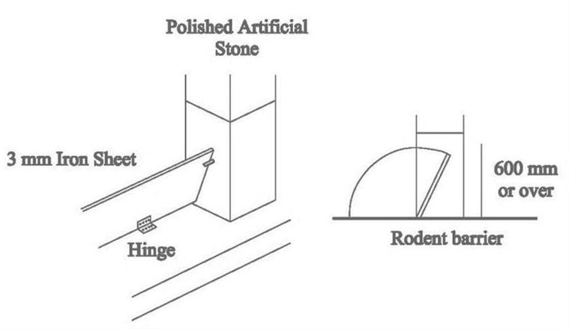

Figure 5 – Rodent barrier

On all possible entries within the warehouse, there should be a screen for bird and rodent control.

Warehouse Management

  - Fumigation

In cases of insect infestation and presence of mold, fumigation should be carried out. The appropriate pest control should be used for insect pests or microorganisms. During fumigation dosage of the chemical and airtight conditions must be carefully observed.

Fumigants should be kept in a special locked storage room.

  - Facility requirement

    - Quality control laboratories

    - Workshops

    - Garage for vehicles

    - Dead stock store

    - Bag stacker

    - Pest control chemicals store

    - Isolation shed

    - Restrooms and washing facilities and accessible facilities

    - Personnel office

  - Safety

    - Guards for machines should be provided.

    - Illuminations should be sufficient and should have a cover guard.

    - Warning signs or boards shall be fixed in hazardous/dangerous places and exits and must be visible on other places.

    - There shall be a provision for fire control equipment as provided in the applicable Building Code.

    - There shall be provisions for first aid kit.

    - There shall be provisions for proper exhaust and ventilating system.

    - There shall be provisions of PPE for people accessing the ware house

    - There shall be a provision for fire control equipment and a fire assembly point as provided in the applicable Building Code.

All warehouses shall be identified by their warehouse name, code and location printed on a standard billboard exhibited outside the warehouse.

ANNEX A
(Informative)
Sample Design of a Standard Warehouse (Capacity 100,000 bags)

A.1 Floor Plan

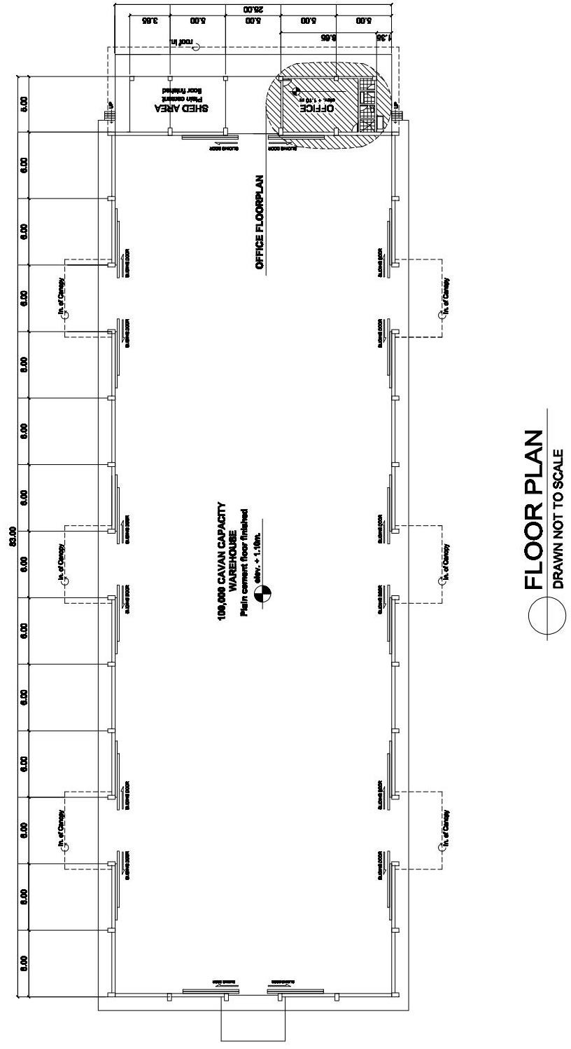

A.2 Elevation

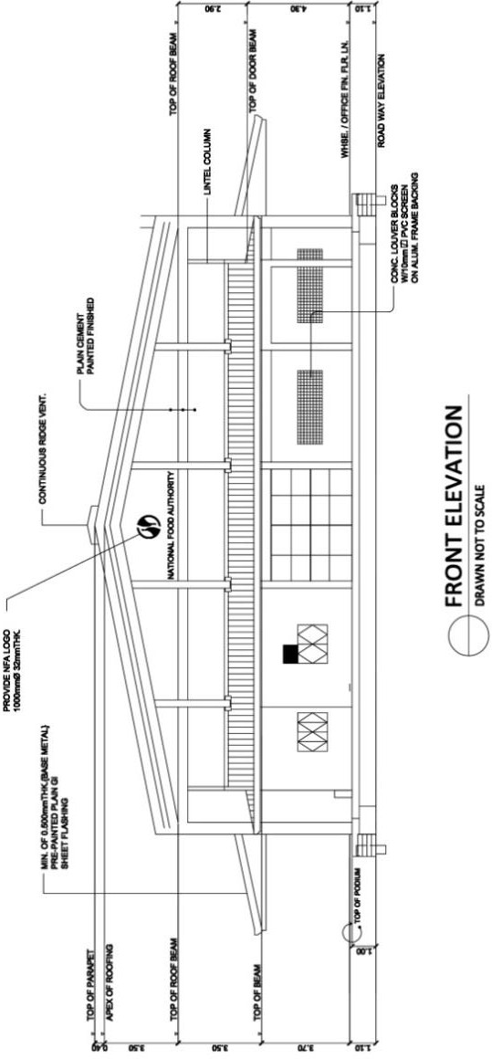
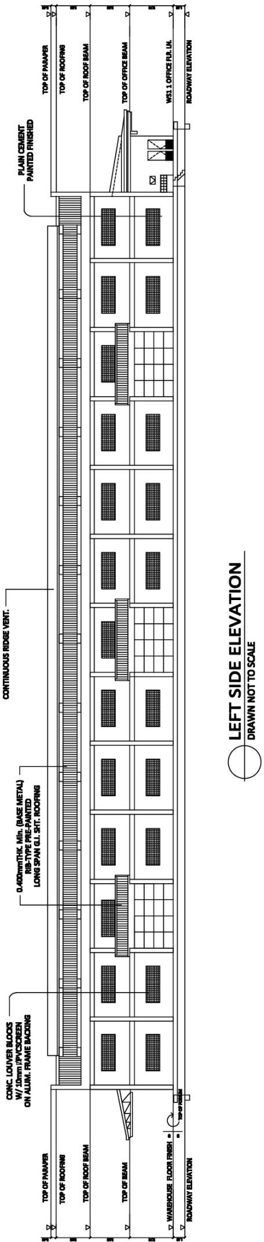

* © 2023 ARSO — All rights of exploitation reserved worldwide for African Member States’ NSBs.

