**Motor vehicle radiators — Specification**

#### Foreword

The African Organization for Standardization (ARSO) is an African intergovernmental organization established by the United Nations Economic Commission for Africa (UNECA) and the Organization of African Unity (AU) in 1977. One of the fundamental mandates of ARSO is to develop and harmonize African Standards (ARS) for the purpose of enhancing Africa’s internal trading capacity, increase Africa’s product and service competitiveness globally and uplift the welfare of African communities. The work of preparing African Standards is normally carried out through ARSO technical committees. Each Member State interested in a subject for which a technical committee has been established has the right to be represented on that committee. International organizations, Regional Economic Communities (RECs), governmental and non-governmental organizations, in liaison with ARSO, also take part in the work.

ARSO Standards are drafted in accordance with the rules given in the ISO/IEC Directives, Part 2.

The main task of technical committees is to prepare ARSO Standards. Draft ARSO Standards adopted by the technical committees are circulated to the member bodies for voting. Publication as an ARSO Standard requires approval by at least 75 % of the member bodies casting a vote.

Attention is drawn to the possibility that some of the elements of this document may be the subject of patent rights. ARSO shall not be held responsible for identifying any or all such patent rights.

This African Standard was prepared by ARSO/TC 59, Automotive technology and engineering

© African Organisation for Standardisation2024 — All rights reserved[1]*

ARSO Central Secretariat

International House 3rd Floor

P. O. Box 57363 — 00200 City Square

NAIROBI, KENYA

Tel. +254-20-2224561, +254-20-3311641, +254-20-3311608

E-mail: [arso@arso-oran.org](http://www.arso-oran.org/arso@arso-oran.org)

Web: [www.arso-oran.org](http://www.arso-oran.org)

|  |
| --- |
| **Copyright notice**  This ARSO document is copyright-protected by ARSO. While the reproduction of this document by participants in the ARSO standards development process is permitted without prior permission from ARSO, neither this document nor any extract from it may be reproduced, stored or transmitted in any form for any other purpose without prior written permission from ARSO.  Requests for permission to reproduce this document for the purpose of selling it should be addressed as shown below or to ARSO’s member body in the country of the requester:  © African Organisation for Standardisation2024 — All rights reserved  ARSO Central Secretariat  International House 3rd Floor  P.O. Box 57363 — 00200 City Square  NAIROBI, KENYA  Tel: +254-20-2224561, +254-20-3311641, +254-20-3311608  E-mail: [arso@arso-oran.org](http://www.arso-oran.org/arso@arso-oran.org)  Web: [www.arso-oran.org](http://www.arso-oran.org)  Reproduction for sales purposes may be subject to royalty payments or a licensing agreement. Violators may be prosecuted. |

**Introduction**

<Text indicating rationale for the development/harmonization of the standard>

**AFRICAN STANDARD**

**Motor vehicle radiators — Specification**

**1 Scope**

This Draft African Standard specifies the general requirements and test methods for automotive radiators manufactured from copper and brass with brackets of steel for use on motor cars, trucks, tractors and off -the road vehicles such as earth moving machinery. Radiators utilizing bolted or cast header tanks are excluded.

This standard does not apply to radiators made of aluminium and plastics.

**2 Normative references**

The following documents are referred to in the text in such a way that some or all of their content constitutes requirements of this document. For dated references, only the edition cited applies. For undated references, the latest edition of the referenced document (including any amendments) applies.

IS 2765, *Indian Standard Specification for radiator hoses*

ISO 4081, *Rubber hoses and tubing for cooling systems for internal-combustion engines — Specification*

ISO 9133, *Passenger cars — Engine cooling systems — Threaded pressure caps and their seats on filler necks*

ISO 9817, *Passenger cars — Engine cooling systems — Dimensions of pressure caps and their ramp seats on filler necks*

ISO 9818, *Passenger cars — Engine cooling systems — Test methods and marking of pressure caps*

ISO 4020, *Road vehicles — Fuel filters for diesel engines — Test methods*

**3 Terms and definitions**

For the purpose of this standard the following definitions apply.

**3.1**

**radiator**

device used for the cooling of an engine of a motor vehicle which uses water as the cooling media which in turn is cooled by air blown through the radiator fins as the water passes through the radiator tubes

**3.2**

**general**

various parts of the radiator shall be as shown in Figure 3

**4 Types**

4.1 Two types of radiators shall be considered, namely:

1. flat fin core as shown in Figure 1; and
2. corrugated fin core as shown in Figure 2.

**4.2** The typical construction of a radiator is shown in Figure 3. However, pressure relief/filler cap may be located on a separate header tank remote from the radiator.

**5 Material requirements**

**5.1** The various parts of the radiator shall be manufactured from material as shown in Table 1.

**Table 1 — Material radiators**

|  |  |  |
| --- | --- | --- |
| **Item** | **Material** | **Hardness** |
| Tubes Flat fins Corrugated pins Header plates Header tanks Branches Brackets | Brass Copper Copper Brass Brass Brass Brass | 90/110/VPN  100/115 VPN  80/110 VPN  90/110 VPN Drawing quality  Quarter hard-seamless  Mild of drawing quality |

**5.2** The material for the tubes shall be 100 % inspected pinholes. The surface of the material shall be free from contamination which can prevent satisfactory wetting and bonding of soldier joints under normal production conditions. It shall also be free from oxides, pinholes, blisters, flakes scratches and other such defects.

**5.3** The fin shall have sufficient face strength to prevent deformation in normal handling.

**5.4** The steel for the production of brackets and frames shall be cold rolled and of suitable quality to allow forming without cracking and to avoid failure due to vibration. Such sheet shall be protected against corrosion by an acceptable method such as terne coating, phosphating, etc. The steel shall be free from defects such as scale, rust, blisters and laminations.

**5.5** Soft solder shall be used for joining the various parts of a radiator. The soft solder shall be made from virgin metal or clean scrap. The material shall be of uniform quality, clean and free from foreign matter.

**5.6** The chemical composition of the copper/brass strips shall be as given in Table 2.

**Table 2 — Copper content in the copper/brass strips**

|  |  |
| --- | --- |
| **Strip** | **Copper content, percentage** |
| Copper  Brass | 98.0, min.  61.5, min.  71.5, max. |

**6 Dimensions**

6.1 Radiators

The dimensions of radiators shall vary according to engine manufacture specifications.

6.2 Filler neck

Small and medium size filler necks shall be as in Figure 4.

6.3 Drain tap seat

A good tank quality draining arrangement shall be provided on the bottom tank.

**7 Workmanship and finish**

**7.1** The radiator core assemblies shall be pickled to remove flux residues after soldering operations have been completed.

**7.2** The radiator shall be free from physical defects. Joints on radiator cores and water inlet and out let shall have no discontinuity and the soldering material shall be evenly distributed throughout. The inside of the filler neck shall be free from solder, paint, cracks and scratches. A suitable protective paint shall be used on radiators.

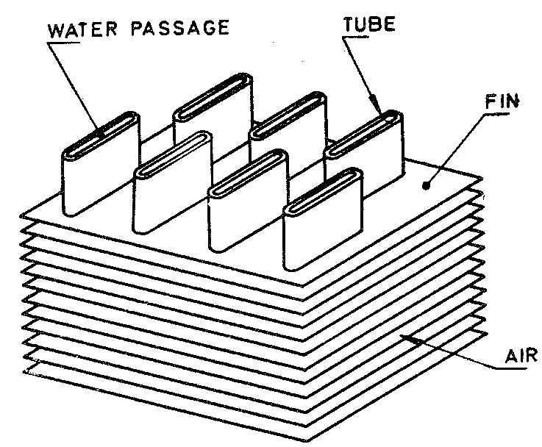

**Figure 1 — Flat fin core (type)**

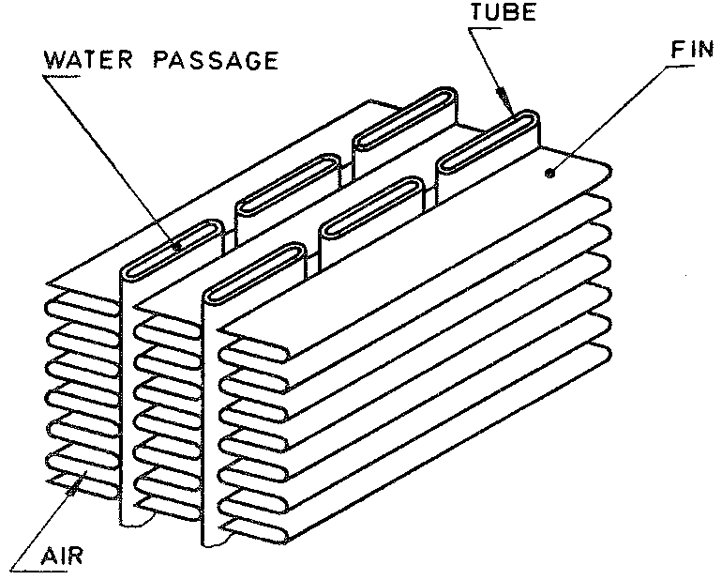

**Figure 2 — Corrugated fin core (type)**

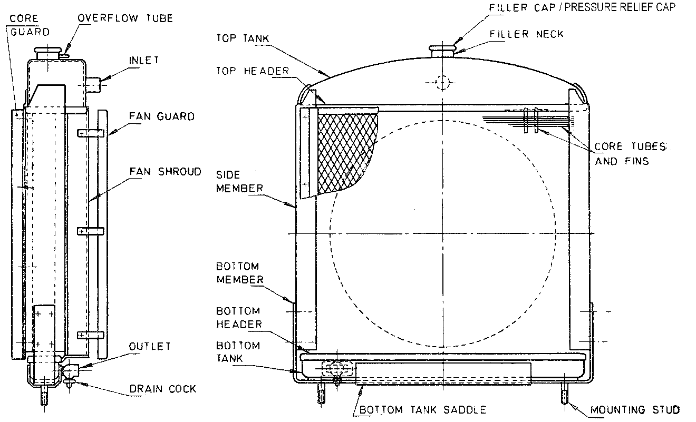

**Figure 3 — Typical arrangement of radiator showing nomenclature**

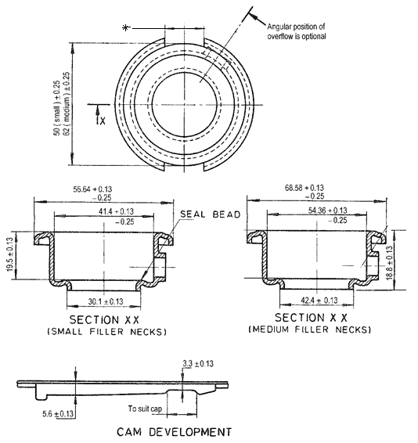

**(Dimensions marked * are to suit pressure relief/filler cap.)**

**Figure 4 — Filler necks**

**8 Tests**

8.1 General

The following tests shall be carried out on the radiators:

1. pressure test;
2. vibration test;
3. leakage test for filler neck seat; and
4. pulsation test.

8.2 Pressure test

This test shall be carried out on every radiator produced for method of test, see Annex A.

8.3 Vibration test

This test shall be carried out on samples from new model production to prove the durability of design. It shall also be carried out as a spot check at least one in every 500 units of same type produced.

NOTE This test is regarded as a destructive test. For test procedure, see Annex B.

8.4 Filler neck test

This test shall be carried out on samples from new model production. It shall also be carried out on a random basis on at least one in every 100 radiators of same type produced. For test method, (see Annex C).

8.5 Pulsation test

This test shall be carried out, on samples of new model production in conjunction with tests under 8.2. Spot checks shall also be carried out at least once per 500 units of same type produced. For test procedure, see Annex D.

NOTE This test is regarded as a destructive test.

9 Repaired radiators

Any radiators repaired after tests 8.1. and 8.3 shall be retested to pass the tests.

**10 Marking**

Each radiator shall be legibly and indelibly marked on the outer casing with the following information:

1. manufacturer’s name or trade mark;
2. part number; and
3. country of origin.

**11 Packaging**

**11.1** Each radiator shall be packaged in such a manner that it is protected from damage during transportation and storage.

**11.2** Each package shall be legibly and indelibly marked with the following information:

1. manufacturer’s name or trade mark;
2. part number; and
3. country of origin.

# Annex A (normative) Pressure test

**A.1 Principle**

This test shall be conducted in a suitably sized tank full of water sufficient to immerse the radiator. Provision shall be made for connecting the radiator to a compressed air line.

**A.2 Procedure**

The radiator shall be immersed in water at normal temperature with all outlets blocked off and subjected to an internal air pressure of twice the cap opening pressure for at least 2 min.

**A.3 Procedure**

During the test, no sign of air leakage shall be noticeable. Every radiator shall undergo and pass this test.

# Annex B (normative) Vibration test

B.1 Principle

This test shall be conducted on a suitable rig, causing vibration in the vertical direction only.

B.2 Procedure

The radiator shall be mounted on the rig using the normal mounting points and filled with water at working pressure. The radiator shall be made to vibrate in the vertical direction to give an acceleration 3 g. The test shall continue until 106 vibrations are completed.

B.3 Report

During or after the test, no leakage shall be noticeable. The mountings of the radiators shall also show no cracks or failure.

# Annex C (normative)

# Leakage test for filler neck seats

(This test shall be performed for the filler cap closed position.)

**C.1 Procedure**

Immerse the complete radiator assembly with pressure cap into water at room temperature and all other outlets blocked off. Apply a gradually increasing air pressure to coolant ducts.

**C.2 Report**

No air leaks from overflow tube shall be permitted up to a pressure of 5 kpa below the nominal pressure required to operate the pressure cap relief valve.

NOTE The pressure cap used during this test should be previously checked for accuracy.

# Annex D (normative) Pulsation test

**D.1 Principle**

This test shall be conducted on a suitable rig holding the radiator vertically by its normal mounting points. Provision shall be made for connecting the radiator to a constant hot water supply (at least 80 ºC) and also to compressed air.

**D.2 Procedure**

Hot water shall be continuously circulated through the radiator. Provision shall be made to automatically increase/decrease the internal system pressure at a controlled rate. The pressure shall be cycled from zero up to 1½ times cap opening pressure and back to zero such that one cycle is completed in 3 s to 5 s. The test shall run continuously until 30 000 cycles have been completed. During the test, the pressure relief cap (if fitted) shall be substituted with a non-opening cap.

**D.3 Report**

During the test, no leakage shall be noticeable.

# Bibliography

Working Group to identify and acknowledge useful literature used in the preparation of this standard.

1. * ©2024 ARSO — All rights of exploitation reserved worldwide for African Member States’ NSBs.