Road vehicles — Fuel filters — Specification

Table of contents

1 Scope 1
2 Normative references 1
3 Terms and definitions 1
4 Materials 1
5 Tests 1
5.1 Pressure drop test 1
5.2 Particle retention test 2
5.3 Burst test for complete filter 2
5.4 Pulsating pressure fatigue test 2
5.5 Bubble test 2
6 Marking 2
Annex A (normative) Bubble Tests 3
Bibliography 5

Foreword

The African Organization for Standardization (ARSO) is an African intergovernmental organization established by the United Nations Economic Commission for Africa (UNECA) and the Organization of African Unity (AU) in 1977. One of the fundamental mandates of ARSO is to develop and harmonize African Standards (ARS) for the purpose of enhancing Africa’s internal trading capacity, increase Africa’s product and service competitiveness globally and uplift the welfare of African communities. The work of preparing African Standards is normally carried out through ARSO technical committees. Each Member State interested in a subject for which a technical committee has been established has the right to be represented on that committee. International organizations, Regional Economic Communities (RECs), governmental and non-governmental organizations, in liaison with ARSO, also take part in the work.

ARSO Standards are drafted in accordance with the rules given in the ISO/IEC Directives, Part 2.

The main task of technical committees is to prepare ARSO Standards. Draft ARSO Standards adopted by the technical committees are circulated to the member bodies for voting. Publication as an ARSO Standard requires approval by at least 75 % of the member bodies casting a vote.

Attention is drawn to the possibility that some of the elements of this document may be the subject of patent rights. ARSO shall not be held responsible for identifying any or all such patent rights.

This African Standard was prepared by ARSO/TC 59, Automotive technology and engineering

© African Organisation for Standardisation 2024 — All rights reserved*

ARSO Central Secretariat
International House 3rd Floor
P. O. Box 57363 — 00200 City Square
NAIROBI, KENYA

Tel. +254-20-2224561, +254-20-3311641, +254-20-3311608

E-mail: arso@arso-oran.org
Web: www.arso-oran.org

Copyright notice

This ARSO document is copyright-protected by ARSO. While the reproduction of this document by participants in the ARSO standards development process is permitted without prior permission from ARSO, neither this document nor any extract from it may be reproduced, stored or transmitted in any form for any other purpose without prior written permission from ARSO.

Requests for permission to reproduce this document for the purpose of selling it should be addressed as shown below or to ARSO’s member body in the country of the requester:

© African Organisation for Standardisation 2024 — All rights reserved

ARSO Central Secretariat
International House 3rd Floor
P.O. Box 57363 — 00200 City Square
NAIROBI, KENYA

Tel: +254-20-2224561, +254-20-3311641, +254-20-3311608

E-mail: arso@arso-oran.org
Web: www.arso-oran.org

Reproduction for sales purposes may be subject to royalty payments or a licensing agreement. Violators may be prosecuted.

Introduction

<Text indicating rationale for the development/harmonization of the standard>

AFRICAN STANDARD
Road vehicles — Fuel filters — Specification

1 Scope

This Draft African Standard specifies materials, performance requirements, and test methods for road vehicles fuel filters

2 Normative references

The following documents are referred to in the text in such a way that some or all of their content constitutes requirements of this document. For dated references, only the edition cited applies. For undated references, the latest edition of the referenced document (including any amendments) applies.

ISO 4020, Road vehicles — Fuel filters for diesel engines — Test methods

3 Terms and definitions

There are no terms and definitions in this document.

4 Materials

4.1 The filter shall be capable of withstanding normal mechanical stresses encountered in service. The use of dissimilar metals likely to cause corrosion shall be avoided.

4.2 The filtering media shall be impregnated fuel filter paper with a maximum pore size of 1.5 microns, wire gauze, felt material, reinforced impregnated paper (with wire gauze) or any other appropriate material that meets the performance requirements specified in this standard as per the particular type of application. The media shall not disintegrate in performance for the specified service period.

4.3 The filter casing may be made of plastic, but if made of sheet metal alloy, it shall be protected against corrosion.

4.4 The filter shall be free from any leaks.

4.5 All materials used for the construction of the filter shall be free from corrosion.

4.6 All seals shall be of rubber (e.g. nitrile rubber) non-reactive with fuel and with a minimum Shore hardness of 65 International Rubber Hardness degrees.

4.7 All gaskets required for mounting the filter element shall have a minimum Shore A hardness of 45 International Rubber Hardness degrees.

4.8 The threaded end plate may be made of galvanized steel sheet or any other non-corrosive material and shall be strong enough to hold engine pressures.

4.9 The compression spring shall be made of spring steel.

4.10 Any adhesive used to bond the filter parts shall be bonded epoxy-based adhesives or equivalent that shall be non-reactive to fuels and shall give a strong bond able to resist mechanical stress encountered in performance.

5 Tests

5.1 Pressure drop test

When tested in accordance with 6.3 of ISO 4020, the pressure drop across the filter shall not exceed the Original Equipment Manufacturer (OEM) specification.

5.2 Particle retention test

When tested in accordance with 6.4 of ISO 4020, the percentage particle retention shall be not less than 90%.

5.3 Burst test for complete filter

When tested in accordance with 6.7 of ISO 4020, the burst pressure of the complete filter shall be not less than 1.45 Mpa.

5.4 Pulsating pressure fatigue test

When tested in accordance with 6.8 of ISO 4020, the filter shall withstand 50 000 cycles without failure.

5.5 Bubble test

When tested in accordance with Annex A of this standard, the volume of escaped air shall not exceed 200 cm3 per minute.

6 Marking

6.1 The filter and filter packaging shall be legibly and indelibly marked on the outer casing with the following:

- manufacturers’ name and/or registered trade mark;
- country of origin; and
- manufacturers’ part number.

6.2 Additional markings indicated on the filter or package shall necessitate additional verifications that the filters comply with the claims indicated.

Annex A
(normative)
Bubble Tests

A.1 Principle

The test liquid shall be straight mineral oil at a temperature of 23 °C ± 5 °C and kinematic viscosity between 4 mm²/s and 6 mm²/s.

A.2 Equipment

A.2.1 Stop-watch

A.2.2 Other equipment shall be as in Figure A.1.

A.3 Procedure

Before mounting the filter element to be tested (9) in Figure A.1 on the rotating axle, immerse it in the test liquid sufficiently long to completely wet the filter medium, and drain off the surplus liquid.

A.3.1 Mount the filter element on the rotating axle (10) and immerse it in the tank (8).

A.3.2 Open the stopcock (3) and adjust the constant pressure device (5) to indicate a pressure of 1.3 kPa ± 0.1 kPa on the liquid manometer (6).

A.3.3 Turn the filter element at approximately 10 min-1 on the rotating axle. The volume of air escaping in one minute shall be measured.

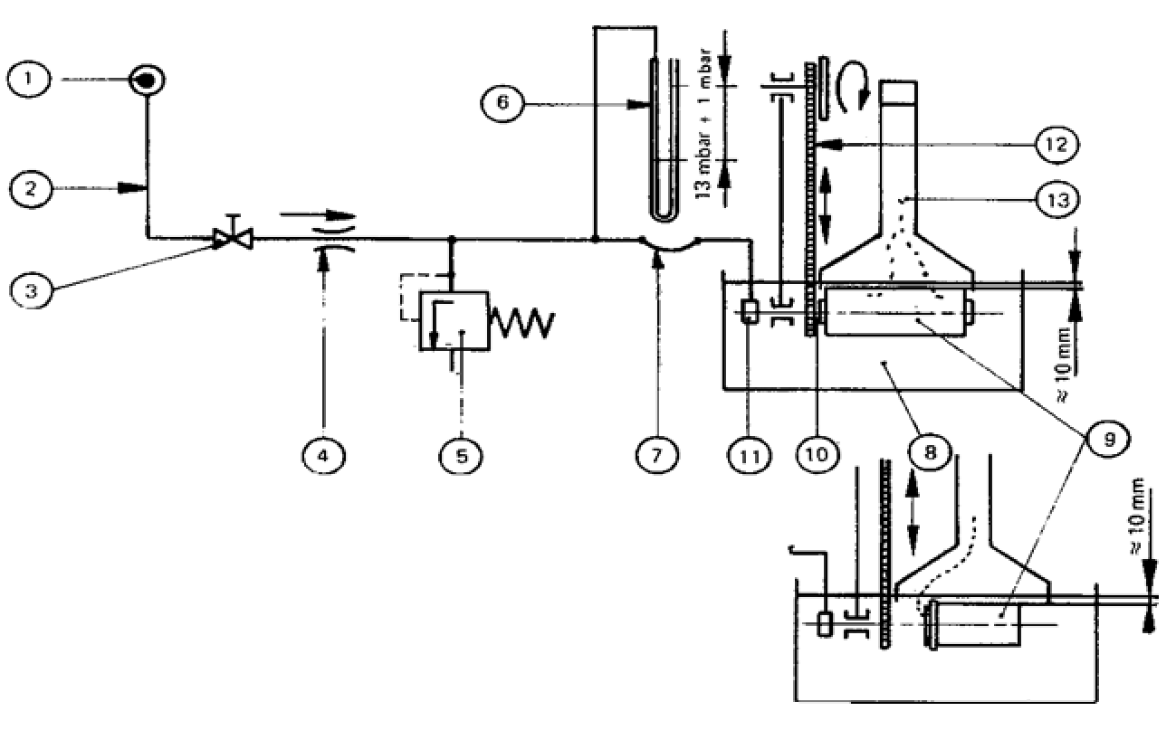

Test components ⎯ key
① Connection to compressed air line; air must be dry
② Connection pipe, of metal, nominal internal diameter 4 mm to 6 mm
③ Stopcock
④ Needle valve (fixed throttle)
⑤ Constant-pressure device, adjustable
⑥ Manometer, adapted to the measuring range
⑦ Flexible hose, nominal diameter 4 mm to 6 mm
⑧ Tank, minimum capacity 20 L
⑨ Filter element to be tested 4 mm to 6 mm
⑩ Rotating axle
⑪ Rotary fitting
⑫ Device for rotation of filter element
⑬ Bubble trap, capacity approximately 1 L, with graduated scale, accuracy of reading 1 cm3
Figure A.1 — Bubble test

Bibliography

Working Group to identify and acknowledge useful literature used in the preparation of this standard.

* © 2024 ARSO — All rights of exploitation reserved worldwide for African Member States’ NSBs.

