DRAFT EAST AFRICAN STANDARD
Cold formed structural steel sections — Specification

EAST AFRICAN COMMUNITY

Copyright notice
This EAC document is copyright-protected by EAC. While the reproduction of this document by participants in the EAC standards development process is permitted without prior permission from EAC, neither this document nor any extract from it may be reproduced, stored or transmitted in any form for any other purpose without prior written permission from EAC.
Requests for permission to reproduce this document for the purpose of selling it should be addressed as shown below or to EAC’s member body in the country of the requester:
© East African Community 2023 — All rights reserved
East African Community
P.O. Box 1096,
Arusha
Tanzania
Tel: + 255 27 2162100
Fax: + 255 27 2162190
E-mail: eac@eachq.org
Web: www.eac-quality.net
Reproduction for sales purposes may be subject to royalty payments or a licensing agreement. Violators may be prosecuted.
Contents Page
Foreword iv
1 Scope 5
2 Normative references 5
3 Terms and definitions 5
4 Symbols 6
5 Dimensions and tolerances 6
5.1 Dimensions 6
5.2 Tolerances 6
5.3 Measurement 7
5.3.1 General 7
5.3.2 Outside dimension 7
5.3.3 Thickness 7
5.3.4 Out-of-roundness 8
5.3.5 Concavity and convexity 8
5.3.6 Squareness 9
5.3.7 External corner profile 9
5.3.8 Twist 10
5.3.9 Straightness 11
6 Compound sections 12
7 Material requirement 12
7.1 Grade designation 12
7.2 Chemical composition 12
7.3 Mechanical properties 12
8 Sampling 13
8.1 General 13
8.2 Test pieces 13
9 Marking 14
Annex A (normative) Section properties 15

Foreword
Development of the East African Standards has been necessitated by the need for harmonizing requirements governing quality of products and services in the East African Community. It is envisaged that through harmonized standardization, trade barriers that are encountered when goods and services are exchanged within the Community will be removed.
The Community has established an East African Standards Committee (EASC) mandated to develop and issue East African Standards (EAS). The Committee is composed of representatives of the National Standards Bodies in Partner States, together with the representatives from the public and private sector organizations in the community.
East African Standards are developed through Technical Committees that are representative of key stakeholders including government, academia, consumer groups, private sector and other interested parties. Draft East African Standards are circulated to stakeholders through the National Standards Bodies in the Partner States. The comments received are discussed and incorporated before finalization of standards, in accordance with the Principles and procedures for development of East African Standards.
East African Standards are subject to review, to keep pace with technological advances. Users of the East African Standards are therefore expected to ensure that they always have the latest versions of the standards they are implementing.
The committee responsible for this document is Technical Committee EASC/TC 035, Steel and steel products.
This fourth edition cancels and replaces the third edition (EAS 134: 2019), which has been technically revised.
Attention is drawn to the possibility that some of the elements of this document may be subject of patent rights. EAC shall not be held responsible for identifying any or all such patent rights.

Cold formed structural steel sections — Specification

1 Scope
This Final Draft East African Standard specifies the requirements and sectional properties of cold formed structural steel sections of thickness of 1 mm to 8 mm for use in structural and general engineering applications.
The sections and their sectional properties are listed in Annex A.

2 Normative references
The following document is referred to in the text in such a way that some or all of its content constitutes requirements of this document. For dated references, only the edition cited applies. For undated references, the latest edition of the referenced document (including any amendments) applies.
ISO 148-1, Metallic materials — Charpy pendulum impact test — Part 1: Test method
ISO 404, Steel and steel products — General technical delivery requirements
ISO 1461, Hot dip galvanized coatings on fabricated iron and steel articles — Specifications and test methods
ISO 6892-1, Metallic materials — Tensile testing — Part 1: Method of test at room temperature
ISO 8492, Metallic materials — Tube — Flattening test
ISO 8493, Metallic materials — Tube — Drift-expanding test
ISO 10799-2, Cold-formed welded structural hollow sections of non-alloy and fine grain steels — Part 2: Dimensions and sectional properties
ISO 12633-2, Hot-finished structural hollow sections of non-alloy and fine grain steels — Part 2: Dimensions and sectional properties
ISO 12944-5, Paints and varnishes — Corrosion protection of steel structures by protective paint systemsPart 5: Protective paint systems
ISO 14347, Fatigue — Design procedure for welded hollow-section joints — Recommendations
ISO 16172, Steel sheet, metallic-coated by the continuous hot-dip process for corrugated steel pipe

3 Terms and definitions
No terms and definitions are listed in this document.
ISO and IEC maintain terminological databases for use in standardization at the following addresses:
— ISO Online browsing platform: available at http://www.iso.org/obp
— IEC Electropedia: available at https://www.electropedia.org

4 Symbols
The following nomenclature shall be used. Units for dimensions are in millimetres and those for section properties in centimetres.
- t section thickness mm
- p distance from edge to section centre of gravity - cm
- A sectional area - cm²
- Z section modulus of section l/p - cm³
- I second moment of area - cm⁴
- r radius of gyration of section $\sqrt{lA}$ - cm
- x, y with reference to x or y axis
- w mass per linear metre - kg/m
- L length - m

5 Dimensions and tolerances

5.1 Dimensions
Dimensions of sections shall be in accordance with those listed in the relevant tables in Annex A.

5.2 Tolerances
Tolerances of characteristic properties shall be as given in Table 1.
Table 1 — Tolerances for characteristic properties
Characteristic | Tolerance
Outside dimensionª | ±1.5 mm or 2 %, whichever is less
Deviation from straightness | 0.17 % of total length
Squareness of corners | 90° ± 2°
Twist | Not to exceed 2 mm ± 0.5 mm per metre
Concavity/convexity | Max. 0.8 %, with a minimum of 0.5 mm for square and rectangular hollow sections
Outside bend radii for right angle bends | - If thickness is less than 6 mm, tolerance is between 1.5 t to 2.5 t  - If thickness is between 6 mm to 8 mm, tolerance is between 2 t to 3 t
Length (6 m):  - Exact  - Standard | 0 and + 10 mm  0 mm and + 50 mm
Thickness | - ±3 % for 1 mm  - above 1 mm ± 7.5 %
Mass per metre for 1 mm thick | ± 3 %
Mass per metre for above 1 mm thick | ± 6.0 %
Deviation from out of roundness | - For D/T ratio ≤ 100: ± 2 %  - For D/T ratio > 100: ± 2 % by agreement
ª This tolerance shall be measured at a distance of not less than 100 mm from the end of the section.

5.3 Measurement

5.3.1 General
All external dimensions including out-of-roundness shall be measured at a distance from the end of the hollow section of not less than D for circular sections, B for square sections or H for rectangular sections, with a minimum of 100 mm.

5.3.2 Outside dimension
When inspecting circular hollow sections, the diameter D shall be measured directly. The limiting cross-sectional positions for measuring B and H are shown in Figure 1, and shall be in accordance with Annex A.

5.3.3 Thickness
The thickness t shall be measured at a positon not less than 2 t from the weld. The limiting cross-sectional positions for measuring the thickness of square and rectangular sections are shown in Figure 1.
NOTE Thickness is normally measured within a distance of half of the outside diameter or half of the length of the longer side from the end of the section.
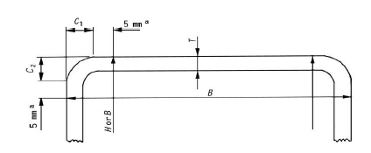
ª This dimension is a maximum when measuring B or H and a minimum when measuring t.
Figure 1 — Limiting cross-sectional positions for measuring the dimensions B, H and t for square or rectangular sections

5.3.4 Out-of-roundness
The out-of-roundness, O, of a circular hollow section shall be calculated as follows:
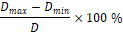
where
D is the nominal outside diameter of a circular hollow section;
D_{max} is the maximum outside diameter; and
D_{min} is the minimum outside diameter.

5.3.5 Concavity and convexity
The concavity (C₁) and convexity (C₂) of the sides of the square or rectangular hollow section shall be measured as shown in Figure 2.
The percentage concavity C₁ shall be calculated as follows:
or
The percentage convexity C₂ shall be calculated as follows:
or
where
B and H are the lengths of the sides containing the concavity C₁ or convexity C_{2.}
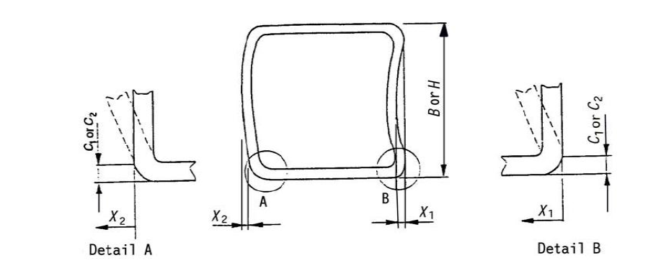
Figure 2 — Measurement of concavity/convexity of square or rectangular hollow sections

5.3.6 Squareness
Squareness of the sides of a square or rectangular hollow section shall be measured as difference between 90º and ɵ as shown in Figure 3.
.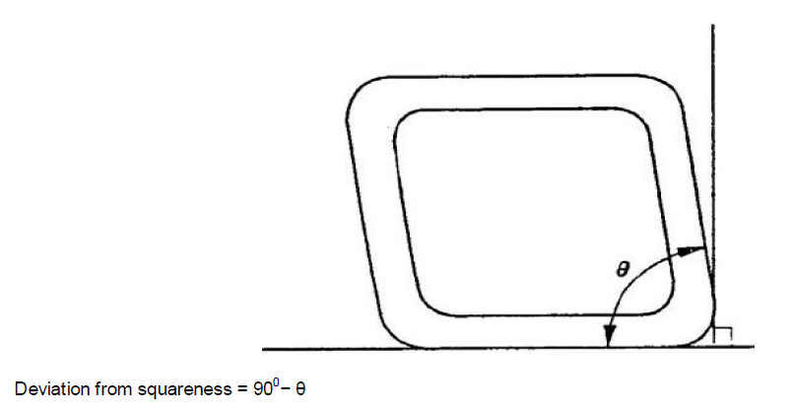
Figure 3 — Squareness of sides of square or rectangular hollow sections

5.3.7 External corner profile
5.3.7.1 The external corner profile of a square or rectangular hollow section shall be measured in accordance with 5.3.7.2 or 5.3.7.3.
5.3.7.2 The corner arc shall be measured with a radius gauge.
5.3.7.3 The distance between the intersection of the flat side and the corner arc and the intersection of the projections of the flat sides to the corner (C1) and (C2) in Figure 4 shall be measured.
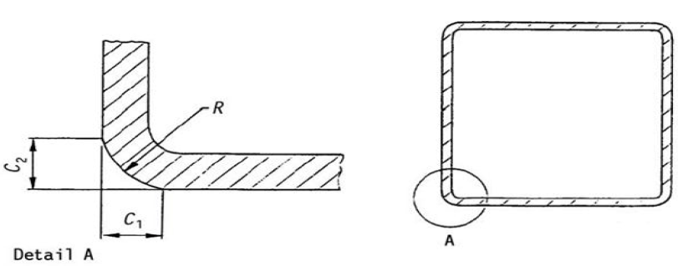
Figure 4 — Outside corner profile of square or rectangular hollow sections

5.3.8 Twist
5.3.8.1 The twist (V) in a square or rectangular hollow section shall be determined in accordance with 5.3.8.2 or 5.3.8.3.
5.3.8.2 The hollow section shall be placed on a horizontal surface with one side at one end pressed against the surface. At the opposite end of the hollow section, the difference in height of the two lower corners from a horizontal surface as shown in Figure 5, shall be measured.
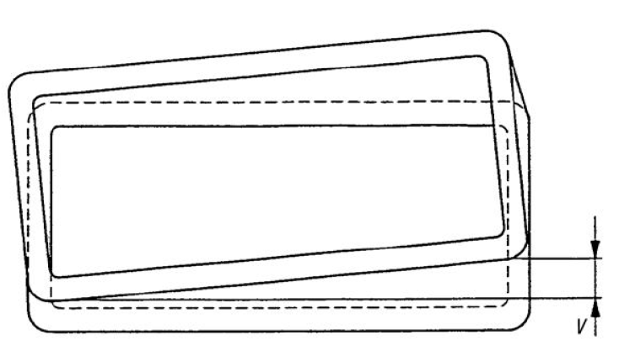
Figure 5 — Twist of square or rectangular hollow sections
5.3.8.3 The twist shall be measured with a spirit level and micrometre gauge (screw). The reference length of the spirit level shall be the distance between the intersection of the flat sides and the corner arcs (see Figure 6). The twist V is the difference between the values V1 (see Figure 6) measured at each end of the section.
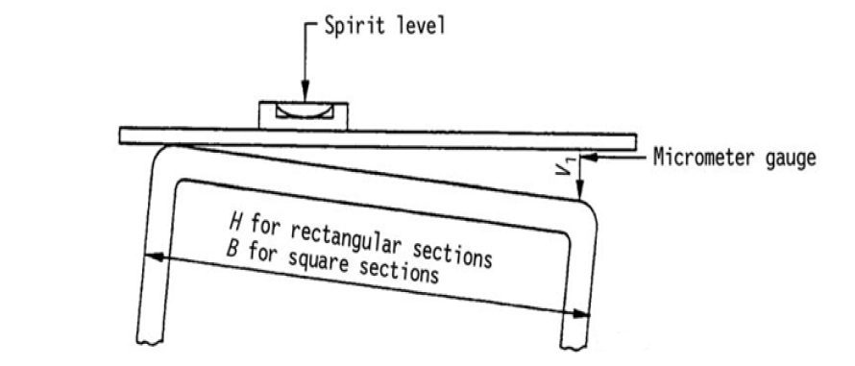
Figure 6 — Measurement of twist

5.3.9 Straightness
The deviation from straightness (e) of total length of a hollow section shall be measured at the point of maximum departure of the hollow section from a straight line connecting its two ends as shown in Figure 7.
The percentage deviation from straightness shall be calculated as follows:
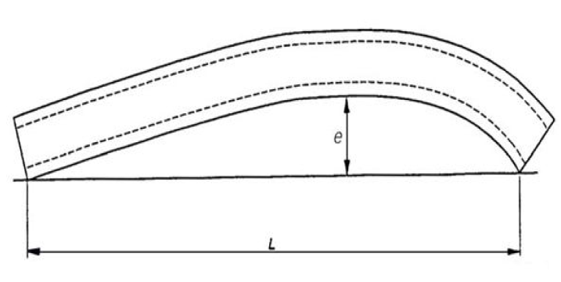
Figure 7 — Measurement of deviation from straightness

6 Compound sections
6.1 Compound sections may be formed by suitably connecting two or more simple sections. For example, an 'I' section can be made from two channels back-to-back, a tube from two inwardly lipped channels lip-to-lip, a 'T" from two angles, etc. Methods of joining sections are specified in ISO 14347.
6.2 Section properties of compound sections may be calculated using the properties of simple sections.
6.3 Compound sections shall be flush at matching joints within 2.0 mm.

7 Material requirement

7.1 Grade designation
The designation of the grades of material shall be based on minimum permissible yield stress and shall be in accordance with Table 2.
Table 2 — Grade designation
Minimum yield stress  N/mm² | Designation of grade
210 | 210
250 | 250
360 | 360

7.2 Chemical composition
The results of ladle chemical analysis of steel from which a hollow section is manufactured shall comply with appropriate limits of Table 3. For grade 360, it shall be permissible to add suitable grain-refining elements to achieve the minimum specified tensile stress, but the total content of these elements shall not exceed 0.15 %.
Table 3 — Ladle chemical analysis limits
Grade of steel | Maximum content  %
Grade of steel | Carbon | Phosphorous | Sulphur | Manganese
210 | 0.20 | 0.05 | 0.05 | -
250 | 0.25 | 0.06 | 0.06 | -
360 | - | - | 0.04 | -

7.3 Mechanical properties
The mechanical properties obtained from test samples taken from the hollow section in accordance with ISO 6892-1, shall comply with the requirements given in Table 4. If other grades of steel are used, their mechanical properties shall be as agreed upon between the purchaser and the manufacturer.
Table 4 — Tensile test requirements
Grade of steel | Minimum yield stress  N/mm² | Ultimate tensile strength  N/mm² | Minimum elongation as a proportion of gauge length  %
210 | 210 | 340 | 24
250 | 250 | 420 | 22
360 | 360 | 480 | 20

7.4 Coating properties (If applicable)
The cold formed steel sections may be supplied with or without coatings. When sections are supplied with coatings, sections shall be hot dip galvanized, aluminium zinc coated, pre -painted or in combination.
When sections are hot dip galvanized they shall comply with ISO 1461.
When sections are aluminium zinc coated they shall comply with ISO 16172.
When sections are pre -painted they shall comply with ISO 12944 -5.

8 Test methods and sampling

8.1 Test methods
8.1.1 Tensile tests
Tensile test to be done according to ISO 6892-1.
8.1.2 Impact tests
Where requested, impact test to be done according to ISO 148-1 and shall be assessed in accordance with ISO 404.
8.1.3 Flattening tests
Flattening test to be done according to ISO 8492 and shall show no sign of cracking.
8.1.4 Flare tests (Drift-expanding tests)
Test to be done according to ISO 8493 and shall not crack or show any other defect.

8.2 Sampling
8.2.1 At least one sample shall be selected from the following batch sizes:
- a 20-tonne or less batch of sections having outside diameter of less than 90 mm; and
- a batch of less than 40 tonnes for all other sections.
8.2.2 If the test fails, two more samples shall be drawn from the batch and tested. If one or both test specimens re-tested fail, the whole batch shall be deemed not to have complied with this standard unless all sections in the batch are tested individually.

9 Marking
Each piece shall be indelibly and legibly marked at least once in every 6-m length with the following:
- manufacturer’s name and/or registered trademark;
- outside dimension in millimetres;
- nominal thickness in millimetres;
- steel grade; and
- country of origin.
Annex A
(normative)
Section properties
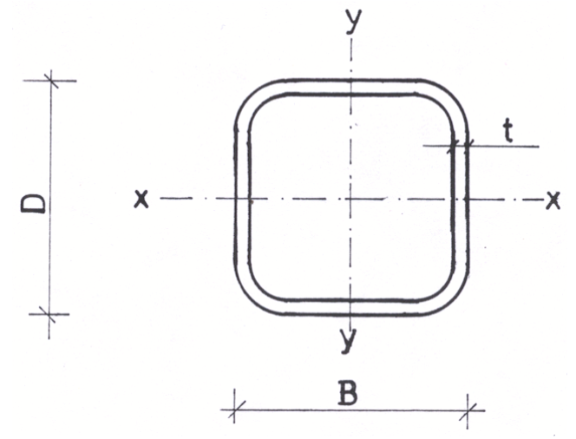
Figure A.1 — Square hollow sections
Table A.1 — Dimensions and properties for cold formed square hollow sections
Size, B x D  mm | Thickness, t  mm | Cross-sectional area, A  cm² | Mass, w  kg/m | Second moment of area,  I_{x} = I_{y}  cm⁴ | Radius of gyration,  R_{x} = R_{y}  cm | Section elastic modulus,  Z_{x} = Z_{y}  cm³
10 x 10 | 1.2 | 0.39 | 0.30 | 0.047129 | 0.349722 | 0.09
10 x 10 | 1.5 | 0.45 | 0.35 | 0.050548 | 0.334382 | 0.10
12 x 12 | 1.0 | 0.41 | 0.33 | 0.080793 | 0.441622 | 0.13
12 x 12 | 1.2 | 0.48 | 0.38 | 0.089707 | 0.431708 | 0.15
12 x 12 | 1.5 | 0.57 | 0.45 | 0.099303 | 0.416629 | 0.17
14 x 14 | 1.0 | 0.49 | 0.39 | 0.135455 | 0.523503 | 0.19
14 x 14 | 1.2 | 0.58 | 0.45 | 0.152281 | 0.513581 | 0.22
14 x 14 | 1.5 | 0.69 | 0.54 | 0.172098 | 0.498665 | 0.25
16 x 16 | 1.0 | 0.57 | 0.45 | 0.210312 | 0.605170 | 0.26
16 x 16 | 1.2 | 0.67 | 0.53 | 0.238689 | 0.595389 | 0.30
16 x 16 | 1.5 | 0.81 | 0.64 | 0.273736 | 0.580584 | 0.34
16 x 16 | 2.0 | 1.02 | 0.80 | 0.313845 | 0.555506 | 0.39
18 x 18 | 1.2 | 0.77 | 0.60 | 0.352772 | 0.677157 | 0.39
18 x 18 | 1.5 | 0.93 | 0.73 | 0.409015 | 0.662433 | 0.45
18 x 18 | 2.0 | 1.18 | 0.92 | 0.478445 | 0.637559 | 0.53
20 x 20 | 1.0 | 0.73 | 0.58 | 0.433771 | 0.768609 | 0.43
20 x 20 | 1.2 | 0.87 | 0.68 | 0.498369 | 0.758898 | 0.50
20 x 20 | 1.5 | 1.05 | 0.83 | 0.582737 | 0.744236 | 0.58
20 x 20 | 2.0 | 1.34 | 1.05 | 0.692186 | 0.719514 | 0.69
25 x 25 | 1.0 | 0.93 | 0.73 | 0.884200 | 0.972840 | 0.71
25 x 25 | 1.2 | 1.11 | 0.87 | 1.025440 | 0.963182 | 0.82
25 x 25 | 1.5 | 1.35 | 1.06 | 1.216722 | 0.948623 | 0.97
25 x 25 | 2.0 | 1.74 | 1.36 | 1.483530 | 0.924152 | 1.19
25 x 25 | 2.5 | 2.09 | 1.64 | 1.689908 | 0.899393 | 1.35
25 x 25 | 3.0 | 2.41 | 1.89 | 1.840962 | 0.874306 | 1.47
30 x 30 | 1.0 | 1.13 | 0.89 | 1.571411 | 1.177033 | 1.05
30 x 30 | 1.2 | 1.35 | 1.06 | 1.833477 | 1.167408 | 1.22
30 x 30 | 1.5 | 1.65 | 1.30 | 2.195967 | 1.152914 | 1.46
30 x 30 | 2.0 | 2.14 | 1.68 | 2.722004 | 1.128595 | 1.81
30 x 30 | 2.5 | 2.59 | 2.03 | 3.155984 | 1.104055 | 2.10
30 x 30 | 3.0 | 3.01 | 2.36 | 3.504194 | 1.079271 | 2.34
40 x 40 | 1.0 | 1.53 | 1.20 | 3.856181 | 1.585365 | 1.93
40 x 40 | 1.2 | 1.83 | 1.43 | 4.532452 | 1.575779 | 2.27
40 x 40 | 1.5 | 2.25 | 1.77 | 5.490241 | 1.561361 | 2.75
40 x 40 | 2.0 | 2.94 | 2.31 | 6.940341 | 1.537218 | 3.47
40 x 40 | 2.5 | 3.59 | 2.82 | 8.215307 | 1.512926 | 4.11
40 x 40 | 3.0 | 4.21 | 3.30 | 9.323785 | 1.488472 | 4.66
40 x 40 | 4.0 | 5.35 | 4.20 | 11.074982 | 1.439028 | 5.54
50 x 50 | 1.2 | 2.31 | 1.81 | 9.075294 | 1.984099 | 3.63
50 x 50 | 1.5 | 2.85 | 2.24 | 11.065556 | 1.969724 | 4.43
50 x 50 | 2.0 | 3.74 | 2.93 | 14.147198 | 1.945680 | 5.66
50 x 50 | 2.5 | 4.59 | 3.60 | 16.944192 | 1.921523 | 6.78
50 x 50 | 3.0 | 5.41 | 4.25 | 19.467546 | 1.897246 | 7.79
50 x 50 | 4.0 | 6.95 | 5.45 | 23.736481 | 1.848303 | 9.49
60 x 60 | 1.5 | 3.45 | 2.71 | 19.521915 | 2.378047 | 6.51
60 x 60 | 2.0 | 4.54 | 3.56 | 25.142576 | 2.354066 | 8.38
60 x 60 | 2.5 | 5.59 | 4.39 | 30.342640 | 2.329994 | 10.11
60 x 60 | 3.0 | 6.61 | 5.19 | 35.135477 | 2.305827 | 11.71
60 x 60 | 4.0 | 8.55 | 6.71 | 43.552060 | 2.257190 | 14.52
75 x 75 | 2.5 | 7.09 | 5.56 | 61.383242 | 2.942582 | 16.37
75 x 75 | 3.0 | 8.41 | 6.60 | 71.620192 | 2.918520 | 19.10
75 x 75 | 4.0 | 10.95 | 8.59 | 90.189328 | 2.870166 | 24.05
75 x 75 | 5.0 | 13.36 | 10.48 | 106.328271 | 2.821487 | 28.35
75 x 75 | 6.0 | 15.63 | 12.27 | 120.165935 | 2.772455 | 32.04
100 x 100 | 3.0 | 11.41 | 8.96 | 177.048901 | 3.939448 | 35.41
100 x 100 | 4.0 | 14.95 | 11.73 | 226.355174 | 3.891359 | 45.27
100 x 100 | 5.0 | 18.36 | 14.41 | 271.107073 | 3.843045 | 54.22
100 x 100 | 6.0 | 21.63 | 16.98 | 311.480730 | 3.794492 | 62.30
100 x 100 | 8.0 | 27.79 | 21.82 | 379.783697 | 3.696607 | 75.96
120 x 120 | 3.0 | 13.81 | 10.84 | 312.350633 | 4.756094 | 52.06
120 x 120 | 4.0 | 18.15 | 14.25 | 402.281212 | 4.708131 | 67.05
120 x 120 | 5.0 | 22.36 | 17.55 | 485.482240 | 4.659988 | 80.91
120 x 120 | 6.0 | 26.43 | 20.75 | 562.167626 | 4.611654 | 93.69
125 x 125 | 3.0 | 14.41 | 11.31 | 354.503672 | 4.960248 | 56.72
125 x 125 | 4.0 | 18.95 | 14.87 | 457.234021 | 4.912310 | 73.16
125 x 125 | 5.0 | 23.36 | 18.33 | 552.624938 | 4.864199 | 88.42
125 x 125 | 6.0 | 27.63 | 21.69 | 640.899775 | 4.815908 | 102.54
125 x 125 | 8.0 | 35.79 | 28.10 | 775.342601 | 4.654253 | 124.05
150 x 150 | 4.0 | 22.95 | 18.01 | 807.825868 | 5.933145 | 107.71
150 x 150 | 5.0 | 28.36 | 22.26 | 982.131865 | 5.885164 | 130.95
150 x 150 | 6.0 | 33.63 | 26.40 | 1 145.923070 | 5.837039 | 152.79
150 x 150 | 8.0 | 43.24 | 33.95 | 1 411.866334 | 5.714180 | 188.25
175 x 175 | 4.0 | 26.95 | 21.15 | 1 303.130714 | 6.953916 | 148.93
175 x 175 | 5.0 | 33.36 | 26.18 | 1 590.877854 | 6.906026 | 181.81
175 x 175 | 6.0 | 39.63 | 31.11 | 1 864.050615 | 6.858015 | 213.03
175 x 175 | 8.0 | 51.79 | 40.66 | 2 325.526067 | 6.700799 | 265.77
200 x 200 | 4.0 | 30.95 | 24.29 | 1 968.148561 | 7.974648 | 196.81
200 x 200 | 5.0 | 38.36 | 30.11 | 2 410.112906 | 7.926824 | 241.01
200 x 200 | 6.0 | 45.63 | 35.82 | 2 832.782410 | 7.878896 | 283.28
200 x 200 | 8.0 | 59.24 | 46.51 | 3 566.321801 | 7.758946 | 356.63
250 x 250 | 4.0 | 38.95 | 30.57 | 3 907.323254 | 10.016043 | 312.59
250 x 250 | 5.0 | 48.36 | 37.96 | 4 805.050198 | 9.968310 | 384.40
250 x 250 | 6.0 | 57.63 | 45.24 | 5 672.058750 | 9.920496 | 453.76
250 x 250 | 8.0 | 75.24 | 59.06 | 7 229.321267 | 9.802218 | 578.35
Note: Other dimensions and their sectional properties may be produced according to ISO 10799-2 or ISO 12633-2.

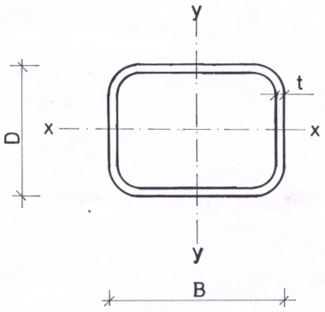
Figure A.2 ― Rectangular hollow section

Table A.2 – Dimensions and properties for cold formed rectangular hollow sections
Size, B x D  mm | Thickness, t  mm | Area,  A  cm² | Mass, w  kg/m | Second Moment of area |  | Radius of gyration |  | Elastic section modulus
 |  |  |  | Major axis x-x  I_{x}  cm⁴ | Minor axis y-y  I_{y}  cm⁴ | Major axis x-x  R_{x}  cm | Minor axis y-y  R_{y}  cm | Major axis x-x  Z_{x}  cm³ | Minor axis y-y  Z_{y}  cm³
30 x 10 | 1.0 | 0.73 | 0.57 | 0.730 | 0.125 | 1.000 | 0.413 | 0.487 | 0.249
30 x 10 | 1.2 | 0.87 | 0.68 | 0.838 | 0.141 | 0.984 | 0.403 | 0.558 | 0.281
30 x 10 | 1.5 | 1.05 | 0.83 | 0.976 | 0.160 | 0.963 | 0.390 | 0.651 | 0.320
30 x 20 | 1.0 | 0.93 | 0.73 | 1.151 | 0.614 | 1.110 | 0.811 | 0.767 | 0.614
30 x 20 | 1.2 | 1.11 | 0.87 | 1.336 | 0.711 | 1.099 | 0.802 | 0.890 | 0.711
30 x 20 | 1.5 | 1.35 | 1.06 | 1.586 | 0.840 | 1.083 | 0.788 | 1.057 | 0.840
30 x 20 | 2.0 | 1.74 | 1.36 | 1.937 | 1.018 | 1.056 | 0.765 | 1.291 | 1.018
35 x 15 | 1.0 | 0.93 | 0.73 | 1.39 | 0.37 | 1.22 | 0.63 | 0.79 | 0.49
35 x 15 | 1.2 | 1.11 | 0.87 | 1.611 | 0.421 | 1.207 | 0.617 | 0.921 | 0.562
35 x 15 | 1.5 | 1.35 | 1.06 | 1.911 | 0.494 | 1.189 | 0.604 | 1.092 | 0.658
35 x 15 | 2.0 | 1.74 | 1.36 | 2.327 | 0.589 | 1.157 | 0.582 | 1.330 | 0.785
35 x 15 | 3.0 | 2.41 | 1.89 | 2.867 | 0.699 | 1.091 | 0.539 | 1.639 | 0.932
35 x 25 | 1.0 | 1.13 | 0.89 | 1.967 | 1.172 | 1.317 | 1.017 | 1.124 | 0.938
35 x 25 | 1.2 | 1.35 | 1.06 | 2.297 | 1.366 | 1.307 | 1.008 | 1.312 | 1.092
35 x 25 | 1.5 | 1.65 | 1.30 | 2.753 | 1.631 | 1.291 | 0.994 | 1.573 | 1.305
35 x 25 | 2.0 | 2.14 | 1.68 | 3.417 | 2.014 | 1.265 | 0.971 | 1.953 | 1.611
35 x 25 | 3.0 | 3.01 | 2.36 | 4.408 | 2.571 | 1.210 | 0.925 | 2.519 | 2.057
35 x 30 | 1.0 | 1.23 | 0.97 | 2.26 | 1.78 | 1.35 | 1.20 | 1.29 | 1.19
35 x 30 | 1.2 | 1.47 | 1.15 | 2.640 | 2.082 | 1.342 | 1.192 | 1.508 | 1.388
35 x 30 | 1.5 | 1.80 | 1.41 | 3.174 | 2.501 | 1.327 | 1.178 | 1.814 | 1.667
35 x 30 | 2.0 | 2.34 | 1.83 | 3.962 | 3.115 | 1.302 | 1.154 | 2.264 | 2.076
35 x 30 | 3.0 | 3.31 | 2.60 | 5.178 | 4.053 | 1.251 | 1.107 | 2.959 | 2.702
40 x 10 | 1.0 | 0.93 | 0.73 | 1.574 | 0.165 | 1.298 | 0.421 | 0.787 | 0.331
40 x 10 | 1.2 | 1.11 | 0.87 | 1.822 | 0.187 | 1.284 | 0.412 | 0.911 | 0.375
40 x 10 | 1.5 | 1.35 | 1.06 | 2.153 | 0.215 | 1.262 | 0.399 | 1.077 | 0.430
40 x 10 | 2.0 | 1.74 | 1.36 | 2.604 | 0.247 | 1.224 | 0.377 | 1.302 | 0.494
40 x 20 | 1.0 | 1.13 | 0.89 | 2.335 | 0.795 | 1.435 | 0.837 | 1.167 | 0.795
40 x 20 | 1.2 | 1.35 | 1.06 | 2.725 | 0.923 | 1.423 | 0.828 | 1.363 | 0.923
40 x 20 | 1.5 | 1.65 | 1.30 | 3.266 | 1.097 | 1.406 | 0.815 | 1.633 | 1.097
40 x 20 | 2.0 | 2.14 | 1.68 | 4.050 | 1.343 | 1.377 | 0.793 | 2.025 | 1.343
40 x 20 | 3.0 | 3.01 | 2.36 | 5.208 | 1.685 | 1.316 | 0.748 | 2.604 | 1.685
40 x 25 | 1.0 | 1.23 | 0.97 | 2.715 | 1.316 | 1.483 | 1.033 | 1.358 | 1.053
40 x 25 | 1.2 | 1.47 | 1.15 | 3.177 | 1.536 | 1.472 | 1.024 | 1.589 | 1.229
40 x 25 | 1.5 | 1.80 | 1.41 | 3.822 | 1.839 | 1.456 | 1.010 | 1.911 | 1.471
40 x 25 | 2.0 | 2.34 | 1.83 | 4.772 | 2.279 | 1.429 | 0.988 | 2.386 | 1.823
40 x 25 | 3.0 | 3.31 | 2.60 | 6.237 | 2.937 | 1.373 | 0.942 | 3.118 | 2.349
40 x 35 | 1.2 | 1.71 | 1.34 | 4.081 | 3.325 | 1.547 | 1.396 | 2.040 | 1.900
40 x 35 | 1.5 | 2.10 | 1.65 | 4.934 | 4.017 | 1.532 | 1.382 | 2.467 | 2.295
40 x 35 | 2.0 | 2.74 | 2.15 | 6.218 | 5.053 | 1.507 | 1.359 | 3.109 | 2.887
40 x 35 | 3.0 | 3.91 | 3.07 | 8.295 | 6.719 | 1.457 | 1.311 | 4.147 | 3.839
45 x 15 | 1.2 | 1.35 | 1.06 | 3.089 | 0.536 | 1.515 | 0.631 | 1.373 | 0.715
45 x 15 | 1.5 | 1.65 | 1.30 | 3.696 | 0.631 | 1.496 | 0.618 | 1.643 | 0.841
45 x 30 | 1.2 | 1.71 | 1.34 | 4.816 | 2.580 | 1.681 | 1.230 | 2.141 | 1.720
45 x 30 | 1.5 | 2.10 | 1.65 | 5.826 | 3.111 | 1.665 | 1.216 | 2.589 | 2.074
45 x 30 | 2.0 | 2.74 | 2.15 | 7.345 | 3.900 | 1.638 | 1.194 | 3.264 | 2.600
45 x 30 | 3.0 | 3.91 | 3.07 | 9.804 | 5.151 | 1.584 | 1.148 | 4.358 | 3.434
50 x 10 | 1.0 | 1.13 | 0.89 | 2.885 | 0.206 | 1.595 | 0.426 | 1.154 | 0.412
50 x 10 | 1.2 | 1.35 | 1.06 | 3.359 | 0.234 | 1.580 | 0.417 | 1.343 | 0.468
50 x 10 | 1.5 | 1.65 | 1.30 | 4.007 | 0.270 | 1.557 | 0.404 | 1.603 | 0.539
50 x 10 | 2.0 | 2.14 | 1.68 | 4.926 | 0.312 | 1.518 | 0.382 | 1.970 | 0.624
50 x 10 | 3.0 | 3.01 | 2.36 | 6.196 | 0.350 | 1.435 | 0.341 | 2.478 | 0.699
50 x 15 | 1.2 | 1.47 | 1.15 | 4.073 | 0.593 | 1.667 | 0.636 | 1.629 | 0.791
50 x 15 | 1.5 | 1.80 | 1.41 | 4.889 | 0.699 | 1.647 | 0.623 | 1.956 | 0.933
50 x 15 | 2.0 | 2.34 | 1.83 | 6.079 | 0.844 | 1.613 | 0.601 | 2.431 | 1.126
50 x 15 | 3.0 | 3.31 | 2.60 | 7.855 | 1.029 | 1.541 | 0.558 | 3.142 | 1.373
50 x 25 | 1.0 | 1.43 | 1.13 | 4.686 | 1.605 | 1.808 | 1.058 | 1.875 | 1.284
50 x 25 | 1.2 | 1.71 | 1.34 | 5.502 | 1.876 | 1.796 | 1.049 | 2.201 | 1.501
50 x 25 | 1.5 | 2.10 | 1.65 | 6.654 | 2.254 | 1.779 | 1.035 | 2.662 | 1.803
50 x 25 | 2.0 | 2.74 | 2.15 | 8.384 | 2.809 | 1.750 | 1.013 | 3.354 | 2.247
50 x 25 | 3.0 | 3.91 | 3.07 | 11.173 | 3.667 | 1.691 | 0.969 | 4.469 | 2.934
55 x 10 | 2.0 | 2.34 | 1.83 | 6.475 | 0.345 | 1.664 | 0.384 | 2.354 | 0.690
55 x 10 | 3.0 | 3.31 | 2.60 | 8.264 | 0.389 | 1.580 | 0.343 | 3.005 | 0.777
55 x 20 | 1.2 | 1.71 | 1.34 | 6.109 | 1.242 | 1.893 | 0.853 | 2.221 | 1.242
55 x 20 | 1.5 | 2.10 | 1.65 | 7.381 | 1.483 | 1.874 | 0.840 | 2.684 | 1.483
55 x 20 | 2.0 | 2.74 | 2.15 | 9.285 | 1.831 | 1.842 | 0.818 | 3.376 | 1.831
55 x 20 | 3.0 | 3.91 | 3.07 | 12.324 | 2.342 | 1.776 | 0.774 | 4.482 | 2.342
55 x 25 | 1.2 | 1.83 | 1.43 | 6.977 | 2.046 | 1.955 | 1.059 | 2.537 | 1.637
55 x 25 | 1.5 | 2.25 | 1.77 | 8.454 | 2.461 | 1.938 | 1.045 | 3.074 | 1.969
55 x 25 | 2.0 | 2.94 | 2.31 | 10.690 | 3.075 | 1.908 | 1.023 | 3.887 | 2.460
55 x 25 | 3.0 | 4.21 | 3.30 | 14.354 | 4.032 | 1.847 | 0.979 | 5.220 | 3.226
55 x 35 | 1.2 | 2.07 | 1.62 | 8.714 | 4.354 | 2.054 | 1.452 | 3.169 | 2.488
55 x 35 | 1.5 | 2.55 | 2.00 | 10.602 | 5.280 | 2.038 | 1.438 | 3.855 | 3.017
55 x 35 | 2.0 | 3.34 | 2.62 | 13.501 | 6.688 | 2.011 | 1.416 | 4.909 | 3.822
55 x 35 | 3.0 | 4.81 | 3.77 | 18.415 | 9.029 | 1.957 | 1.370 | 6.696 | 5.160
55 x 45 | 1.2 | 2.31 | 1.81 | 10.451 | 7.695 | 2.129 | 1.827 | 3.800 | 3.420
55 x 45 | 1.5 | 2.85 | 2.24 | 12.749 | 9.375 | 2.114 | 1.813 | 4.636 | 4.167
55 x 45 | 2.0 | 3.74 | 2.93 | 16.311 | 11.971 | 2.089 | 1.790 | 5.931 | 5.320
55 x 45 | 3.0 | 5.41 | 4.25 | 22.475 | 16.431 | 2.039 | 1.743 | 8.173 | 7.303
60 x 15 | 1.2 | 1.71 | 1.34 | 6.606 | 0.708 | 1.968 | 0.644 | 2.202 | 0.944
60 x 15 | 1.5 | 2.10 | 1.65 | 7.969 | 0.837 | 1.947 | 0.631 | 2.656 | 1.116
60 x 15 | 2.0 | 2.74 | 2.15 | 9.999 | 1.014 | 1.911 | 0.609 | 3.333 | 1.353
60 x 15 | 3.0 | 3.91 | 3.07 | 13.184 | 1.250 | 1.837 | 0.566 | 4.395 | 1.667
60 x 20 | 1.2 | 1.83 | 1.43 | 7.643 | 1.348 | 2.046 | 0.859 | 2.548 | 1.348
60 x 20 | 1.5 | 2.25 | 1.77 | 9.253 | 1.612 | 2.027 | 0.846 | 3.084 | 1.612
60 x 20 | 2.0 | 2.94 | 2.31 | 11.681 | 1.994 | 1.994 | 0.824 | 3.894 | 1.994
60 x 20 | 3.0 | 4.21 | 3.30 | 15.623 | 2.561 | 1.927 | 0.780 | 5.208 | 2.561
60 x 30 | 1.2 | 2.07 | 1.62 | 9.718 | 3.327 | 2.169 | 1.269 | 3.239 | 2.218
60 x 30 | 1.5 | 2.55 | 2.00 | 11.820 | 4.025 | 2.152 | 1.256 | 3.940 | 2.683
60 x 30 | 2.0 | 3.34 | 2.62 | 15.047 | 5.078 | 2.123 | 1.234 | 5.016 | 3.385
60 x 30 | 3.0 | 4.81 | 3.77 | 20.501 | 6.798 | 2.065 | 1.189 | 6.834 | 4.532
60 x 40 | 1.0 | 1.93 | 1.52 | 9.986 | 5.378 | 2.272 | 1.667 | 3.329 | 2.689
60 x 40 | 1.2 | 2.31 | 1.81 | 11.792 | 6.340 | 2.262 | 1.658 | 3.931 | 3.170
60 x 40 | 1.5 | 2.85 | 2.24 | 14.387 | 7.715 | 2.246 | 1.645 | 4.796 | 3.857
60 x 40 | 2.0 | 3.74 | 2.93 | 18.412 | 9.831 | 2.220 | 1.622 | 6.137 | 4.916
60 x 40 | 3.0 | 5.41 | 4.25 | 25.379 | 13.440 | 2.166 | 1.576 | 8.460 | 6.720
60 x 40 | 4.0 | 6.95 | 5.45 | 30.987 | 16.280 | 2.112 | 1.531 | 10.329 | 8.140
65 x 25 | 1.2 | 2.07 | 1.62 | 10.627 | 2.386 | 2.268 | 1.075 | 3.270 | 1.909
65 x 25 | 1.5 | 2.55 | 2.00 | 12.919 | 2.876 | 2.250 | 1.062 | 3.975 | 2.301
65 x 25 | 2.0 | 3.34 | 2.62 | 16.430 | 3.605 | 2.219 | 1.039 | 5.055 | 2.884
65 x 25 | 3.0 | 4.81 | 3.77 | 22.334 | 4.763 | 2.155 | 0.995 | 6.872 | 3.810
65 x 25 | 4.0 | 6.15 | 4.83 | 26.832 | 5.567 | 2.089 | 0.952 | 8.256 | 4.454
65 x 30 | 1.2 | 2.19 | 1.72 | 11.848 | 3.576 | 2.328 | 1.279 | 3.646 | 2.384
65 x 30 | 1.5 | 2.70 | 2.12 | 14.431 | 4.330 | 2.311 | 1.266 | 4.440 | 2.887
65 x 30 | 2.0 | 3.54 | 2.78 | 18.415 | 5.471 | 2.282 | 1.244 | 5.666 | 3.647
65 x 30 | 3.0 | 5.11 | 4.01 | 25.219 | 7.347 | 2.222 | 1.199 | 7.760 | 4.898
65 x 30 | 4.0 | 6.55 | 5.14 | 30.558 | 8.737 | 2.160 | 1.155 | 9.403 | 5.825
65 x 35 | 1.2 | 2.31 | 1.81 | 13.069 | 5.040 | 2.381 | 1.479 | 4.021 | 2.880
65 x 35 | 1.5 | 2.85 | 2.24 | 15.944 | 6.122 | 2.364 | 1.465 | 4.906 | 3.498
65 x 35 | 2.0 | 3.74 | 2.93 | 20.400 | 7.779 | 2.336 | 1.443 | 6.277 | 4.445
65 x 35 | 3.0 | 5.41 | 4.25 | 28.105 | 10.570 | 2.280 | 1.398 | 8.648 | 6.040
65 x 35 | 4.0 | 6.95 | 5.45 | 34.285 | 12.725 | 2.221 | 1.353 | 10.549 | 7.271
70 x 20 | 1.2 | 2.07 | 1.62 | 11.411 | 1.560 | 2.351 | 0.869 | 3.260 | 1.560
70 x 20 | 1.5 | 2.55 | 2.00 | 13.861 | 1.869 | 2.330 | 0.856 | 3.960 | 1.869
70 x 20 | 2.0 | 3.34 | 2.62 | 17.600 | 2.319 | 2.297 | 0.834 | 5.029 | 2.319
70 x 20 | 3.0 | 4.81 | 3.77 | 23.838 | 2.999 | 2.227 | 0.790 | 6.811 | 2.999
70 x 20 | 4.0 | 6.15 | 4.83 | 28.508 | 3.428 | 2.153 | 0.747 | 8.145 | 3.428
70 x 30 | 1.2 | 2.31 | 1.81 | 14.251 | 3.825 | 2.486 | 1.288 | 4.072 | 2.550
70 x 30 | 1.5 | 2.85 | 2.24 | 17.380 | 4.635 | 2.469 | 1.275 | 4.966 | 3.090
70 x 30 | 2.0 | 3.74 | 2.93 | 22.225 | 5.863 | 2.439 | 1.253 | 6.350 | 3.909
70 x 30 | 3.0 | 5.41 | 4.25 | 30.576 | 7.896 | 2.378 | 1.208 | 8.736 | 5.264
70 x 30 | 4.0 | 6.95 | 5.45 | 37.231 | 9.418 | 2.315 | 1.164 | 10.637 | 6.279
70 x 50 | 1.2 | 2.79 | 2.19 | 19.932 | 11.934 | 2.675 | 2.070 | 5.695 | 4.773
70 x 50 | 1.5 | 3.45 | 2.71 | 24.420 | 14.595 | 2.660 | 2.056 | 6.977 | 5.838
70 x 50 | 2.0 | 4.54 | 3.56 | 31.476 | 18.758 | 2.634 | 2.033 | 8.993 | 7.503
70 x 50 | 3.0 | 6.61 | 5.19 | 44.052 | 26.104 | 2.582 | 1.987 | 12.586 | 10.441
70 x 50 | 4.0 | 8.55 | 6.71 | 54.676 | 32.222 | 2.529 | 1.942 | 15.622 | 12.889
75 x 25 | 1.2 | 2.31 | 1.81 | 15.309 | 2.726 | 2.577 | 1.087 | 4.082 | 2.181
75 x 25 | 1.5 | 2.85 | 2.24 | 18.660 | 3.290 | 2.558 | 1.074 | 4.976 | 2.632
75 x 25 | 2.0 | 3.74 | 2.93 | 23.837 | 4.135 | 2.526 | 1.052 | 6.357 | 3.308
75 x 25 | 3.0 | 5.41 | 4.25 | 32.718 | 5.493 | 2.460 | 1.008 | 8.725 | 4.395
75 x 25 | 4.0 | 6.95 | 5.45 | 39.726 | 6.460 | 2.391 | 0.964 | 10.594 | 5.168
75 x 50 | 1.5 | 3.602 | 2.828 | 28.791 | 15.478 | 2.827 | 2.073 | 7.677 | 6.191
75 x 50 | 2.0 | 4.74 | 3.72 | 37.163 | 19.911 | 2.801 | 2.050 | 9.910 | 7.964
75 x 50 | 2.5 | 5.84 | 4.58 | 44.951 | 24.001 | 2.775 | 2.027 | 11.987 | 9.601
75 x 50 | 3.0 | 6.91 | 5.42 | 52.169 | 27.763 | 2.748 | 2.005 | 13.912 | 11.105
75 x 50 | 4.0 | 8.95 | 7.02 | 64.958 | 34.343 | 2.694 | 1.959 | 17.322 | 13.737
75 x 50 | 5.0 | 10.86 | 8.52 | 75.651 | 39.747 | 2.640 | 1.913 | 20.174 | 15.899
80 x 40 | 1.2 | 2.79 | 2.19 | 23.663 | 8.147 | 2.915 | 1.710 | 5.916 | 4.073
80 x 40 | 1.5 | 3.45 | 2.71 | 28.989 | 9.939 | 2.898 | 1.697 | 7.247 | 4.970
80 x 40 | 2.0 | 4.54 | 3.56 | 37.358 | 12.722 | 2.869 | 1.675 | 9.339 | 6.361
80 x 40 | 3.0 | 6.61 | 5.19 | 52.252 | 17.556 | 2.812 | 1.630 | 13.063 | 8.778
80 x 40 | 4.0 | 8.55 | 6.71 | 64.795 | 21.486 | 2.753 | 1.585 | 16.199 | 10.743
80 x 60 | 1.5 | 4.05 | 3.18 | 38.233 | 24.656 | 3.072 | 2.467 | 9.558 | 8.219
80 x 60 | 2.0 | 5.34 | 4.19 | 49.528 | 31.873 | 3.046 | 2.444 | 12.382 | 10.624
80 x 60 | 3.0 | 7.81 | 6.13 | 70.048 | 44.891 | 2.995 | 2.398 | 17.512 | 14.964
80 x 60 | 4.0 | 10.15 | 7.97 | 87.920 | 56.117 | 2.943 | 2.352 | 21.980 | 18.706
90 x 30 | 1.5 | 3.45 | 2.71 | 32.929 | 5.854 | 3.088 | 1.302 | 7.317 | 3.903
90 x 30 | 2.0 | 4.54 | 3.56 | 42.388 | 7.434 | 3.057 | 1.280 | 9.420 | 4.956
90 x 30 | 3.0 | 6.61 | 5.19 | 59.136 | 10.092 | 2.991 | 1.236 | 13.141 | 6.728
90 x 30 | 4.0 | 8.55 | 6.71 | 73.107 | 12.144 | 2.924 | 1.192 | 16.246 | 8.096
100 x 20 | 1.5 | 3.45 | 2.71 | 35.940 | 2.641 | 3.227 | 0.875 | 7.188 | 2.641
100 x 20 | 2.0 | 4.54 | 3.56 | 46.167 | 3.295 | 3.190 | 0.852 | 9.233 | 3.295
100 x 20 | 3.0 | 6.61 | 5.19 | 64.105 | 4.313 | 3.115 | 0.808 | 12.821 | 4.313
100 x 20 | 4.0 | 8.55 | 6.71 | 78.814 | 4.996 | 3.036 | 0.764 | 15.763 | 4.996
100 x 40 | 2.0 | 5.34 | 4.19 | 65.377 | 15.612 | 3.500 | 1.710 | 13.075 | 7.806
100 x 40 | 3.0 | 7.81 | 6.13 | 92.341 | 21.672 | 3.439 | 1.666 | 18.468 | 10.836
100 x 40 | 4.0 | 10.15 | 7.97 | 115.699 | 26.691 | 3.377 | 1.622 | 23.140 | 13.345
100 x 50 | 2.5 | 7.09 | 5.56 | 91.205 | 31.059 | 3.587 | 2.093 | 18.241 | 12.424
100 x 50 | 3.0 | 8.41 | 6.60 | 106.459 | 36.058 | 3.558 | 2.071 | 21.292 | 14.423
100 x 50 | 4.0 | 10.95 | 8.59 | 134.142 | 44.950 | 3.500 | 2.026 | 26.828 | 17.980
100 x 50 | 5.0 | 13.36 | 10.48 | 158.190 | 52.455 | 3.441 | 1.982 | 31.638 | 20.982
100 x 50 | 6.0 | 15.63 | 12.27 | 178.761 | 58.675 | 3.382 | 1.937 | 35.752 | 23.470
120 x 60 | 3.0 | 10.21 | 8.01 | 189.123 | 64.403 | 4.304 | 2.512 | 31.520 | 21.468
120 x 60 | 4.0 | 13.35 | 10.48 | 240.745 | 81.248 | 4.247 | 2.467 | 40.124 | 27.083
120 x 80 | 2.0 | 7.74 | 6.07 | 159.772 | 86.040 | 4.544 | 3.335 | 26.629 | 21.510
120 x 80 | 2.5 | 9.59 | 7.53 | 195.754 | 105.192 | 4.518 | 3.312 | 32.626 | 26.296
120 x 80 | 3.0 | 11.41 | 8.96 | 230.199 | 123.436 | 4.492 | 3.289 | 38.366 | 30.859
120 x 80 | 4.0 | 14.95 | 11.73 | 294.591 | 157.296 | 4.439 | 3.244 | 49.098 | 39.324
125 x 75 | 3.0 | 11.41 | 8.96 | 242.851 | 110.523 | 4.614 | 3.113 | 38.856 | 29.473
125 x 75 | 4.0 | 14.95 | 11.73 | 310.771 | 140.653 | 4.560 | 3.067 | 49.723 | 37.507
125 x 75 | 5.0 | 18.36 | 14.41 | 372.521 | 167.682 | 4.505 | 3.022 | 59.603 | 44.715
125 x 75 | 6.0 | 21.63 | 16.98 | 428.305 | 191.761 | 4.450 | 2.977 | 68.529 | 51.136
140 x 60 | 2.0 | 7.74 | 6.07 | 193.130 | 52.065 | 4.996 | 2.594 | 27.590 | 17.355
140 x 60 | 2.5 | 9.59 | 7.53 | 236.550 | 63.430 | 4.967 | 2.572 | 33.793 | 21.143
140 x 60 | 3.0 | 11.41 | 8.96 | 278.085 | 74.159 | 4.937 | 2.550 | 39.726 | 24.720
140 x 60 | 4.0 | 14.95 | 11.73 | 355.602 | 93.813 | 4.877 | 2.505 | 50.800 | 31.271
150 x 50 | 3.0 | 11.41 | 8.96 | 298.555 | 52.648 | 5.116 | 2.148 | 39.807 | 21.059
150 x 50 | 4.0 | 14.95 | 11.73 | 381.399 | 66.163 | 5.051 | 2.104 | 50.853 | 26.465
150 x 50 | 5.0 | 18.36 | 14.41 | 456.299 | 77.872 | 4.986 | 2.060 | 60.840 | 31.149
150 x 50 | 6.0 | 21.63 | 16.98 | 523.483 | 87.895 | 4.919 | 2.016 | 69.798 | 35.158
150 x 75 | 3.0 | 12.91 | 10.13 | 379.600 | 129.974 | 5.423 | 3.173 | 50.613 | 34.660
150 x 75 | 4.0 | 16.95 | 13.30 | 488.006 | 165.884 | 5.366 | 3.129 | 65.067 | 44.236
150 x 75 | 5.0 | 20.86 | 16.37 | 587.757 | 198.360 | 5.309 | 3.084 | 78.368 | 52.896
150 x 75 | 6.0 | 24.63 | 19.34 | 679.093 | 227.558 | 5.251 | 3.039 | 90.546 | 60.682
150 x 100 | 3.0 | 14.41 | 11.31 | 460.645 | 247.639 | 5.654 | 4.146 | 61.419 | 49.528
150 x 100 | 4.0 | 18.95 | 14.87 | 594.613 | 318.569 | 5.602 | 4.100 | 79.282 | 63.714
150 x 100 | 5.0 | 23.36 | 18.33 | 719.215 | 384.024 | 5.549 | 4.055 | 95.895 | 76.805
150 x 100 | 6.0 | 27.63 | 21.69 | 800.121 | 429.761 | 5.381 | 3.944 | 106.683 | 85.952
150 x 100 | 8.0 | 35.79 | 28.10 | 1,067.14 | 559.76 | 5.46 | 3.95 | 142.29 | 111.95
200 x 50 | 4.0 | 18.948 | 14.874 | 815.520 | 87.388 | 6.560 | 2.148 | 81.552 | 34.955
200 x 50 | 5.0 | 23.36 | 18.33 | 983.891 | 103.316 | 6.490 | 2.103 | 98.389 | 41.327
200 x 50 | 6.0 | 27.63 | 21.69 | 1138.680 | 117.173 | 6.419 | 2.059 | 113.868 | 46.869
200 x 50 | 8.0 | 35.79 | 28.10 | 1408.746 | 139.249 | 6.274 | 1.972 | 140.875 | 55.700
200 x 100 | 4.0 | 22.95 | 18.01 | 1199.722 | 410.782 | 7.230 | 4.231 | 119.972 | 82.156
200 x 100 | 5.0 | 28.36 | 22.26 | 1459.280 | 496.940 | 7.174 | 4.186 | 145.928 | 99.388
200 x 100 | 6.0 | 33.63 | 26.40 | 1703.342 | 576.921 | 7.116 | 4.142 | 170.334 | 115.384
200 x 100 | 8.0 | 43.24 | 33.94 | 2,090.91 | 705.37 | 6.95 | 4.04 | 209.09 | 141.07
200 x 150 | 4.0 | 26.95 | 21.15 | 1583.935 | 1021.039 | 7.667 | 6.155 | 158.394 | 136.139
200 x 150 | 5.0 | 33.36 | 26.19 | 1934.696 | 1245.049 | 7.616 | 6.109 | 193.470 | 166.006
200 x 150 | 6.0 | 39.63 | 31.11 | 2268.062 | 1457.143 | 7.565 | 6.063 | 226.806 | 194.286
200 x 150 | 8.0 | 51.24 | 40.22 | 2,828.62 | 1,815.57 | 7.43 | 5.95 | 282.86 | 242.08
300 x 100 | 4.0 | 30.95 | 24.29 | 3289.494 | 591.748 | 10.310 | 4.373 | 219.300 | 118.350
300 x 100 | 5.0 | 38.36 | 30.11 | 4065.277 | 722.774 | 10.295 | 4.341 | 271.018 | 144.555
300 x 100 | 6.0 | 45.63 | 35.82 | 4776.872 | 842.361 | 10.231 | 4.296 | 318.458 | 168.472
300 x 100 | 8.0 | 59.24 | 46.50 | 5,978.04 | 1,044.78 | 10.05 | 4.20 | 398.54 | 208.96
300 x 200 | 4.0 | 38.95 | 30.57 | 5072.923 | 2736.575 | 11.413 | 8.382 | 338.195 | 273.658
300 x 200 | 5.0 | 48.36 | 37.96 | 6241.110 | 3360.946 | 11.361 | 8.337 | 416.074 | 336.095
300 x 200 | 6.0 | 57.63 | 45.24 | 7370.312 | 3962.222 | 11.309 | 8.291 | 491.354 | 396.222
300 x 200 | 8.0 | 75.24 | 59.06 | 9389.451 | 5041.735 | 11.171 | 8.186 | 625.963 | 504.174
350 x 150 | 4.0 | 38.95 | 30.57 | 6133.375 | 1660.679 | 12.549 | 6.530 | 350.479 | 221.424
350 x 150 | 5.0 | 48.36 | 37.96 | 7544.127 | 2033.799 | 12.490 | 6.485 | 431.093 | 271.173
350 x 150 | 6.0 | 57.63 | 45.24 | 8906.982 | 2390.803 | 12.432 | 6.441 | 508.970 | 318.774
350 x 150 | 8.0 | 75.24 | 59.06 | 11322.126 | 3026.693 | 12.267 | 6.342 | 646.979 | 403.559
400 x 100 | 6.0 | 57.63 | 45.24 | 10132.070 | 1107.801 | 13.259 | 4.384 | 506.603 | 221.560
400 x 100 | 8.0 | 75.24 | 59.06 | 12827.344 | 1384.195 | 13.057 | 4.289 | 641.367 | 276.839
Note: Other dimensions and their sectional properties may be produced according to ISO 10799-2 or ISO 12633-2.

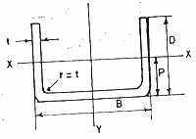
Figure A.3 ― Plain channel section

Table A.3 — Dimensions and properties for cold formed plain channel sections
Size,  B x D  mm | Thickness, t  mm | Area, A  cm² | Mass, w  kg/m | Centroid  Y-axis  Py  cm | Second Moment of area |  | Elastic section modulus |  | Radius of gyration
 |  |  |  |  | Axis x-x  Ix  cm⁴ | Axis y-y  Iy  cm⁴ | Axis x-x  Zx  cm³ | Axis y-y  Zy  cm³ | Axis x-x  Rx  cm | Axis y-y  Ry  cm
40 x 25 | 1.5 | 1.305 | 1.024 | 0.750 | 1.430 | 3.414 | 1.907 | 0.171 | 1.047 | 1.617
40 x 25 | 2.0 | 1.720 | 1.350 | 0.769 | 1.904 | 4.391 | 2.477 | 0.220 | 1.052 | 1.598
40 x 40 | 1.5 | 1.755 | 1.378 | 1.391 | 5.768 | 5.082 | 4.146 | 0.254 | 1.813 | 1.702
40 x 40 | 2.0 | 2.320 | 1.821 | 1.410 | 7.681 | 6.559 | 5.446 | 0.328 | 1.820 | 1.681
50 x 25 | 3.0 | 2.820 | 2.214 | 0.735 | 2.875 | 10.425 | 3.912 | 0.417 | 1.010 | 1.923
60 x 40 | 3.0 | 4.020 | 3.156 | 1.254 | 11.674 | 23.449 | 9.306 | 0.782 | 1.704 | 2.415
60x 40 | 4.0 | 5.280 | 4.145 | 1.291 | 15.535 | 29.818 | 12.034 | 0.994 | 1.715 | 2.376
75 x 40 | 3.0 | 4.470 | 3.509 | 1.143 | 11.779 | 39.335 | 10.303 | 1.049 | 1.623 | 2.966
75 x 40 | 4.0 | 5.880 | 4.616 | 1.180 | 15.679 | 50.396 | 13.292 | 1.344 | 1.633 | 2.928
75 x 40 | 4.5 | 6.570 | 5.157 | 1.198 | 17.626 | 55.574 | 14.717 | 1.482 | 1.638 | 2.908
100 x 50 | 3.0 | 5.820 | 4.569 | 1.361 | 23.090 | 91.355 | 16.961 | 1.827 | 1.992 | 3.962
100 x 50 | 4.0 | 7.680 | 6.029 | 1.398 | 30.743 | 118.170 | 21.992 | 2.363 | 2.001 | 3.923
100 x 50 | 4.5 | 8.595 | 6.747 | 1.416 | 34.563 | 130.938 | 24.407 | 2.619 | 2.005 | 3.903
100 x 50 | 6.0 | 11.280 | 8.855 | 1.470 | 46.007 | 166.794 | 31.293 | 3.336 | 2.020 | 3.845
120 x 50 | 3.0 | 6.420 | 5.040 | 1.248 | 23.256 | 139.729 | 18.633 | 2.329 | 1.903 | 4.665
120 x 50 | 4.0 | 8.480 | 6.657 | 1.285 | 30.969 | 181.444 | 24.102 | 3.024 | 1.911 | 4.626
120 x 50 | 6.0 | 12.480 | 9.797 | 1.358 | 46.365 | 258.106 | 34.150 | 4.302 | 1.927 | 4.548
120 x 65 | 4.5 | 10.845 | 8.513 | 1.857 | 75.799 | 246.486 | 40.824 | 4.108 | 2.644 | 4.767
125 x 65 | 4.0 | 9.880 | 7.756 | 1.805 | 67.526 | 243.789 | 37.405 | 3.901 | 2.614 | 4.967
125 x 65 | 6.0 | 14.580 | 11.445 | 1.878 | 101.071 | 348.518 | 53.813 | 5.576 | 2.633 | 4.889
150 x 50 | 6.0 | 14.280 | 11.210 | 1.224 | 46.800 | 442.624 | 38.224 | 5.902 | 1.810 | 5.567
150 x 70 | 4.0 | 11.280 | 8.855 | 1.838 | 84.728 | 393.942 | 46.091 | 5.253 | 2.741 | 5.910
150 x 70 | 6.0 | 16.680 | 13.094 | 1.912 | 126.844 | 567.112 | 66.358 | 7.561 | 2.758 | 5.831
150 x 75 | 4.0 | 11.680 | 9.169 | 2.024 | 103.961 | 415.263 | 51.373 | 5.537 | 2.983 | 5.963
150 x 75 | 6.0 | 17.280 | 13.565 | 2.097 | 155.636 | 598.234 | 74.223 | 7.976 | 3.001 | 5.884
200 x 75 | 4.5 | 15.345 | 12.046 | 1.776 | 118.215 | 906.376 | 66.578 | 9.064 | 2.776 | 7.685
200 x 75 | 4.0 | 13.680 | 10.739 | 1.757 | 105.128 | 812.250 | 59.833 | 8.122 | 2.772 | 7.706
200 x 75 | 5.0 | 17.000 | 13.345 | 1.794 | 131.294 | 998.917 | 73.180 | 9.989 | 2.779 | 7.665
200 x 75 | 6.0 | 20.280 | 15.920 | 1.831 | 157.433 | 1179.314 | 85.979 | 11.793 | 2.786 | 7.626
200 x 100 | 6.0 | 23.280 | 18.275 | 2.723 | 369.445 | 1461.674 | 135.692 | 14.617 | 3.984 | 7.924

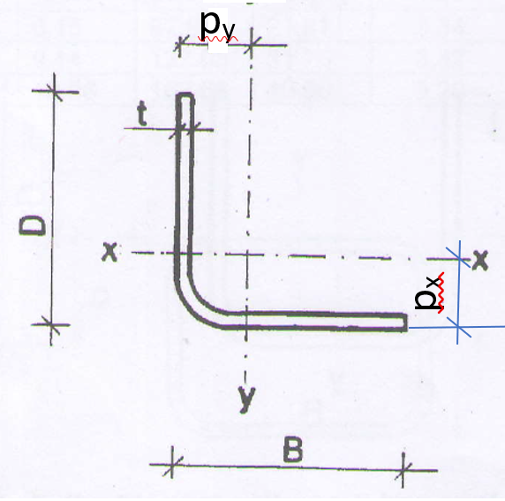
Figure A.4 ― Plain equal angles section
Table A.4 — Dimensions and properties for cold formed plain equal angles sections
Size,  B × D  mm | Thickness, t  mm | Cross sectional area, A  cm² | Mass, w  kg/m | Centroid, P  cm | Axis X-X |  |  | Axis Y-Y
 |  |  |  |  | I_{x}  cm⁴ | Z_{x}  cm³ | R_{x}  cm | I_{y}  cm⁴ | Z_{y}  cm³ | R_{y}  cm
20 x 20 | 2.5 | 0.888 | 0.69 | 1.10 | 0.33 | 0.24 | 0.614 | 0.33 | 0.23 | 0.614
25 x 25 | 2.5 | 1.13 | 0.89 | 0.75 | 0.68 | 0.39 | 0.775 | 0.68 | 0.38 | 0.775
25 x 25 | 2.0 | 1.65 | 1.09 | 0.70 | 0.42 | 1.06 | 1.12 | 0.42 | 1.06 | 1.12
25 x 25 | 3 | 1.33 | 1.05 | 0.78 | 0.80 | 0.46 | 0.773 | 0.80 | 0.46 | 0.773
30 x 30 | 2.0 | 1.23 | 1.10 | 0.84 | 1.10 | 1.05 | 1.09 | 1.10 | 1.05 | 1.09
30 x 30 | 2.5 | 1.38 | 1.08 | 0.87 | 1.24 | 0.58 | 0.941 | 1.24 | 0.58 | 0.941
30 x 30 | 3 | 1.63 | 1.28 | 0.90 | 1.43 | 0.68 | 0.935 | 1.43 | 0.68 | 0.935
32 x 32 | 3 | 1.74 | 1.37 | 0.91 | 1.54 | 0.67 | 0.94 | 1.54 | 0.67 | 0.94
32 x 32 | 4 | 2.24 | 1.76 | 0.898 | 1.86 | 0.81 | 0.91 | 1.86 | 0.81 | 0.91
32 x 32 | 4.5 | 2.48 | 1.88 | 0.906 | 1.99 | 0.87 | 0.90 | 1.99 | 0.87 | 0.90
32 x 32 | 6 | 3.12 | 2.45 | 1.03 | 2.30 | 1.06 | 0.86 | 2.30 | 1.06 | 0.86
40 x 40 | 2.0 | 1.46 | 1.14 | 1.09 | 2.46 | 1.23 | 1.21 | 2.46 | 1.23 | 1.21
40 x 40 | 2.5 | 1.88 | 1.47 | 1.13 | 2.96 | 1.03 | 1.25 | 2.96 | 1.03 | 1.25
40 x 40 | 3 | 2.22 | 1.74 | 1.06 | 3.18 | 1.08 | 1.20 | 3.18 | 1.08 | 1.20
40 x 40 | 4 | 2.88 | 2.26 | 1.097 | 3.92 | 1.32 | 1.17 | 3.92 | 1.32 | 1.17
40 x 40 | 4.5 | 3.20 | 2.51 | 1.11 | 4.24 | 1.47 | 1.15 | 4.24 | 1.47 | 1.15
40 x 40 | 6 | 4.08 | 3.20 | 1.23 | 5.66 | 2.04 | 1.18 | 5.66 | 2.04 | 1.18
50 x 50 | 2.0 | 1.86 | 1.46 | 1.34 | 4.85 | 1.33 | 1.59 | 4.85 | 1.33 | 1.59
50 x 50 | 3 | 2.83 | 2.22 | 1.40 | 7.01 | 1.94 | 1.57 | 7.01 | 1.94 | 1.57
50 x 50 | 4 | 3.70 | 2.90 | 1.45 | 8.89 | 2.50 | 1.56 | 8.89 | 2.50 | 1,56
50 x 50 | 4.4 | 4.10 | 3.22 | 1.42 | 8.91 | 2.49 | 1.47 | 8.91 | 2.49 | 1.47
50 x 50 | 6 | 5.28 | 4.14 | 1.48 | 12.43 | 3.53 | 1.53 | 12.43 | 3.53 | 1.53
60 x 60 | 4 | 4.50 | 3.53 | 1.68 | 16.01 | 3.70 | 1.88 | 16.01 | 3.70 | 1.88
60 x 60 | 6 | 6.53 | 5.13 | 1.80 | 22.55 | 5.37 | 1.87 | 22.55 | 5.37 | 1.87
65 x 65 | 4.5 | 5.45 | 4.28 | 1.79 | 19.03 | 4.04 | 1.87 | 19.03 | 4.04 | 1.87
65 x 65 | 6 | 7.08 | 5.56 | 1.85 | 25.90 | 5.57 | 1.91 | 25.90 | 5.57 | 1.91
75 x 75 | 6 | 8.69 | 6.78 | 2.09 | 46.88 | 8.67 | 2.33 | 46.88 | 8.67 | 2.33
90 x 90 | 6 | 10.08 | 7.91 | 2.48 | 74.42 | 11.41 | 2.72 | 74.42 | 11.41 | 2.72
100 x 100 | 6 | 11.30 | 8.87 | 2.80 | 112.59 | 15.59 | 3.15 | 112.28 | 15.59 | 3.15

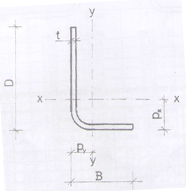
Figure A.5 — Plain unequal angles
Table A.5 — Dimensions and properties for cold formed plain unequal angle sections
Size,  B x D  mm | Thickness, t  mm | Area, A  cm² | Mass, w  kg/m | Centroid |  | Axis, x-x |  |  | Axis, y-y
 |  |  |  | Px  cm | Py  cm | Ix  cm⁴ | zx  cm³ | rx  cm | Iy  cm⁴ | zy  cm³ | ry  cm
50 x 40 | 6.0 | 4.65 | 3.67 | 1.53 | 1.11 | 9.96 | 2.87 | 1.04 | 5.41 | 1.83 | 1.08
65 x 50 | 6.0 | 6.18 | 4.85 | 1.99 | 1.31 | 11.68 | 2.59 | 1.24 | 11.74 | 3.12 | 1.38
75 x 50 | 6.0 | 6.78 | 5.32 | 2.40 | 1.22 | 35.81 | 7.02 | 1.15 | 17.58 | 4.57 | 1.61
90 x 65 | 6.0 | 8.58 | 6.73 | 2.76 | 1.59 | 66.56 | 10.67 | 1.51 | 28.58 | 5.73 | 1.83
90 x 75 | 6.0 | 9.78 | 7.61 | 3.01 | 1.93 | 94.54 | 13.53 | 1.76 | 45.09 | 7.86 | 2.15

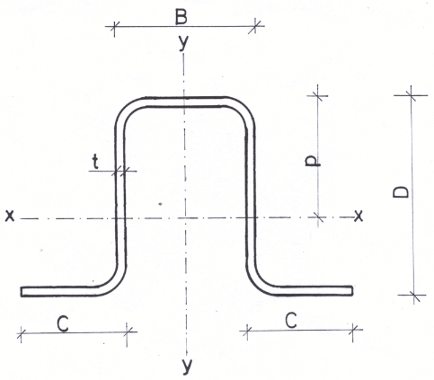
Figure A.6 ― Cold formed outwardly lipped channel section
Table A.6 — Dimensions and properties for cold formed outwardly lipped channel sections
Size  mm |  |  | Thickness, t  mm | Area, A  cm² | Mass, w  kg/m | Centroid, p  cm | Axis x-x |  |  | Axis y-y
B | D | C |  |  |  |  | Ix  cm⁴ | zx  cm³ | rx  cm | Iy  cm⁴ | zy  cm³ | ry  cm
20 | 20 | 10 | 1.5 | 1.20 | 0.94 | 1.116 | 0.6860 | 0.610 | 1.75 | 1.7260 | 1.730 | 1.195
20 | 20 | 15 | 2.0 | 1.54 | 1.20 | 1.118 | 0.7910 | 0.710 | 0.72 | 2.1300 | 0.930 | 1.180
25 | 25 | 15 | 1.5 | 1.43 | 1.12 | 1.305 | 1.2900 | 0.990 | 0.95 | 2.6540 | 1.020 | 1.363
25 | 25 | 15 | 2.0 | 1.84 | 1.44 | 1.313 | 1.5630 | 0.920 | 0.92 | 3.3000 | 1.290 | 1.340
40 | 25 | 15 | 1.5 | 1.88 | 1.47 | 2.077 | 4.0470 | 1.950 | 1.47 | 3.2760 | 1.260 | 1.321
40 | 25 | 15 | 2.0 | 2.44 | 1.91 | 2.078 | 5.0220 | 2.410 | 1.44 | 4.0900 | 1.600 | 1.295
50 | 50 | 20 | 1.5 | 2.70 | 2.12 | 2.366 | 10.0800 | 3.820 | 1.93 | 16.4500 | 3.780 | 2.467
50 | 50 | 20 | 2.0 | 3.54 | 2.77 | 2.365 | 12.8000 | 3.850 | 1.90 | 21.0600 | 4.900 | 2.442
75 | 50 | 20 | 2.0 | 4.74 | 3.71 | 3.590 | 36.9700 | 9.850 | 2.79 | 31.0100 | 6.460 | 2.559
75 | 50 | 20 | 2.5 | 5.84 | 4.58 | 3.588 | 44.5700 | 11.880 | 2.76 | 37.4300 | 7.880 | 2.532
75 | 50 | 20 | 3.0 | 6.91 | 5.42 | 3.586 | 51.5600 | 13.740 | 2.73 | 43.4000 | 9.230 | 2.507
100 | 50 | 30 | 2.0 | 5.93 | 4.66 | 5.166 | 79.3600 | 15.360 | 3.66 | 41.8500 | 7.890 | 2.657
100 | 50 | 30 | 2.5 | 7.33 | 5.76 | 5.167 | 96.400 | 18.650 | 3.63 | 50.7400 | 9.660 | 2.631
100 | 50 | 30 | 3.0 | 8.70 | 6.28 | 5.166 | 112.40000 | 21.750 | 3.60 | 59.0600 | 11.350 | 2.605

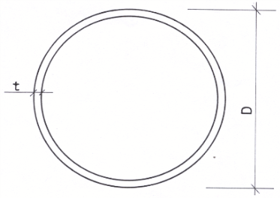
Figure A.7 ― Circular tubes
Table A.7 — Dimensions and properties for cold formed circular tubes
Diameter, D  mm | Thickness, t  mm | Area, A  cm² | Mass, w  kg/m | Second Moment of Area, I  cm⁴ | Radius of gyration, r  cm | Elastic section modulus, z  cm³
10 | 1.00 | 0.28 | 0.22 | 0.0290 | 0.3202 | 0.06
10 | 1.20 | 0.33 | 0.26 | 0.0327 | 0.3140 | 0.07
10 | 1.50 | 0.40 | 0.31 | 0.0373 | 0.3052 | 0.07
12 | 1.00 | 0.35 | 0.27 | 0.0527 | 0.3905 | 0.09
12 | 1.20 | 0.41 | 0.32 | 0.0601 | 0.3842 | 0.10
12 | 1.50 | 0.49 | 0.39 | 0.0696 | 0.3750 | 0.12
16 | 1.00 | 0.47 | 0.37 | 0.1331 | 0.5315 | 0.17
16 | 1.20 | 0.56 | 0.44 | 0.1538 | 0.5250 | 0.19
16 | 1.50 | 0.68 | 0.54 | 0.1815 | 0.5154 | 0.23
16 | 2.00 | 0.88 | 0.69 | 0.2199 | 0.5000 | 0.27
20 | 1.00 | 0.60 | 0.47 | 0.2701 | 0.6727 | 0.27
20 | 1.20 | 0.71 | 0.56 | 0.3144 | 0.6660 | 0.31
20 | 1.50 | 0.87 | 0.68 | 0.3755 | 0.6562 | 0.38
20 | 2.00 | 1.13 | 0.89 | 0.4638 | 0.6403 | 0.46
22 | 1.00 | 0.66 | 0.52 | 0.3646 | 0.7433 | 0.33
22 | 1.20 | 0.78 | 0.62 | 0.4255 | 0.7366 | 0.39
22 | 1.50 | 0.97 | 0.76 | 0.5103 | 0.7267 | 0.46
22 | 2.00 | 1.26 | 0.99 | 0.6347 | 0.7106 | 0.58
25 | 1.00 | 0.75 | 0.59 | 0.5439 | 0.8493 | 0.44
25 | 1.20 | 0.90 | 0.70 | 0.6370 | 0.8425 | 0.51
25 | 1.50 | 1.11 | 0.87 | 0.7677 | 0.8325 | 0.61
25 | 2.00 | 1.45 | 1.13 | 0.9629 | 0.8162 | 0.77
28 | 1.00 | 0.85 | 0.67 | 0.7741 | 0.9552 | 0.55
28 | 1.20 | 1.01 | 0.79 | 0.9090 | 0.9485 | 0.65
28 | 1.50 | 1.25 | 0.98 | 1.0999 | 0.9384 | 0.79
28 | 2.00 | 1.63 | 1.28 | 1.3888 | 0.9220 | 0.99
30 | 1.00 | 0.91 | 0.72 | 0.9590 | 1.0259 | 0.64
30 | 1.20 | 1.09 | 0.85 | 1.1278 | 1.0191 | 0.75
30 | 1.50 | 1.34 | 1.05 | 1.3676 | 1.0090 | 0.91
30 | 2.00 | 1.76 | 1.38 | 1.7331 | 0.9925 | 1.16
30 | 3.00 | 2.55 | 2.00 | 2.3478 | 0.9605 | 1.57
32 | 1.00 | 0.97 | 0.76 | 1.1713 | 1.0966 | 0.73
32 | 1.20 | 1.16 | 0.91 | 1.3791 | 1.0898 | 0.86
32 | 1.50 | 1.44 | 1.13 | 1.6755 | 1.0796 | 1.05
32 | 2.00 | 1.89 | 1.48 | 2.1303 | 1.0630 | 1.33
32 | 3.00 | 2.73 | 2.15 | 2.9044 | 1.0308 | 1.82
38 | 1.00 | 1.16 | 0.91 | 1.9908 | 1.3086 | 1.05
38 | 1.20 | 1.39 | 1.09 | 2.3513 | 1.3018 | 1.24
38 | 1.50 | 1.72 | 1.35 | 2.8696 | 1.2916 | 1.51
38 | 2.00 | 2.26 | 1.78 | 3.6761 | 1.2748 | 1.93
38 | 3.00 | 3.30 | 2.59 | 5.0889 | 1.2420 | 2.68
42 | 1.00 | 1.29 | 1.01 | 2.7085 | 1.4500 | 1.29
42 | 1.20 | 1.54 | 1.21 | 3.2037 | 1.4431 | 1.53
42 | 1.50 | 1.91 | 1.50 | 3.9189 | 1.4329 | 1.87
42 | 2.00 | 2.51 | 1.97 | 5.0398 | 1.4160 | 2.40
42 | 3.00 | 3.68 | 2.89 | 7.0306 | 1.3829 | 3.35
45 | 1.00 | 1.38 | 1.09 | 3.3473 | 1.5560 | 1.49
45 | 1.20 | 1.65 | 1.30 | 3.9632 | 1.5491 | 1.76
45 | 1.50 | 2.05 | 1.61 | 4.8550 | 1.5389 | 2.16
45 | 2.00 | 2.70 | 2.12 | 6.2588 | 1.5219 | 2.78
45 | 3.00 | 3.96 | 3.11 | 8.7740 | 1.4887 | 3.90
48 | 1.00 | 1.48 | 1.16 | 4.0795 | 1.6621 | 1.70
48 | 1.20 | 1.76 | 1.39 | 4.8342 | 1.6552 | 2.01
48 | 1.50 | 2.19 | 1.72 | 5.9295 | 1.6449 | 2.47
48 | 2.00 | 2.89 | 2.27 | 7.6602 | 1.6279 | 3.19
48 | 3.00 | 4.24 | 3.33 | 10.7845 | 1.5945 | 4.49
50 | 1.20 | 1.84 | 1.44 | 5.4805 | 1.7259 | 2.19
50 | 1.50 | 2.29 | 1.79 | 6.7274 | 1.7156 | 2.69
50 | 2.00 | 3.02 | 2.37 | 8.7021 | 1.6985 | 3.48
50 | 3.00 | 4.43 | 3.48 | 12.2828 | 1.6651 | 4.91
51 | 1.00 | 1.57 | 1.23 | 4.9113 | 1.7681 | 1.93
51 | 1.20 | 1.88 | 1.47 | 5.8242 | 1.7612 | 2.28
51 | 1.50 | 2.33 | 1.83 | 7.1519 | 1.7509 | 2.80
51 | 2.00 | 3.08 | 2.42 | 9.2567 | 1.7339 | 3.63
51 | 3.00 | 4.52 | 3.55 | 13.0814 | 1.7004 | 5.13
57 | 1.20 | 2.10 | 1.65 | 8.1922 | 1.9733 | 2.87
57 | 1.50 | 2.62 | 2.05 | 10.0787 | 1.9629 | 3.54
57 | 2.00 | 3.46 | 2.71 | 13.0860 | 1.9458 | 4.59
57 | 3.00 | 5.09 | 4.00 | 18.6105 | 1.9121 | 6.53
60 | 1.20 | 2.22 | 1.74 | 9.5854 | 2.0793 | 3.20
60 | 1.50 | 2.76 | 2.16 | 11.8021 | 2.0690 | 3.93
60 | 2.00 | 3.64 | 2.86 | 15.3443 | 2.0518 | 5.11
60 | 3.00 | 5.37 | 4.22 | 21.8808 | 2.0180 | 7.29
63 | 1.20 | 2.33 | 1.83 | 11.1282 | 2.1854 | 3.53
63 | 1.50 | 2.90 | 2.28 | 13.7117 | 2.1750 | 4.35
63 | 2.00 | 3.83 | 3.01 | 17.8485 | 2.1578 | 5.67
63 | 3.00 | 5.66 | 4.44 | 25.5138 | 2.1240 | 8.10
76 | 1.50 | 3.51 | 2.76 | 24.3698 | 2.6345 | 6.41
76 | 2.00 | 4.65 | 3.65 | 31.8536 | 2.6173 | 8.38
76 | 3.00 | 6.88 | 5.40 | 45.9133 | 2.5831 | 12.08
89 | 2.00 | 5.47 | 4.29 | 51.7527 | 3.0767 | 11.63
89 | 3.00 | 8.11 | 6.36 | 75.0345 | 3.0424 | 16.86
89 | 3.25 | 8.76 | 6.87 | 80.5982 | 3.0339 | 18.11
89 | 4.00 | 10.68 | 8.39 | 96.6927 | 3.0085 | 21.73
89 | 4.85 | 12.82 | 10.07 | 113.8834 | 2.9801 | 25.59
100 | 2.00 | 6.16 | 4.83 | 73.9614 | 3.4655 | 14.79
100 | 3.00 | 9.14 | 7.18 | 107.6386 | 3.4311 | 21.53
100 | 4.00 | 12.07 | 9.47 | 139.2333 | 3.3971 | 27.85
114 | 2.00 | 7.04 | 5.52 | 110.3923 | 3.9604 | 19.37
114 | 3.00 | 10.46 | 8.21 | 161.2588 | 3.9259 | 28.29
114 | 5.00 | 17.12 | 13.44 | 254.8464 | 3.8578 | 44.71
114 | 6.00 | 20.36 | 15.98 | 297.7673 | 3.8243 | 52.24
127 | 3.00 | 11.69 | 9.18 | 224.7795 | 4.3853 | 35.40
127 | 4.00 | 15.46 | 12.14 | 292.6514 | 4.3510 | 46.09
127 | 5.00 | 19.17 | 15.05 | 357.1861 | 4.3170 | 56.25
127 | 6.00 | 22.81 | 17.91 | 418.4948 | 4.2833 | 65.90
140 | 3.00 | 12.91 | 10.14 | 303.1149 | 4.8448 | 43.30
140 | 4.00 | 17.09 | 13.42 | 395.5200 | 4.8104 | 56.50
140 | 5.00 | 21.21 | 16.65 | 483.8189 | 4.7762 | 69.12
140 | 6.00 | 25.26 | 19.83 | 568.1352 | 4.7424 | 81.16
152 | 3.00 | 14.04 | 11.03 | 389.9171 | 5.2690 | 51.30
152 | 4.00 | 18.60 | 14.60 | 509.6575 | 5.2345 | 67.06
165 | 3.00 | 15.27 | 11.99 | 501.1081 | 5.7285 | 60.74
165 | 4.00 | 20.23 | 15.88 | 656.0271 | 5.6940 | 79.52
165 | 4.85 | 24.40 | 19.16 | 783.1354 | 5.6648 | 94.93
216 | 5.00 | 33.15 | 26.02 | 1,845.7691 | 7.4621 | 170.90
216 | 6.00 | 39.59 | 31.08 | 2,184.1362 | 7.4277 | 202.23
216 | 7.00 | 45.97 | 36.08 | 2,512.6963 | 7.3934 | 232.66
Note: Other dimensions and their sectional properties may be produced according to ISO 10799-2 or ISO 12633-2.

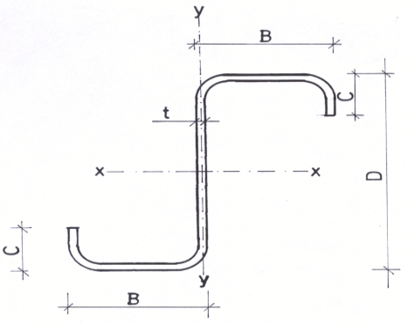
Figure A.8 ― Zed purlins
Table A.8 — Dimensions and properties for cold formed structural steel zed purlins
Dimension  mm |  |  | Thickness  mm | Area  cm² | Mass per metre run  kg/m | Centroid  cm |  | Moment of Inertia  cm⁴ |  | Section modulus of elasticity  cm³ |  | Radius of gyration  cm
B | D | C | t | A | W | C_{X} | C_{y} | I_{XX} | I_{YY} | Z_{XX} | Z_{YY} | R_{XX} | R_{YY}
50 | 75 | 20 | 1.5 | 3.135 | 2.461 | 3.75 | 5 | 33.594 | 61.256 | 6.719 | 16.335 | 3.2735 | 4.4203
50 | 75 | 20 | 2.0 | 4.14 | 3.250 | 3.75 | 5 | 43.917 | 77.754 | 8.783 | 20.734 | 3.2570 | 4.3337
50 | 100 | 20 | 2.0 | 4.64 | 3.642 | 5 | 5 | 86.718 | 77.755 | 17.344 | 15.551 | 4.3231 | 4.0936
50 | 113 | 20 | 2.0 | 4.9 | 3.847 | 5.65 | 5 | 115.594 | 77.756 | 23.119 | 13.762 | 4.8570 | 3.9835
50 | 125 | 20 | 2.0 | 5.14 | 4.035 | 6.25 | 5 | 146.518 | 77.757 | 29.304 | 12.441 | 5.3391 | 3.8895
50 | 138 | 20 | 2.0 | 5.4 | 4.239 | 6.9 | 5 | 184.852 | 77.758 | 36.970 | 11.269 | 5.8508 | 3.7947
50 | 150 | 20 | 2.0 | 5.64 | 4.427 | 7.5 | 5 | 224.881 | 77.759 | 44.976 | 10.368 | 6.3145 | 3.7131
50 | 150 | 20 | 2.5 | 7 | 5.495 | 7.5 | 5 | 277.536 | 92.451 | 55.507 | 12.327 | 6.2967 | 3.6342
50 | 163 | 20 | 2.0 | 5.9 | 4.632 | 8.15 | 5 | 273.485 | 77.760 | 54.697 | 9.541 | 6.8083 | 3.6304
50 | 163 | 20 | 2.5 | 7.325 | 5.750 | 8.15 | 5 | 337.715 | 92.452 | 67.543 | 11.344 | 6.7900 | 3.5527
50 | 175 | 20 | 2.0 | 6.14 | 4.820 | 8.75 | 5 | 323.369 | 77.760 | 64.674 | 8.887 | 7.2571 | 3.5587
50 | 175 | 20 | 2.5 | 7.625 | 5.986 | 8.75 | 5 | 399.503 | 92.454 | 79.901 | 10.566 | 7.2384 | 3.4821
63 | 175 | 20 | 2.0 | 6.66 | 5.228 | 8.75 | 6.3 | 362.279 | 147.516 | 57.505 | 16.859 | 7.3754 | 4.7063
63 | 175 | 20 | 2.5 | 8.275 | 6.496 | 8.75 | 6.3 | 447.860 | 177.244 | 71.089 | 20.256 | 7.3568 | 4.6281
75 | 175 | 20 | 3.0 | 10.59 | 8.313 | 8.75 | 7.5 | 584.760 | 336.506 | 77.968 | 38.458 | 7.4309 | 5.6370
50 | 200 | 20 | 2.0 | 6.64 | 5.212 | 10 | 5 | 443.545 | 77.762 | 88.709 | 7.776 | 8.1731 | 3.4222
50 | 200 | 20 | 2.5 | 8.25 | 6.476 | 10 | 5 | 548.422 | 92.457 | 109.684 | 9.246 | 8.1532 | 3.3477
75 | 200 | 20 | 2.5 | 9.5 | 7.458 | 10 | 7.5 | 670.323 | 290.003 | 89.376 | 29.000 | 8.4000 | 5.5251
75 | 200 | 20 | 3.0 | 11.34 | 8.902 | 10 | 7.5 | 796.504 | 336.512 | 106.201 | 33.651 | 8.3808 | 5.4475
50 | 225 | 20 | 2.0 | 7.14 | 5.605 | 11.25 | 5 | 586.970 | 77.764 | 117.394 | 6.912 | 9.0669 | 3.3002
50 | 225 | 20 | 2.5 | 8.875 | 6.967 | 11.25 | 5 | 726.247 | 92.460 | 145.249 | 8.219 | 9.0460 | 3.2277
50 | 225 | 20 | 3.0 | 10.59 | 8.313 | 11.25 | 5 | 862.610 | 105.437 | 172.522 | 9.372 | 9.0252 | 3.1554
75 | 225 | 20 | 2.0 | 8.14 | 6.390 | 11.25 | 7.5 | 711.296 | 239.830 | 94.839 | 21.318 | 9.3479 | 5.4280
75 | 225 | 20 | 2.5 | 10.125 | 7.948 | 11.25 | 7.5 | 880.961 | 290.006 | 117.461 | 25.778 | 9.3278 | 5.3519
75 | 225 | 20 | 3.0 | 12.09 | 9.491 | 11.25 | 7.5 | 1047.436 | 336.517 | 139.658 | 29.913 | 9.3079 | 5.2758
50 | 250 | 20 | 2.0 | 7.64 | 5.997 | 12.5 | 5 | 755.208 | 77.765 | 151.042 | 6.221 | 9.9423 | 3.1904
50 | 250 | 20 | 2.5 | 9.5 | 7.458 | 12.5 | 5 | 934.932 | 92.464 | 186.986 | 7.397 | 9.9204 | 3.1198
50 | 250 | 20 | 3.0 | 11.34 | 8.902 | 12.5 | 5 | 1111.104 | 105.443 | 222.221 | 8.435 | 9.8985 | 3.0493
75 | 250 | 20 | 2.0 | 8.64 | 6.782 | 12.5 | 7.5 | 908.971 | 239.831 | 121.196 | 19.187 | 10.2569 | 5.2686
75 | 250 | 20 | 2.5 | 10.75 | 8.439 | 12.5 | 7.5 | 1126.365 | 290.009 | 150.182 | 23.201 | 10.2361 | 5.1940
75 | 250 | 20 | 3.0 | 12.84 | 10.079 | 12.5 | 7.5 | 1339.899 | 336.523 | 178.653 | 26.922 | 10.2154 | 5.1195

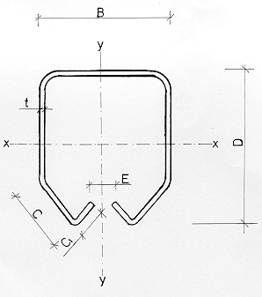
Figure A.9 ― Cold formed mono rail sections
Table A.9 — Dimensions and properties or cold formed steel mono rail sections
Dimension  mm |  |  |  |  | Thickness  mm |  | Area  cm² |  | Mass  kg/m |  | Axis x-x |  |  |  | Axis y-y
B | D | C | C₁ | E |  | t |  | A |  | w |  | I_{x}  cm⁴ | z_{x}  cm³ | r_{x}  cm |  | I_{y}  cm⁴ | z_{y}  cm³ | r_{x}  cm
57 | 67 | 15.0 | 10.0 | 13.7 |  | 3.0 |  | 6.27 |  | 4.92 |  | 34.3400 | 9.190 | 2.34 |  | 31.6300 | 11.100 | 2.25
42 | 54 | 12.5 | 8.0 | 8.0 |  | 2.5 |  | 3.97 |  | 3.12 |  | 14.35000 | 4.640 | 1.90 |  | 11.1100 | 5.290 | 1.67
33 | 34 | 9.5 | 6.5 | 10.5 |  | 2.0 |  | 2.22 |  | 1.74 |  | 3.2200 | 1.650 | 1.20 |  | 3.6700 | 2.220 | 1.28

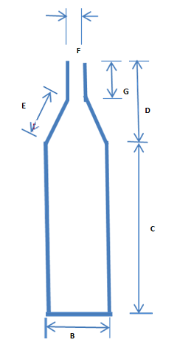
Figure A.10 ― Bottle sections
Table A.10 — Dimensions and properties of cold formed steel bottle sections
Nominal size  mm | Dimension  mm |  |  |  |  |  | Thickness  mm | Mass  kg/m
Nominal size  mm | B | C | D | E | F | G | t | w
94 | 34 | 64 | 30 | 15 | 2 | 15 | 1.0 | 1.74
94 | 34 | 64 | 30 | 15 | 2 | 15 | 1.2 | 2.10
94 | 34 | 64 | 30 | 15 | 2 | 15 | 1.5 | 2.60
94 | 34 | 64 | 30 | 15 | 2 | 15 | 2.0 | 3.50

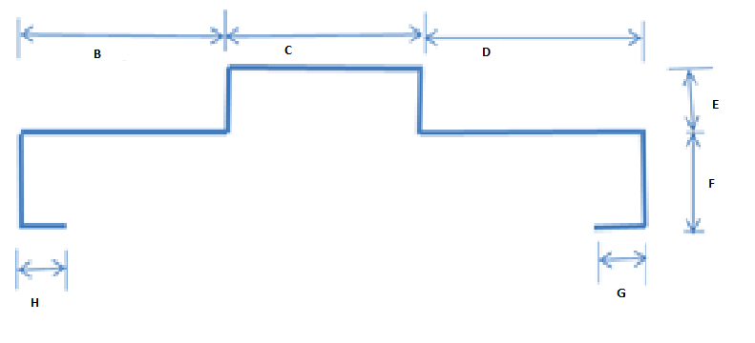
Figure A.11 ― Door frame
Table A.11 — Dimensions and properties of cold formed steel door frame sections
Nominal size  mm | Dimension  mm |  |  |  |  |  | Thickness  mm | Mass  kg/m
Nominal size  mm | B | C | D | E | F | G/H | t | w
150 | 48 | 54 | 48 | 13 | 30.00 | 12.00 | 1.0 | 1.9
130 | 45 | 50 | 35 | 15.00 | 30.15 | 15.15 | 1.0 | 1.8
130 | 45 | 50 | 35 | 15.00 | 30.15 | 15.15 | 1.2 | 2.1
130 | 45 | 50 | 35 | 15.00 | 30.15 | 15.15 | 1.5 | 2.6
130 | 45 | 50 | 35 | 15.00 | 30.15 | 15.15 | 2.0 | 3.5

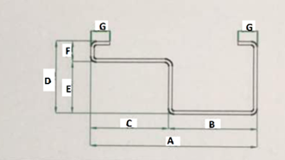
Figure A.12 — Half door frame section
Table A.12 — Dimensions and properties of cold formed steel door frame section
Dimension  mm |  |  |  |  |  |  | Thickness  mm
A | B | C | D | E | F | G | Thickness  mm
95 | 50 | 45 | 42 | 15 | 30 | 11 | 1.0
95 | 50 | 45 | 42 | 15 | 30 | 11 | 1.2
95 | 50 | 45 | 42 | 15 | 30 | 11 | 1.5
100 | 48 | 52 | 42 | 12 | 29 | 13 | 1.0
100 | 48 | 52 | 42 | 12 | 29 | 13 | 1.2
100 | 48 | 52 | 42 | 12 | 29 | 13 | 1.5
105 | 60 | 45 | 60 | 15 | 45 | 12 | 1.0
105 | 60 | 45 | 60 | 15 | 45 | 12 | 1.2
105 | 60 | 45 | 60 | 15 | 45 | 12 | 1.5
125 | 70 | 55 | 60 | 15 | 45 | 12 | 1.0
125 | 70 | 55 | 60 | 15 | 45 | 12 | 1.2
125 | 70 | 55 | 60 | 15 | 45 | 12 | 1.5

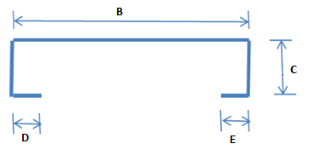
Figure A.13 ― Cold formed fascia board
Table A.13 — Dimensions and properties of cold formed steel fascia board sections
Nominal size  mm | Dimension  mm |  |  | Thickness  mm | Mass  kg/m
Nominal size  mm | B | C | D or E | t | w
150 x 30 | 150 | 30 | 13 | 1.0 | 1.80
150 x 30 | 150 | 30 | 13 | 1.2 | 2.17
150 x 30 | 150 | 30 | 13 | 1.5 | 2.58
190 x 30 | 190 | 30 | 13 | 1.2 | 2.38
190 x 30 | 190 | 30 | 13 | 1.5 | 2.88
200 x 30 | 200 | 30 | 13 | 1.2 | 2.67
200 x 30 | 200 | 30 | 13 | 1.5 | 3.25

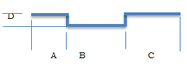
Figure A.14 ― Omega sections

Table A.14 — Dimensions and properties of Omega sections
Dimension  mm |  |  |  | Thickness, t  mm
A | B | C | D | Thickness, t  mm
35 | 50 | 45 | 17 | 1.0
35 | 50 | 45 | 17 | 1.2
35 | 50 | 45 | 17 | 1.5
35 | 50 | 45 | 17 | 2.0

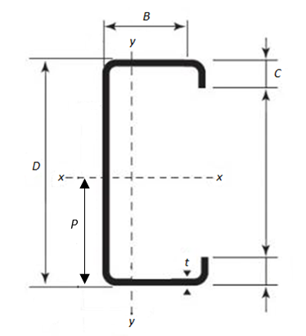
Figure A.15 ― Cold formed inwardly lipped channel section

Table A.15 — Dimensions and properties for cold formed inwardly lipped channel sections
Dimension  mm |  |  | Thickness  mm | Area  cm² | Mass per metre run  kg/m | Centroid  cm |  | Moment of inertia  cm⁴ |  | Section modulus of elasticity  cm³ |  | Radius of gyration  cm
B | D | C | t | A | W | C_{x} | C_{y} | I_{XX} | I_{YY} | Z_{XX} | Z_{YY} | R_{XX} | R_{YY}
50 | 75 | 20 | 1.5 | 3.1350 | 2.4610 | 2.0939 | 3.7500 | 29.0565 | 12.2259 | 7.7484 | 5.8388 | 3.0444 | 1.9748
50 | 75 | 20 | 2.0 | 4.1400 | 3.2499 | 2.0942 | 3.7500 | 37.8675 | 15.8185 | 10.0980 | 7.5535 | 3.0244 | 1.9547
50 | 100 | 20 | 2.0 | 4.6400 | 3.6424 | 1.8793 | 5.0000 | 73.9179 | 17.5943 | 14.7836 | 9.3621 | 3.9913 | 1.9473
50 | 100 | 20 | 2.5 | 5.7500 | 4.5138 | 1.8804 | 5.0000 | 90.6510 | 21.3501 | 18.1302 | 11.3538 | 3.9706 | 1.9269
50 | 125 | 20 | 2.0 | 5.1400 | 4.0349 | 1.7062 | 6.2500 | 124.4683 | 19.0249 | 19.9149 | 11.1503 | 4.9209 | 1.9239
50 | 125 | 20 | 2.5 | 6.3750 | 5.0044 | 1.7083 | 6.2500 | 153.0078 | 23.0905 | 24.4813 | 13.5164 | 4.8991 | 1.9032
50 | 138 | 20 | 2.0 | 5.4000 | 4.2390 | 1.6289 | 6.9000 | 157.0036 | 19.6643 | 22.7541 | 12.0722 | 5.3921 | 1.9083
50 | 138 | 20 | 2.5 | 6.7000 | 5.2595 | 1.6315 | 6.9000 | 193.1830 | 23.8674 | 27.9975 | 14.6289 | 5.3697 | 1.8874
50 | 150 | 20 | 2.0 | 5.6400 | 4.4274 | 1.5638 | 7.5000 | 191.0812 | 20.2022 | 25.4775 | 12.9184 | 5.8206 | 1.8926
50 | 150 | 20 | 2.5 | 7.0000 | 5.4950 | 1.5670 | 7.5000 | 235.2865 | 24.5207 | 31.3715 | 15.6485 | 5.7976 | 1.8716
50 | 150 | 20 | 3.0 | 8.3400 | 6.5469 | 1.5701 | 7.5000 | 278.1142 | 28.5692 | 37.0819 | 18.1953 | 5.7747 | 1.8508
50 | 163 | 20 | 2.0 | 5.9000 | 4.6315 | 1.4993 | 8.1500 | 232.5865 | 20.7357 | 28.5382 | 13.8300 | 6.2786 | 1.8747
50 | 163 | 20 | 2.5 | 7.3250 | 5.7501 | 1.5030 | 8.1500 | 286.5929 | 25.1682 | 35.1648 | 16.7454 | 6.2550 | 1.8536
50 | 163 | 20 | 3.0 | 8.7300 | 6.8531 | 1.5067 | 8.1500 | 338.9955 | 29.3235 | 41.5945 | 19.4621 | 6.2315 | 1.8327
50 | 175 | 20 | 2.0 | 6.1400 | 4.8199 | 1.4446 | 8.7500 | 275.3191 | 21.1880 | 31.4650 | 14.6668 | 6.6963 | 1.8576
50 | 175 | 20 | 2.5 | 7.6250 | 5.9856 | 1.4488 | 8.7500 | 339.4401 | 25.7170 | 38.7932 | 17.7509 | 6.6721 | 1.8365
50 | 175 | 20 | 3.0 | 9.0900 | 7.1357 | 1.4530 | 8.7500 | 401.7336 | 29.9626 | 45.9124 | 20.6216 | 6.6479 | 1.8155
63 | 175 | 20 | 2.0 | 6.6600 | 5.2281 | 1.9135 | 8.7500 | 314.2286 | 36.6786 | 35.9118 | 19.1682 | 6.8689 | 2.3468
63 | 175 | 20 | 2.5 | 8.2750 | 6.4959 | 1.9162 | 8.7500 | 387.7974 | 44.7463 | 44.3197 | 23.3511 | 6.8457 | 2.3254
63 | 175 | 20 | 3.0 | 9.8700 | 7.7480 | 1.9190 | 8.7500 | 459.4282 | 52.4013 | 52.5061 | 27.3066 | 6.8226 | 2.3042
50 | 200 | 20 | 2.0 | 6.6400 | 5.2124 | 1.3434 | 10.0000 | 378.7445 | 22.0256 | 37.8745 | 16.3958 | 7.5525 | 1.8213
50 | 200 | 20 | 2.5 | 8.2500 | 6.4763 | 1.3485 | 10.0000 | 467.4219 | 26.7325 | 46.7422 | 19.8241 | 7.5271 | 1.8001
50 | 200 | 20 | 3.0 | 9.8400 | 7.7244 | 1.3537 | 10.0000 | 553.7592 | 31.1445 | 55.3759 | 23.0076 | 7.5018 | 1.7791
75 | 200 | 20 | 2.0 | 7.6400 | 5.9974 | 2.2212 | 10.0000 | 476.7579 | 58.0380 | 47.6758 | 26.1291 | 7.8995 | 2.7562
75 | 200 | 20 | 2.5 | 9.5000 | 7.4575 | 2.2237 | 10.0000 | 589.3229 | 71.0351 | 58.9323 | 31.9448 | 7.8762 | 2.7345
75 | 200 | 20 | 3.0 | 11.3400 | 8.9019 | 2.2262 | 10.0000 | 699.3042 | 83.4600 | 69.9304 | 37.4901 | 7.8528 | 2.7129

