DRAFT EAST AFRICAN STANDARD
Steel tubes for non-pressure purposes — Steel tubes for rolls for conveyor belt idles — Specification

EAST AFRICAN COMMUNITY

Copyright notice
This EAC document is copyright-protected by EAC. While the reproduction of this document by participants in the EAC standards development process is permitted without prior permission from EAC, neither this document nor any extract from it may be reproduced, stored or transmitted in any form for any other purpose without prior written permission from EAC.
Requests for permission to reproduce this document for the purpose of selling it should be addressed as shown below or to EAC’s member body in the country of the requester:
© East African Community 2024 — All rights reserved
East African Community
P.O. Box 1096,
Arusha
Tanzania
Tel: + 255 27 2162100
Fax: + 255 27 2162190
E-mail: eac@eachq.org
Web: www.eac-quality.net
Reproduction for sales purposes may be subject to royalty payments or a licensing agreement. Violators may be prosecuted.
Contents Page
Foreword iv
1 Scope 1
2 Normative references 1
3 Terms and definitions 1
4 Requirements 1
4.1 Grade and type 1
4.1.1 Type 1
4.1.2 Grade 2
4.2 Material 2
4.3 Mechanical properties 2
4.4 Dimensions 2
4.5 Scarfing 2
4.6 Workmanship 3
4.7 Cross-welds 3
4.8 Coating 3
5 Packing and marking 3
5.1 Packing 3
5.2 Marking 3
6 Inspection and test methods 3
6.1 Inspection 3
6.2 Tensile test 3
6.3 Ovality test 4
6.3.1 Apparatus 4
6.3.2 Test pieces 4
6.3.3 Procedure 4
6.4 Visual test for scarfing 4
6.4.1 Apparatus 4
6.4.2 Test pieces 5
6.4.3 Procedure 5
6.5 Visual test for chatter 5
6.5.1 Apparatus 5
6.5.2 Test pieces 5
6.5.3 Procedure 5
6.6 Flattening test 5
6.6.1 Apparatus 5
6.6.2 Test pieces 5
6.6.3 Procedure 5
6.7 Flare test 6
6.7.1 Apparatus 6
6.7.2 Test piece 6
6.7.3 Procedure 6
Annex A (normative) Sampling and compliance 9
A.1 Sampling 9
Bibliography 10
Foreword
Development of the East African Standards has been necessitated by the need for harmonizing requirements governing quality of products and services in the East African Community. It is envisaged that through harmonized standardization, trade barriers that are encountered when goods and services are exchanged within the Community will be removed.
The Community has established an East African Standards Committee (EASC) mandated to develop and issue East African Standards (EAS). The Committee is composed of representatives of the National Standards Bodies in Partner States, together with the representatives from the public and private sector organizations in the community.
East African Standards are developed through Technical Committees that are representative of key stakeholders including government, academia, consumer groups, private sector and other interested parties. Draft East African Standards are circulated to stakeholders through the National Standards Bodies in the Partner States. The comments received are discussed and incorporated before finalization of standards, in accordance with the Principles and procedures for development of East African Standards.
East African Standards are subject to review, to keep pace with technological advances. Users of the East African Standards are therefore expected to ensure that they always have the latest versions of the standards they are implementing.
The committee responsible for this document is Technical Committee EASC/TC 35, Steel and steel products.
Attention is drawn to the possibility that some of the elements of this document may be subject of patent rights. EAC shall not be held responsible for identifying any or all such patent rights.

Steel tubes for non-pressure purposes — Steel tubes for rolls for conveyor belt idles — Specification

1 Scope
This Draft East African Standard specifies the requirements, sampling and test methods of welded steel tubes for use in the manufacture of rolls for conveyor belt idlers.

2 Normative references
The following referenced documents are referred to in the text in such a way that some or all of their content constitutes requirements of this document. For dated references, only the edition cited applies. For undated references, the latest edition of the referenced document (including any amendments) applies.

ISO 6892-1, Metallic materials — Tensile testing — Part 1: Method of test at room temperature
ISO 1537, Continuous mechanical handling equipment for loose bulk materials — Troughed belt conveyors (other than portable conveyors) — Idlers

3 Terms and definitions
For the purposes of this document, the following terms and definitions apply.

ISO and IEC maintain terminological databases for use in standardization at the following addresses:
— ISO Online browsing platform: available at http://www.iso.org/obp

3.1
acceptable
acceptable to the authority administering this standard, or to the parties concluding the purchase contract, as relevant

3.2
defective
steel tube that fails in one or more respects to comply with the relevant requirements of this standard

3.3
lot
not less than 25 and not more than 3 200 tubes of the same nominal outside diameter, nominal wall thickness and length, made by one manufacturer, and submitted at any one time for inspection and testing

4 Requirements

4.1 Grade and type

4.1.1 Type
Tubes for rolls shall be of electrically (induction/resistance) welded mild steel.

4.1.2 Grade
The grade of the tube shall comply with the properties given in Table 1.

Table 1 —Tensile properties of tubes
Yield stress  MPA, min | Tensile strength  MPa, min | Elongation  %, min
230 | 320 | 10

4.2 Material
Tubes shall be of steel whose ladle chemical composition complies with the following:
- carbon content: 0.25 %, max, (by mass); and
- sulphur and phosphorus content: each 0.06 %, max, (by mass).

4.3 Mechanical properties
4.3.1 The tensile strength, yield stress and elongation of a tube shall be determined in accordance with 6.3, and shall be at least the appropriate values given in Table 1.

4.3.2 When tested in accordance with 6.7 and 6.8, a tube shall show no sign of cracking.

4.4 Dimensions
All dimensions of steel tubes for roll of conveyor belt idles shall be according to ISO 1537.

4.5 Scarfing
4.5.1 The inner and outer weld protrusion shall be removed by scarfing.

4.5.2 The outer scarfing shall blend smoothly with the outer diameter of the tube and shall not protrude above the tube by more than 0.1 mm or indent within the wall of the tube by more than 0.1 mm.

4.5.3 The inner scarfing shall not stand protrude of the tube wall by more than 0.1 mm or indent within the wall of the tube by more than 0.35 mm.

4.5.4 When tested in accordance with 6.5, the depth or height of the scarfed section over an area of 15 mm either side of the centre line of the scarfed section shall not exceed 0.1 mm.

4.5.5 The longitudinal variation of the scarfing shall not exceed the values indicated in Table 2.

Table 2 — Longitudinal weld variation (Dimensions in millimetres)
S/N | Outside diameter (OD) of tube | Tolerance
1 | OD ˂ 127 | ± 0.15
2 | 127 ≤ OD ≤ 152.4 | ± 0.175
3 | OD ˃ 152.4 | ± 0.2

4.5.6 When tested in accordance with 6.6, the protrusion or indent of chatter shall not exceed 0.1 mm.

4.6 Workmanship
4.6.1 Tubes shall have an acceptable finish and shall be free from defects that affect their serviceability.

4.6.2 The presence of superficial “powder” rusting on the surface of uncoated tubes shall not be regarded as prejudicial to the serviceability of the tubes.

4.6.3 Tubes shall be supplied with “mill cut” ends and any deformation shall not extend more than 100 mm from the cut.

4.7 Cross-welds
Tubes for rolls shall have no cross-welds.

4.8 Coating
Unless otherwise specified by the purchaser tubes shall be supplied uncoated.

5 Packing and marking

5.1 Packing
Tubes shall be supplied loose or bundled as required. When supplied in bundles, only tubes of the same nominal outside diameter and wall thickness shall be packed together.

5.2 Marking
5.2.1 The following information shall appear in legible and indelible marking on a label or labels attached to at least one bundle, carton or pallet, as relevant, per size of the tube in a consignment. The following information shall be legibly and indelibly marked on each tube:
- manufacturer’s name or trade mark; and
- batch code (if required).

5.2.2 The following information shall appear in legible and indelible marking on a label securely attached to each bundle:
- manufacturer’s name or trade mark;
- batch code or order number;
- grade and type; and
- nominal outside diameter and wall thickness.

6 Inspection and test methods

6.1 Inspection
Visually examine and measure each tube in the sample for compliance with the requirements of 4.4 - 4.8. If required, sampling shall be done in accordance with Annex A.

6.2 Tensile test
Carry out the test in accordance with the relevant test method given in RS ISO 6892-1 and check for compliance with the requirements of 4.3.1. For the determination of elongation, use a gauge length of 5.65 (where So is the original cross-sectional area).

6.3 Ovality test

6.3.1 Apparatus
6.3.1.1 V-rollers.

6.3.1.2 Dial gauge with probe.

6.3.2 Test pieces
From the pipe(s) selected for testing, cut a piece of 1 m in length and Deburr the test piece.

6.3.3 Procedure
6.3.3.1 Place a test piece on the v-rollers and position the dial gauge probe in such a way that it touches the outside of the tube at a point diametrically opposite a support roller (see figure 1).

6.3.3.2 Rotate the tube about its longitudinal axis (centreline) and complete a full revolution of the tube.

6.3.3.3 Set the zero point of the dial indicator at the lowest point on the tube circumference and then read the ovality as the maximum deflection of the dial indicator needle.

6.3.3.4 The ovality shall not exceed the values given in ISO 1537.

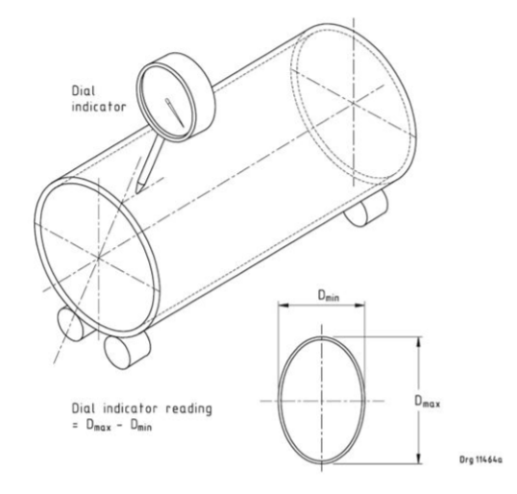
Figure 1 — Test for ovality

6.4 Visual test for scarfing

6.4.1 Apparatus
6.4.1.1 V-rollers.

6.4.1.2 Dial gauge with probe for measuring ovality.

6.4.2 Test pieces
From the pipe(s) selected for testing; cut a piece of 1 m in length and Deburr the test piece.

6.4.3 Procedure
6.4.3.1 Place a test piece on the v-rollers and position the dial gauge probe in such a way that it touches the outside of the tube initially away from the scarfed section.

6.4.3.2 Rotate and slide the tube along its longitudinal and horizontal axis as appropriate.

6.4.3.3 Measure the depth or height of the external scarf over the length of the tube covering an area 15 mm either side of the scarfed section of the tube.

6.4.3.4 The depth or height of the scarfed section over this area shall not exceed the values indicated in 4.5.2.

6.5 Visual test for chatter

6.5.1 Apparatus
6.5.1.1 V-rollers.

6.5.1.2 Dial gauge with probe.

6.5.2 Test pieces
From the pipe(s) selected for testing; cut a piece of 1 m in length and Deburr the test piece.

6.5.3 Procedure
6.5.3.1 Place a test piece on the v-rollers and position the dial gauge probe as appropriate.

6.5.3.2 Whilst moving the tube along its longitudinal axis (along the weld seam); measure the height by which the scarfing protrudes above the outer diameter of the tube and the depth of indentation which the scarfing presents beneath the diameter of the tube outer wall.

6.5.3.3 The readings obtained shall not exceed the values indicated in 4.5.4.

6.6 Flattening test

6.6.1 Apparatus
Compressive testing machine with parallel platens of width at least equal to 1.5 times the diameter of the pipe under test.

6.6.2 Test pieces
From the pipe selected for testing; cut two pieces of pipe (at least 40 mm each in length) and Deburr the test pieces.

6.6.3 Procedure
6.6.3.1 Place one test piece in the testing machine with the weld positioned as shown in figure 2(a).

6.6.3.2 Apply a steadily increasing force until the distance between the two platens is 60 % ± 1 % of the actual outside diameter of the pipe (see figure 2(b)).

6.6.3.3 Remove the test piece and examine it for signs of cracking. Check for compliance with 4.3.2.

6.6.3.4 Place one test piece in the testing machine with the weld positioned as shown in figure 2(c).

6.6.3.5 Apply a steadily increasing force until the distance between the two platens is 15 % ± 1 % of the actual outside diameter of the pipe (see figure 2(d)).

6.6.3.6 Remove the test piece and examine it for signs of cracking. Check for compliance with 4.3.2.

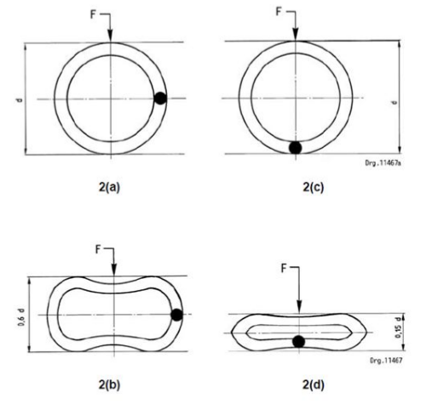
Figure 2 — Flattening test

6.7 Flare test

6.7.1 Apparatus
6.7.1.1 Compressive testing machine;

6.7.1.2 Steel cone of included angle 60° and of base diameter at least 1.1 times the outside diameter of the pipe

6.7.2 Test piece
Cut a piece of suitable length but of length equal to at least the outside diameter of the pipe and Deburr the ends of the test piece.

6.7.3 Procedure
6.7.3.1 Place the cone and the test piece in the testing machine as shown in figure 3.
6.7.3.2 Apply a steadily increasing force until the end of the test piece flares to a diameter 10 % ± 1 % larger than the outside diameter of the pipe.
6.7.3.3 Examine the flared end of the test piece and check for compliance with 4.3.2.

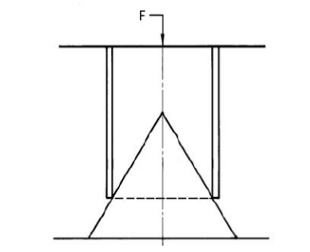
Figure 3 ― Flare test

Annex A
(normative)
Sampling and compliance

A.1 Sampling
A.1.1 The following sampling procedure shall be applied in determining whether a lot complies with the relevant requirements of this part of the standard.

Table A.1 ― Sampling
Lot size.  (number of tubes) | Sample size.  (number of tubes) | Number of defectives allowed
Lot size.  (number of tubes) | Sample size.  (number of tubes) | Inspection | Testing
25 – 90 | 13 | 0 | 0
91 - 150 | 20 | 1 | 1
151 - 280 | 32 | 2 | 1
281 - 500 | 50 | 3 | 1
501 – 1 200 | 80 | 4 | 2
1 201 – 3 200 | 125 | 5 | 2

Bibliography
[1] RS 263-3, Steel tubes for non-pressure purposes — Specification — Part 3: Steel tubes for rolls for conveyor belt idles
[2] SANS 657-3, Steel tubes for non-pressure purposes — Part 3: Steel tubes for rolls for conveyor belt idlers

