Cold formed non-structural steel hollow sections — Specification


TECHNICAL COMMITTEE REPRESENTATION
The following organizations were represented on the Technical Committee:
- Howard Humphreys East Africa Ltd
- Devki Steel Mills
- Tononoka Steels
- Apex Steel Ltd
- Mabati Rolling Mills
- Kenya Bureau of Standards — Secretariat
REVISION OF KENYA STANDARDS
In order to keep abreast of progress in industry, Kenya Standards shall be regularly reviewed. Suggestions for improvements to published standards, addressed to the Managing Director, Kenya Bureau of Standards, are welcome.
© Kenya Bureau of Standards,2024
Copyright. Users are reminded that by virtue of Section 25 of the Copyright Act, Cap. 130 of 2001 of the Laws of Kenya, copyright subsists in all Kenya Standards and except as provided under Section 25 of this Act, no Kenya Standard produced by Kenya Bureau of Standards may be reproduced, stored in a retrieval system in any form or transmitted by any means without prior permission in writing from the Managing Director.

Cold formed non-structural steel hollow sections — Specification
Kenya Bureau of Standards, Popo Road, Off Mombasa Road,
P.O. Box 54974 - 00200, Nairobi, Kenya
 | +254 020 6948000, + 254 722202137, + 254 734600471
 | info@kebs.org
 | @KEBS_ke
 | kenya bureau of standards (kebs)
Foreword

This Kenya Standard was prepared by the Steel Technical Committee under the guidance of the Standards Projects Committee, and it is in accordance with the procedures of the Kenya Bureau of Standards.
Non-structural hollow sections of thickness below 4 mm have increased in demand in the Kenyan market. These sections are normally used for making decorative works by fabricators like grills. Thus, there is need to standardize these sections.
Cold formed non-structural steel hollow sections — Specification

- Scope

This Draft Standard specifies the requirements and sectional properties of cold formed non-structural steel hollow sections of thickness ≤4.00mm for use in non-structural applications.

The sections and their sectional properties are listed in Annex A.

- Normative references

The following document is referred to in the text in such a way that some or all of its content constitutes requirements of this document. For dated references, only the edition cited applies. For undated references, the latest edition of the referenced document (including any amendments) applies.

ISO 14347, Fatigue — Design procedure for welded hollow-section joints — Recommendations
ISO 148-1, Metallic materials — Charpy pendulum impact test — Part 1: Test method
ISO 404, Steel and steel products — General technical delivery requirements
ISO 1461, Hot dip galvanized coatings on fabricated iron and steel articles — Specifications and test methods
ISO 6892-1, Metallic materials — Tensile testing — Part 1: Method of test at room temperature
ISO 8492, Metallic materials — Tube — Flattening test
ISO 8493, Metallic materials — Tube — Drift-expanding test
ISO 12944-5, Paints and varnishes — Corrosion protection of steel structures by protective paint systemsPart 5: Protective paint systems
ISO 16172, Steel sheet, metallic-coated by the continuous hot-dip process for corrugated steel pipe

- Terms and definitions

No terms and definitions are listed in this document.

- Symbols

The following nomenclature shall be used. Units for dimensions are in millimetres and those for section properties in centimetres.

t | section thickness | - mm
p | distance from edge to section centre of gravity | - cm
A | sectional area | - cm²
Z | section modulus of section l/p | - cm³
I  r | second moment of area  radius of gyration of section 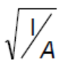 | - cm⁴  - ^{cm}

© EAC 2024 – All rights reserved 1

x, y | with reference to x or y axis
w | mass per linear metre | - kg/m
L | length | - m

- Dimensions and tolerances

  - Dimensions

Dimensions of sections shall be in accordance with those listed in the relevant tables in Annex A.

  - Tolerances

Tolerances of characteristic properties shall be as given in Table 1.

Table 1 — Tolerances for characteristic properties

Characteristic | Tolerance
Outside dimensionª | ±1.5 mm or 2 %, whichever is less
Deviation from straightness | 0.17 % of total length
Squareness of corners | 90° ± 2°
Twist | Not to exceed 2 mm ± 0.5 mm per metre
Concavity/convexity | maximum 1.5 %, for square and rectangular hollow sections
Outside bend radii for right angle bends | If thickness is less than 4 mm, tolerance is between 1.5 t to 2.5 t
Length (6 m):  Exact  Standard | 0 and + 10 mm  0 mm and + 50 mm
Thickness | ±3 % for ≤1 mm  ±7.5% for ˃1 mm
Mass per metre) | ±2% for thickness < 1.00 mm  ±3% for 1.00 mm thickness  ±6% for thickness ˃ 1.00 mm
Deviation from out of roundness | For D/T ratio ≤ 100: ± 2 %
ª This tolerance shall be measured at a distance of not less than 100 mm from the end of the section.

  - Measurement

    - General

All external dimensions including out-of-roundness shall be measured at a distance from the end of the hollow section of not less than D for circular sections, B for square sections or H for rectangular sections, with a minimum of 100 mm.

    - Outside dimension

When inspecting circular hollow sections, the diameter D shall be measured directly. The limiting cross- sectional positions for measuring B and H are shown in Figure 1, and shall be in accordance with Annex A₃.

    - Thickness

The thickness t shall be measured at a position not less than 2t from the weld. The limiting cross-sectional positions for measuring the thickness of square and rectangular sections are shown in Figure 1.

NOTE Thickness is normally measured within a distance of half of the outside diameter or half of the length of the longer side from the end of the section.

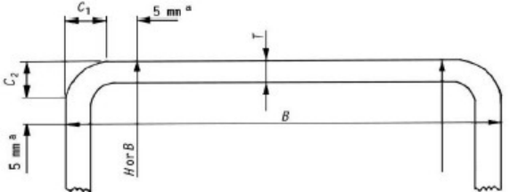

ª This dimension is a maximum when measuring B or H and a minimum when measuring t.

Figure 1 — Limiting cross-sectional positions for measuring the dimensions B, H and t for square or rectangular steel hollow sections

    - Out-of-roundness

The out-of-roundness, O, of a circular hollow section shall be calculated as follows:
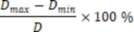

where

D is the nominal outside diameter of a circular steel hollow section;
D_{max} is the maximum outside diameter; and
D_{min} is the minimum outside diameter.

    - Concavity and convexity

The concavity (C₁) and convexity (C₂) of the sides of the square or rectangular steel hollow section shall be measured as shown in Figure 2.

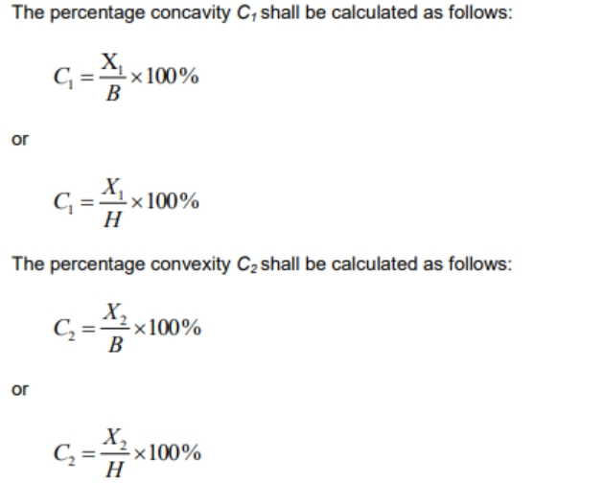
where

B and H are the lengths of the sides containing the concavity C₁ or convexity C_{2.}

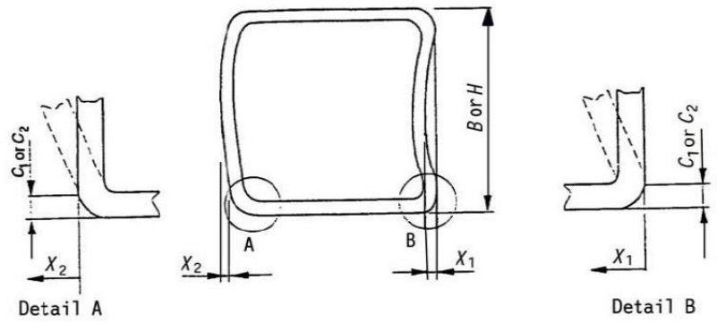

Figure 2 — Measurement of concavity/convexity of square or rectangular steel hollow sections

    - Squareness

Squareness of the sides of a square or rectangular steel hollow section shall be measured as difference between 90º and ɵ as shown in Figure 3.

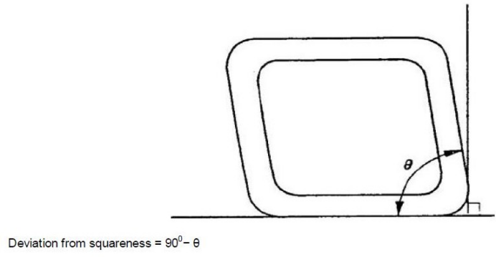.

Figure 3 — Squareness of sides of square or rectangular steel hollow sections

    - External corner profile

      - The external corner profile of a square or rectangular steel hollow section shall be measured in accordance with 5.3.7.2 or 5.3.7.3.

      - The corner arc shall be measured with a radius gauge.

      - The distance between the intersection of the flat side and the corner arc and the intersection of the projections of the flat sides to the corner (C1) and (C2) in Figure 4 shall be measured.

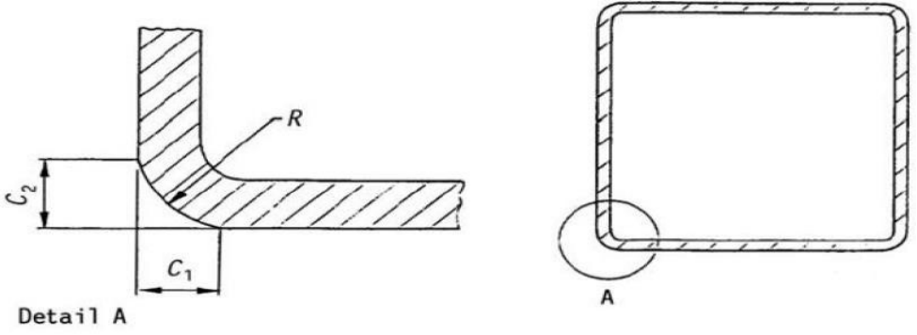

Figure 4 — Outside corner profile of square or rectangular steel hollow sections

    - Twist

The twist (V) in a square or rectangular steel hollow section shall be determined in accordance with 5.3.8.2 or 5.3.8.3.

The hollow section shall be placed on a horizontal surface with one side at one end pressed against the surface. At the opposite end of the hollow section, the difference in height of the two lower corners from a horizontal surface as shown in Figure 5, shall be measured.

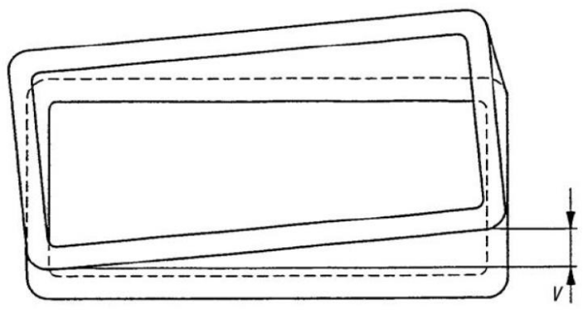

Figure 5 — Twist of square or rectangular steel hollow sections

The twist shall be measured with a spirit level and micrometre gauge (screw). The reference length of the spirit level shall be the distance between the intersection of the flat sides and the corner arcs (see Figure 6). The twist V is the difference between the values V₁ (see Figure 6) measured at each end of the section.
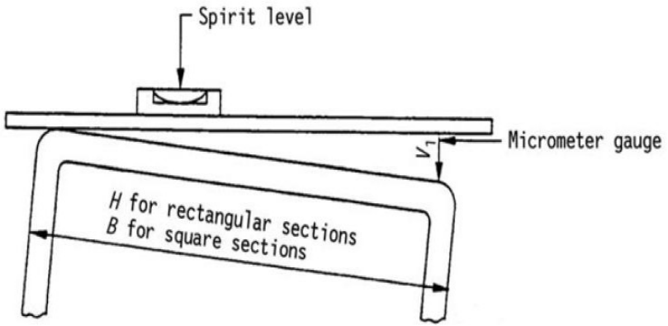

Figure 6 — Measurement of twist

    - Straightness

The deviation from straightness (e) of total length of a hollow section shall be measured at the point of maximum departure of the hollow section from a straight line connecting its two ends as shown in Figure 7.

The percentage deviation from straightness shall be calculated as follows:

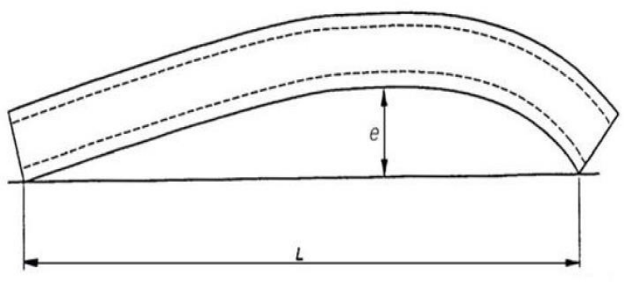

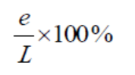

Figure 7 — Measurement of deviation from straightness

- Compound sections

Compound sections may be formed by suitably connecting two or more simple sections. For example, an 'I' section can be made from two channels back-to-back, a tube from two inwardly lipped channels lip-to-lip, a 'T" from two angles, etc. Methods of joining sections are specified in ISO 14347.

Section properties of compound sections may be calculated using the properties of simple sections.

Compound sections shall be flush at matching joints within 2.0 mm.

- Material requirement

  - Grade designation

The designation of the grades of material shall be based on minimum permissible yield stress and shall be in accordance with Table 2.

Table 2 — Grade designation

Minimum yield stress  N/mm² | Designation of grade
210 | 210
250 | 250
360 | 360

  - Chemical composition

The results of ladle chemical analysis of steel from which a hollow steel section is manufactured shall comply with appropriate limits of Table 3. For grade 360, it shall be permissible to add suitable grain-refining elements to achieve the minimum specified tensile stress, but the total content of these elements shall not exceed 0.15 %.

Table 3 — Ladle chemical analysis limits

Grade of steel | Maximum content  %
Grade of steel | Carbon | Phosphorous | Sulphur | Manganese
210 | 0.20 | 0.05 | 0.05 | -
250 | 0.25 | 0.06 | 0.06 | -
360 | - | - | 0.04 | -

  - Mechanical properties

The mechanical properties obtained from test samples taken from the hollow steel section in accordance with Clause 8, shall comply with the requirements given in Table 4. If other grades of steel are used, their mechanical properties shall be as agreed upon between the purchaser and the manufacturer.

Table 4 — Tensile test requirements

Grade of steel | Minimum yield stress  N/mm² | Ultimate tensile strength  N/mm² | Minimum elongation as a proportion of gauge length  %
210 | 210 | 340 | 24
250 | 250 | 420 | 22
360 | 360 | 480 | 20

7.4 Coating properties (If applicable)

The cold formed steel sections may be supplied with or without coatings. When sections are supplied with coatings, sections shall be hot dip galvanized, aluminium zinc coated, pre -painted or in combination.

When sections are hot dip galvanized, they shall comply with ISO 1461.
When sections are aluminium zinc coated, they shall comply with ISO 16172.
When sections are pre -painted they shall comply with ISO 12944 -5.

- Test methods and sampling

  - Test methods
    - Tensile tests
Tensile test to be done according to ISO 6892-1.

    - Impact tests
Where requested, impact test to be done according to ISO 148-1 and shall be assessed in accordance with ISO 404.

    - Flattening tests
Flattening test to be done according to ISO 8492 and shall show no sign of cracking.

    - Flare tests (Drift-expanding tests)
Test to be done according to ISO 8493 and shall not crack or show any other defect.

  - General

At least one sample shall be selected from the following batch sizes:

a 20-tonne or less batch of sections having outside diameter of less than 90 mm; and

a batch of less than 40 tonnes for all other sections.

If the test fails, two more samples shall be drawn from the batch and tested. If one or both test specimens re-tested fail, the whole batch shall be deemed not to have complied with this standard unless all sections in the batch are tested individually.

- Marking

Each piece shall be indelibly and legibly marked at least once in every 6-m length with the following:

- manufacturer’s name and/or registered trademark;

- outside dimensions in millimetres;

- nominal thickness in millimetres;

- non structural

- Nominal mass per metre run (kg/m)

Annex A
(normative)
Section properties

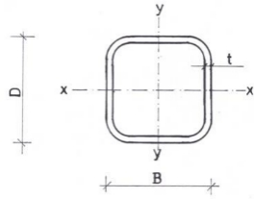

Figure A.1 — Square steel hollow sections

Table A.1 — Dimensions and properties for cold formed square steel hollow sections

WIDTH B (mm) | HEIGHT H (mm) | THICK (mm) | CROSS SECT (cm²) | NOMINAL MASS/M (KG/M) | NOMINAL MASS/6M  (KG) | SECOND MOMENT OF AREA (cm⁴) | RADIUS OF GYRATION (cm) | ELASTIC SECTION MODULUS (cm³) | PLASTIC SECTION MODULUS (cm³) | TORSIONAL INERTIA CONSTANT (cm⁴) | TORSIONAL MODULUS CONSTANT (cm³) | SUPERFICIAL AREA/M LENGTH (m²/m)
10 | 10 | 0.8 | 0.278 | 0.218 | 1.309 | 0.038 | 0.370 | 0.076 | 0.094 | 0.065 | 0.115 | 0.0373
10 | 10 | 0.9 | 0.307 | 0.241 | 1.445 | 0.041 | 0.365 | 0.082 | 0.102 | 0.071 | 0.124 | 0.0369
10 | 10 | 1 | 0.334 | 0.262 | 1.574 | 0.043 | 0.360 | 0.087 | 0.110 | 0.076 | 0.132 | 0.0366
12 | 12 | 0.8 | 0.342 | 0.268 | 1.610 | 0.070 | 0.451 | 0.116 | 0.141 | 0.116 | 0.176 | 0.0453
12 | 12 | 0.9 | 0.379 | 0.297 | 1.784 | 0.076 | 0.447 | 0.126 | 0.155 | 0.128 | 0.191 | 0.0449
16 | 16 | 0.8 | 0.470 | 0.369 | 2.213 | 0.178 | 0.615 | 0.222 | 0.265 | 0.289 | 0.335 | 0.0613
16 | 16 | 0.9 | 0.523 | 0.410 | 2.462 | 0.195 | 0.610 | 0.243 | 0.292 | 0.319 | 0.367 | 0.0609
20 | 20 | 0.8 | 0.598 | 0.469 | 2.816 | 0.362 | 0.778 | 0.362 | 0.426 | 0.579 | 0.545 | 0.0773
20 | 20 | 0.9 | 0.667 | 0.523 | 3.140 | 0.399 | 0.773 | 0.399 | 0.472 | 0.643 | 0.601 | 0.0769
18 | 18 | 0.8 | 0.534 | 0.419 | 2.515 | 0.259 | 0.697 | 0.288 | 0.341 | 0.417 | 0.433 | 0.0693
18 | 18 | 0.9 | 0.595 | 0.467 | 2.801 | 0.285 | 0.692 | 0.316 | 0.377 | 0.462 | 0.477 | 0.0689
18 | 18 | 1 | 0.654 | 0.514 | 3.082 | 0.309 | 0.687 | 0.343 | 0.411 | 0.506 | 0.518 | 0.0686
23 | 23 | 0.8 | 0.694 | 0.545 | 3.268 | 0.563 | 0.901 | 0.490 | 0.573 | 0.893 | 0.736 | 0.0893
23 | 23 | 0.9 | 0.775 | 0.608 | 3.649 | 0.622 | 0.896 | 0.541 | 0.636 | 0.993 | 0.813 | 0.0889
25 | 25 | 0.8 | 0.758 | 0.595 | 3.570 | 0.732 | 0.982 | 0.585 | 0.683 | 1.155 | 0.879 | 0.0973
25 | 25 | 0.9 | 0.847 | 0.665 | 3.988 | 0.809 | 0.978 | 0.647 | 0.759 | 1.286 | 0.973 | 0.0969
30 | 30 | 0.8 | 0.918 | 0.721 | 4.323 | 1.293 | 1.187 | 0.862 | 0.999 | 2.024 | 1.294 | 0.1173
30 | 30 | 0.9 | 1.027 | 0.806 | 4.836 | 1.434 | 1.182 | 0.956 | 1.113 | 2.257 | 1.436 | 0.1169
38 | 38 | 0.8 | 1.174 | 0.922 | 5.529 | 2.688 | 1.513 | 1.415 | 1.630 | 4.171 | 2.123 | 0.1493
38 | 38 | 0.9 | 1.315 | 1.032 | 6.192 | 2.992 | 1.508 | 1.575 | 1.819 | 4.662 | 2.364 | 0.1489
40 | 40 | 0.8 | 1.238 | 0.972 | 5.831 | 3.149 | 1.595 | 1.575 | 1.812 | 4.878 | 2.363 | 0.1573
40 | 40 | 0.9 | 1.387 | 1.089 | 6.532 | 3.507 | 1.590 | 1.753 | 2.023 | 5.453 | 2.631 | 0.1569
50 | 50 | 0.9 | 1.747 | 1.371 | 8.227 | 6.976 | 1.998 | 2.790 | 3.203 | 10.771 | 4.187 | 0.1969
50 | 50 | 1 | 1.934 | 1.518 | 9.110 | 7.688 | 1.994 | 3.075 | 3.538 | 11.909 | 4.615 | 0.1966
60 | 60 | 1 | 2.334 | 1.832 | 10.994 | 13.467 | 2.402 | 4.489 | 5.145 | 20.749 | 6.735 | 0.2366
60 | 60 | 1.2 | 2.785 | 2.186 | 13.119 | 15.942 | 2.392 | 5.314 | 6.114 | 24.694 | 7.974 | 0.2359
75 | 75 | 1.5 | 4.352 | 3.416 | 20.498 | 38.921 | 2.991 | 10.379 | 11.941 | 60.288 | 15.575 | 0.2949
75 | 75 | 2 | 5.737 | 4.504 | 27.021 | 50.490 | 2.967 | 13.464 | 15.609 | 79.047 | 20.216 | 0.2931
100 | 100 | 2 | 7.737 | 6.074 | 36.441 | 123.010 | 3.987 | 24.602 | 28.305 | 190.540 | 36.918 | 0.3931
100 | 100 | 2.5 | 9.589 | 7.527 | 45.165 | 150.634 | 3.963 | 30.127 | 34.859 | 235.204 | 45.227 | 0.3914
150 | 150 | 3 | 17.408 | 13.666 | 81.993 | 622.738 | 5.981 | 83.032 | 95.530 | 964.608 | 124.597 | 0.5897

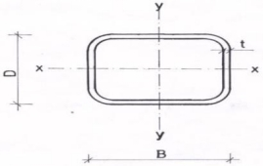

Figure A.2 ― Rectangular steel hollow section

Table A.2 – Dimensions and properties for ― Rectangular steel hollow section cold formed rectangular steel hollow sections
WIDTH B (mm) | HEIGHT H (mm) | THICK (mm) | CROSS SECT (cm²) | NOMINAL MASS/M (KG/M) | NOMINAL MASS/6M (KG) | SECOND MOMENT OF AREA (cm4) |  | RADIUS OF GYRATION (cm) |  | ELASTIC SECTION MODULUS (cm3) |  | PLASTIC SECTION MODULUS (cm3) |  | TORSIONAL INERTIA CONSTANT (cm⁴) | SUPERFICIAL AREA/M LENGTH (m²/m)
 |  |  |  |  |  | yy | zz | yy | zz | yy | zz | yy | zz
30 | 10 | 0.8 | 0.598 | 0.469 | 2.816 | 0.106 | 0.610 | 0.421 | 1.010 | 0.212 | 0.407 | 0.241 | 0.532 | 0.307 | 0.077
30 | 10 | 0.9 | 0.667 | 0.523 | 3.140 | 0.116 | 0.672 | 0.416 | 1.004 | 0.231 | 0.448 | 0.266 | 0.589 | 0.339 | 0.077
40 | 10 | 0.8 | 0.758 | 0.595 | 3.570 | 0.140 | 1.305 | 0.430 | 1.312 | 0.280 | 0.652 | 0.315 | 0.871 | 0.438 | 0.097
40 | 10 | 0.9 | 0.847 | 0.665 | 3.988 | 0.153 | 1.442 | 0.425 | 1.305 | 0.306 | 0.721 | 0.348 | 0.967 | 0.482 | 0.097
40 | 20 | 0.8 | 0.918 | 0.721 | 4.323 | 0.657 | 1.920 | 0.846 | 1.446 | 0.657 | 0.960 | 0.734 | 1.184 | 1.577 | 0.117
40 | 20 | 0.9 | 1.027 | 0.806 | 4.836 | 0.727 | 2.130 | 0.842 | 1.440 | 0.727 | 1.065 | 0.816 | 1.319 | 1.755 | 0.117
40 | 25 | 0.8 | 0.998 | 0.783 | 4.700 | 1.083 | 2.227 | 1.042 | 1.494 | 0.866 | 1.113 | 0.973 | 1.341 | 2.305 | 0.127
40 | 25 | 0.9 | 1.117 | 0.877 | 5.260 | 1.202 | 2.474 | 1.037 | 1.489 | 0.961 | 1.237 | 1.084 | 1.495 | 2.571 | 0.127
50 | 25 | 0.8 | 1.158 | 0.909 | 5.454 | 1.317 | 3.831 | 1.067 | 1.819 | 1.054 | 1.532 | 1.167 | 1.880 | 3.130 | 0.147
50 | 25 | 0.9 | 1.297 | 1.018 | 6.108 | 1.463 | 4.264 | 1.062 | 1.813 | 1.170 | 1.705 | 1.301 | 2.098 | 3.493 | 0.147
60 | 40 | 0.9 | 1.747 | 1.371 | 8.227 | 4.883 | 9.059 | 1.672 | 2.277 | 2.441 | 3.020 | 2.727 | 3.590 | 9.896 | 0.197
75 | 50 | 1.2 | 2.905 | 2.281 | 13.684 | 12.648 | 23.479 | 2.086 | 2.843 | 5.059 | 6.261 | 5.660 | 7.452 | 25.689 | 0.246
75 | 50 | 1.5 | 3.602 | 2.828 | 16.966 | 15.478 | 28.791 | 2.073 | 2.827 | 6.191 | 7.677 | 6.970 | 9.185 | 31.700 | 0.245
80 | 40 | 1 | 2.334 | 1.832 | 10.994 | 6.899 | 19.984 | 1.719 | 2.926 | 3.449 | 4.996 | 3.791 | 6.100 | 16.254 | 0.237
100 | 50 | 2 | 5.737 | 4.504 | 27.021 | 25.675 | 74.983 | 2.115 | 3.615 | 10.270 | 14.997 | 11.462 | 18.505 | 61.586 | 0.293
150 | 50 | 2 | 7.737 | 6.074 | 36.441 | 37.201 | 207.532 | 2.193 | 5.179 | 14.880 | 27.671 | 16.262 | 35.348 | 104.240 | 0.393
150 | 50 | 2.5 | 9.589 | 7.527 | 45.165 | 45.175 | 254.082 | 2.171 | 5.148 | 18.070 | 33.878 | 19.949 | 43.520 | 127.736 | 0.391
200 | 100 | 3 | 17.408 | 13.666 | 81.993 | 318.233 | 924.348 | 4.276 | 7.287 | 63.647 | 92.435 | 70.309 | 113.250 | 754.279 | 0.590

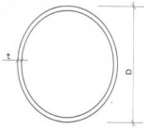

Figure A.7 ― Circular steel tubes

Table A.7 — Dimensions and properties for cold formed circular steel tubes
OD (mm) | THICK (mm) |  | CROSS SECT (cm²) |  | NOMINAL MASS/M (KG/M) |  | NOMINAL MASS /6M (KG) |  | SECOND MOMENT OF AREA (cm⁴) |  | RADIUS OF GYRATION (cm) |  | ELASTIC SECTION MODULUS (cm³) |  | PLASTIC SECTION MODULUS (cm³) |  | TORSIONAL INERTIA CONSTANT (cm⁴) |  | TORSIONAL MODULUS CONSTANT (cm³) |  | SUPERFICIAL AREA/M LENGTH (m²/m)
10 | 0.8 |  | 0.231 |  | 0.182 |  | 1.089 |  | 0.025 |  | 0.326 |  | 0.049 |  | 0.068 |  | 0.049 |  | 0.099 |  | 0.031
10 | 0.9 |  | 0.257 |  | 0.202 |  | 1.212 |  | 0.027 |  | 0.323 |  | 0.054 |  | 0.075 |  | 0.054 |  | 0.108 |  | 0.031
10 | 1 |  | 0.283 |  | 0.222 |  | 1.332 |  | 0.029 |  | 0.320 |  | 0.058 |  | 0.081 |  | 0.058 |  | 0.116 |  | 0.031
10 | 1.2 |  | 0.332 |  | 0.260 |  | 1.563 |  | 0.033 |  | 0.314 |  | 0.065 |  | 0.094 |  | 0.065 |  | 0.131 |  | 0.031
10 | 1.5 |  | 0.401 |  | 0.314 |  | 1.887 |  | 0.037 |  | 0.305 |  | 0.075 |  | 0.110 |  | 0.075 |  | 0.149 |  | 0.031
12 | 0.8 |  | 0.282 |  | 0.221 |  | 1.326 |  | 0.044 |  | 0.397 |  | 0.074 |  | 0.101 |  | 0.089 |  | 0.148 |  | 0.038
12 | 0.9 |  | 0.314 |  | 0.246 |  | 1.478 |  | 0.049 |  | 0.394 |  | 0.081 |  | 0.111 |  | 0.097 |  | 0.162 |  | 0.038
12 | 1 |  | 0.346 |  | 0.271 |  | 1.628 |  | 0.053 |  | 0.391 |  | 0.088 |  | 0.121 |  | 0.105 |  | 0.176 |  | 0.038
12 | 1.2 |  | 0.407 |  | 0.320 |  | 1.918 |  | 0.060 |  | 0.384 |  | 0.100 |  | 0.141 |  | 0.120 |  | 0.200 |  | 0.038
12 | 1.5 |  | 0.495 |  | 0.388 |  | 2.331 |  | 0.070 |  | 0.375 |  | 0.116 |  | 0.167 |  | 0.139 |  | 0.232 |  | 0.038
16 | 0.8 |  | 0.382 |  | 0.300 |  | 1.800 |  | 0.111 |  | 0.538 |  | 0.138 |  | 0.185 |  | 0.221 |  | 0.277 |  | 0.050
16 | 0.9 |  | 0.427 |  | 0.335 |  | 2.011 |  | 0.122 |  | 0.535 |  | 0.153 |  | 0.205 |  | 0.244 |  | 0.305 |  | 0.050
20 | 0.8 |  | 0.483 |  | 0.379 |  | 2.273 |  | 0.223 |  | 0.679 |  | 0.223 |  | 0.295 |  | 0.446 |  | 0.446 |  | 0.063
20 | 0.9 |  | 0.540 |  | 0.424 |  | 2.544 |  | 0.247 |  | 0.676 |  | 0.247 |  | 0.329 |  | 0.494 |  | 0.494 |  | 0.063
22 | 0.8 |  | 0.533 |  | 0.418 |  | 2.510 |  | 0.300 |  | 0.750 |  | 0.273 |  | 0.360 |  | 0.600 |  | 0.545 |  | 0.069
22 | 0.9 |  | 0.597 |  | 0.468 |  | 2.810 |  | 0.333 |  | 0.747 |  | 0.302 |  | 0.401 |  | 0.665 |  | 0.605 |  | 0.069
25 | 0.8 |  | 0.608 |  | 0.478 |  | 2.865 |  | 0.446 |  | 0.856 |  | 0.357 |  | 0.469 |  | 0.892 |  | 0.713 |  | 0.079
25 | 0.9 |  | 0.681 |  | 0.535 |  | 3.210 |  | 0.495 |  | 0.853 |  | 0.396 |  | 0.523 |  | 0.991 |  | 0.793 |  | 0.079
28 | 0.8 |  | 0.684 |  | 0.537 |  | 3.220 |  | 0.633 |  | 0.962 |  | 0.452 |  | 0.592 |  | 1.266 |  | 0.904 |  | 0.088
28 | 0.9 |  | 0.766 |  | 0.602 |  | 3.609 |  | 0.704 |  | 0.959 |  | 0.503 |  | 0.661 |  | 1.409 |  | 1.006 |  | 0.088
30 | 0.8 |  | 0.734 |  | 0.576 |  | 3.457 |  | 0.783 |  | 1.033 |  | 0.522 |  | 0.682 |  | 1.566 |  | 1.044 |  | 0.094
30 | 0.9 |  | 0.823 |  | 0.646 |  | 3.876 |  | 0.872 |  | 1.029 |  | 0.581 |  | 0.762 |  | 1.744 |  | 1.162 |  | 0.094
32 | 0.8 |  | 0.784 |  | 0.616 |  | 3.694 |  | 0.955 |  | 1.103 |  | 0.597 |  | 0.779 |  | 1.910 |  | 1.194 |  | 0.101
32 | 0.9 |  | 0.879 |  | 0.690 |  | 4.142 |  | 1.064 |  | 1.100 |  | 0.665 |  | 0.871 |  | 2.128 |  | 1.330 |  | 0.101
38 | 0.8 |  | 0.935 |  | 0.734 |  | 4.404 |  | 1.618 |  | 1.316 |  | 0.852 |  | 1.107 |  | 3.236 |  | 1.703 |  | 0.119
38 | 0.9 |  | 1.049 |  | 0.824 |  | 4.941 |  | 1.806 |  | 1.312 |  | 0.951 |  | 1.239 |  | 3.612 |  | 1.901 |  | 0.119
42 | 0.8 |  | 1.036 |  | 0.813 |  | 4.878 |  | 2.198 |  | 1.457 |  | 1.047 |  | 1.358 |  | 4.396 |  | 2.093 |  | 0.132
42 | 0.9 |  | 1.162 |  | 0.912 |  | 5.474 |  | 2.455 |  | 1.453 |  | 1.169 |  | 1.521 |  | 4.910 |  | 2.338 |  | 0.132
42 | 1 |  | 1.288 |  | 1.011 |  | 6.068 |  | 2.708 |  | 1.450 |  | 1.290 |  | 1.681 |  | 5.417 |  | 2.580 |  | 0.132
45 | 0.8 |  | 1.111 |  | 0.872 |  | 5.233 |  | 2.714 |  | 1.563 |  | 1.206 |  | 1.563 |  | 5.428 |  | 2.412 |  | 0.141
45 | 0.9 |  | 1.247 |  | 0.979 |  | 5.874 |  | 3.033 |  | 1.559 |  | 1.348 |  | 1.751 |  | 6.066 |  | 2.696 |  | 0.141
48 | 0.8 |  | 1.186 |  | 0.931 |  | 5.588 |  | 3.305 |  | 1.669 |  | 1.377 |  | 1.782 |  | 6.610 |  | 2.754 |  | 0.151
48 | 0.9 |  | 1.332 |  | 1.046 |  | 6.273 |  | 3.695 |  | 1.666 |  | 1.539 |  | 1.997 |  | 7.389 |  | 3.079 |  | 0.151
48 | 1 |  | 1.477 |  | 1.159 |  | 6.955 |  | 4.079 |  | 1.662 |  | 1.700 |  | 2.209 |  | 8.159 |  | 3.400 |  | 0.151
51 | 0.8 |  | 1.262 |  | 0.991 |  | 5.943 |  | 3.976 |  | 1.775 |  | 1.559 |  | 2.016 |  | 7.952 |  | 3.118 |  | 0.160
51 | 0.9 |  | 1.417 |  | 1.112 |  | 6.673 |  | 4.446 |  | 1.772 |  | 1.744 |  | 2.259 |  | 8.893 |  | 3.487 |  | 0.160
60 | 1 |  | 1.854 |  | 1.455 |  | 8.731 |  | 8.069 |  | 2.086 |  | 2.690 |  | 3.481 |  | 16.137 |  | 5.379 |  | 0.189
76 | 1.2 |  | 2.820 |  | 2.214 |  | 13.283 |  | 19.729 |  | 2.645 |  | 5.192 |  | 6.715 |  | 39.459 |  | 10.384 |  | 0.239
89 | 1.5 |  | 4.124 |  | 3.237 |  | 19.423 |  | 39.478 |  | 3.094 |  | 8.872 |  | 11.486 |  | 78.957 |  | 17.743 |  | 0.280
216 | 4.0 |  | 26.644 |  | 20.916 |  | 125.494 |  | 1497.402 |  | 7.497 |  | 138.648 |  | 179.797 |  | 2994.804 |  | 277.297 |  | 0.679
273 | 4.0 |  | 33.808 |  | 26.539 |  | 159.235 |  | 3058.645 |  | 9.512 |  | 224.077 |  | 289.465 |  | 6117.290 |  | 448.153 |  | 0.858

