##### DRAFT EAST AFRICAN STANDARD

Low pressure Liquefied Petroleum Gas (LPG) regulator for use with LPG cylinder valve — Specification

EAST AFRICAN COMMUNITY

**Copyright notice**

This EAC document is copyright-protected by EAC. While the reproduction of this document by participants in the EAC standards development process is permitted without prior permission from EAC, neither this document nor any extract from it may be reproduced, stored or transmitted in any form for any other purpose without prior written permission from EAC.

Requests for permission to reproduce this document for the purpose of selling it should be addressed as shown below or to EAC’s member body in the country of the requester:

*© East African Community 2025 — All rights reserved*

*East African Community*

*P.O. Box 1096,*

*Arusha*

*Tanzania*

*Tel: + 255 27 2162100*

*Fax: + 255 27 2162190*

*E-mail:* [*eac@eachq.org*](mailto:eac@eachq.org)

*Web:* [*www.eac-quality.net*](http://www.eac-quality.net)

Reproduction for sales purposes may be subject to royalty payments or a licensing agreement. Violators may be prosecuted.

Foreword

Development of the East African Standards has been necessitated by the need for harmonizing requirements governing quality of products and services in the East African Community. It is envisaged that through harmonized standardization, trade barriers that are encountered when goods and services are exchanged within the Community will be removed.

The Community has established an East African Standards Committee (EASC) mandated to develop and issue East African Standards (EAS). The Committee is composed of representatives of the National Standards Bodies in Partner States, together with the representatives from the public and private sector organizations in the community.

East African Standards are developed through Technical Committees that are representative of key stakeholders including government, academia, consumer groups, private sector and other interested parties. Draft East African Standards are circulated to stakeholders through the National Standards Bodies in the Partner States. The comments received are discussed and incorporated before finalization of standards, in accordance with the Principles and procedures for development of East African Standards.

East African Standards are subject to review, to keep pace with technological advances. Users of the East African Standards are therefore expected to ensure that they always have the latest versions of the standards they are implementing.

The committee responsible for this document is Technical Committee EASC/TC 038.

Attention is drawn to the possibility that some of the elements of this document may be subject of patent rights. EAC shall not be held responsible for identifying any or all such patent rights.

Low pressure Liquefied Petroleum Gas (LPG) regulator for use with LPG cylinder valve — Specification

# **1 Scope**

This Draft East African Standard specifies materials, construction, performance, safety and testing requirements for low-pressure single-stage regulator for use with liquefied petroleum gas mixtures in the vapour phase and designed for a set outlet pressure of 3.0 kPa (0.4 Psi) and a flow not exceeding 2 kg/h.

# **2 Normative references**

The following documents are referred to in the text in such a way that some or all of their content constitutes requirements of this document. For dated references, only the edition cited applies. For undated references, the latest edition of the referenced document (including any amendments) applies.

There are no normative references in this document.

# **3 Terms and definitions**

For the purposes of this document, the following terms and definitions shall apply.

ISO and IEC maintain terminological databases for use in standardization at the following addresses:

— IEC Electropedia: available at <http://www.electropedia.org/>

— ISO Online browsing platform: available at <http://www.iso.org/obp>

3.1

liquefied petroleum gas (LPG)

pure propane, butane or a mixture of the propane and butane

3.2

low pressure liquefied petroleum gas regulator

device whose function is to maintain the value of the controlled outlet pressure within its tolerance for all values of the inlet pressure range

3.3

body

main pressure containing envelope which provides the fluid flow passageway and the pipe end connections

3.4

lock-up pressure

the pressure at the regulator outlet, under no-flow conditions

3.5

minimum flow rate

the flow rate at an inlet pressure of 80 kPa (11.5 Psi) and an outlet pressure of not less than 2.2 kPa (0.3 Psi)

3.6

nominal flow rate

the quantity of gas, in kilograms per hour, that a regulator, fitted with an outlet tailpiece or an outlet connector of a specified bore, supplies at the set outlet pressure and at an inlet pressure of 700 kPa

3.7

set outlet pressure

the outlet pressure (at an inlet pressure of 700 kPa (100Psi)) to which a regulator has been set at the factory and that is regarded as the nominal operating pressure of the regulator

3.8

single- stage regulator

regulator in which reduction of the inlet down to the desired regulated outlet pressure is achieved in one stage only

# **4 Materials**

## **4.1 General**

**4.1.1** All components’ parts shall be manufactured from or be treated with materials compatible with LPG as well as be unaffected by chemical or thermal influences that may be encountered in normal use.

**4.1.2** The cantilever (which is part of the mechanism that controls the flow through the inlet orifice) shall be metallic.

**4.1.3** The body for all regulators shall be manufactured from alloys of zinc and/or aluminium by die casting.

**4.1.4** Brass parts shall not be susceptible to season cracking.

## **4.2 Diaphragm material**

The diaphragm material shall be of synthetic rubber or any other material equally suitable for the application and shall satisfy the following requirements:

a) The material shall be free from porosity, pits and foreign particles and shall have a smooth, non-tacky surface with minimum talc or bloom.

b) The material shall not show change of more than 10 IRHD when subjected to ageing of 72 hours at 70˚ C.

c) The material shall be capable of withstanding a clamping pressure of 490 KPa (70 Psi) whereby the material itself or the substance with which the fabric layer has been impregnated shall not be pressed away, flowed away or bruised or otherwise damaged.

d) The material shall be such that when an assembled regulator is subjected to pressure test, the diaphragm shall not pullout or burst at a pressure less than 275 KPa (40 Psi).

e) The material after immersion in commercial LPG for 72 hours shall not change in hardness value exceeding 15 IRHD.

f) The material shall be such that the flexibility of the diaphragm shall not be impaired after samples of the same have recovered completely to ambient temperatures from cooling to -20˚C or heating to 65˚C.

## **4.3 Valve pad material**

Valve pad material shall be of synthetic rubber or other materials equally suitable for the application and of the quality to satisfy the following minimum requirements;

a) The valve pad material shall be free from porosity, pits and foreign particles and shall have a smooth, non-tacky surface with minimum bloom.

b) The material after immersion in commercial LPG for 72 hours shall not change in hardness value exceeding 15 IRHD.

c) The material shall not show change of more than 10 IRHD when subjected to ageing of 72 hours at 70 ºC.

d) The valve pad when fitted in its housing then immersed in LPG in the vapour phase for 72 hours shall not show evidence of being forced out of position due to swelling or other cause.

# **5 Construction and workmanship**

## **5.1 General**

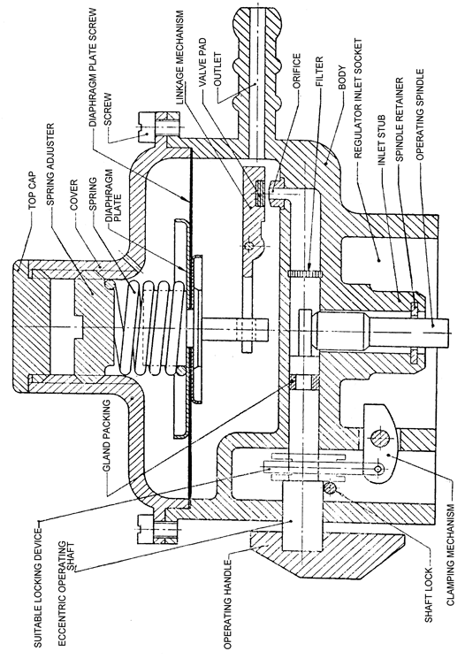A typical regulator shall be as shown in Figure 1.

Figure 1 — Sectional illustration of pressure regulator for use with self- closing spring loaded type valve

## **5.2 Body**

**5.2.1** The body and cover shall be strong enough to withstand the stress of connecting the regulator to the cylinder valve or piping installation and to withstand normal stress imposed by the service conditions without developing leakage at joints, permanent deformation or other damage which might impair the functioning of the regulator.

**5.2.2** After machining and before finishing treatment ( for example painting) the body shall be pressure tested for porosity with gas or air at a pressure of not less than 98 KPa (14 Psi)

## **5.3 Vent**

The breather hole (air vent above diaphragm space) shall be of such a size and at such a location on the cover that:

a) it does not easily get clogged or blocked.

b) the accidental entry of foreign matter is minimized.

c) It would be difficult for an instrument inserted through the air vent hole to reach the diaphragm.

## **5.4 Safety mechanisms**

### **5.4.1 Excess flow mechanism**

The regulator shall have an inbuilt excess flow mechanism to prevent the discharge rate or shut off the gas flow for values of flow rate between 120 % of the guaranteed rate.

### **5.4.2 Child lock**

The regulator shall incorporate a child lock mechanism to avoid an unintentional turning on and unintentional disconnection of the regulator from the cylinder.

## **5.5 Valve pad fitting**

**5.5.1** A valve pad (resilient) shall be so retained without the use of adhesive that it cannot loosen or work out of position under such service conditions.

**5.5.2** The inlet orifice and valve pad of the pressure regulator shall be protected by the provision of a filter of suitable material compatible with LPG, of appropriate size of perforations that does not hamper flow of vapour, but is effective against ingress action of contaminating agents in the gas.

## **5.6 Connections**

### **5.6.1 Inlet connections**

**5.6.1.1** The inlet of the pressure regulator shall be cast integrally as an inseparable part of the body or so fixed such that it cannot be separated without damaging the body.

**5.6.1.2** The size and the profile of the inlet connection shall match the outlet end of the unified valve of LPG cylinder to achieve a leak-proof coupled joint without the use of tools or without the use of a resilient packing or washer or gasket as part of the regulator.

**5.6.1.3** The inlet connection shall also be capable to withstand a minimum pneumatic pressure of 1666 Kpa (240 Psi) at ambient temperature

### **5.6.2 Outlet connection**

The outlet nozzle shall be horizontal cast integrally with the body as shown in Figure 2.

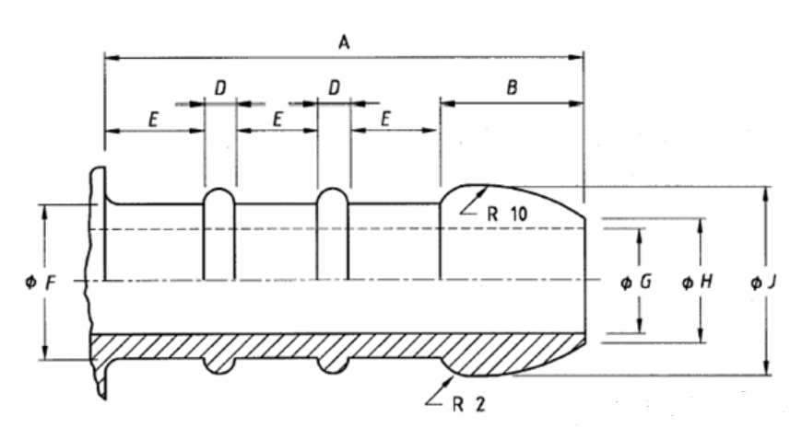

|  |  |  |  |  |  |  |  |  |
| --- | --- | --- | --- | --- | --- | --- | --- | --- |
| Nominal size | A  mm | B  mm | D  mm | E  mm | Dia  F (mm) | Dia  G (mm) | Dia  H (mm) | Dia  J (mm) |
| 8 | 23.0– 24.0 | 6.75 -7.25 | 1.5 ± 0.1 | 4.3 - 4.7 | 8.0 - 8.2 | 5.2- 5.6 | 6.8 – 7.2 | 10.0 – 10.3 |

Figure 2 — Outlet connection

## **5.7 Position of mounting and operation**

Unless otherwise specified by the manufacturer, the regulator shall be suitable for mounting and operation in a horizontal and top-side-up position.

# **6 Soundness and performance**

## **6.1 Gas-tightness**

**6.1.1** The regulator shall be leak tight when tested pneumatically at a pressure of 14.7Kpa (2 Psi) applied through the outlet connection of a fully assembled regulator and held for a period of between 30 and 60seconds. To get stability, adequate time is allowed between introduction of the test medium and the start of observation, so that the internal parts attain balanced positions

**6.1.2** Those parts of the regulator which are normally subjected to full cylinder pressure shall be leak-tight at a minimum hydrostatic pressure of 1.5 times the saturated vapour pressure of the gas at 65˚C subject to a minimum of 1764 Kpa (255 Psi) for 120 seconds.

**6.1.3** Those parts of the regulator which are normally subjected to full cylinder pressure shall also be tested for soundness at a pressure of 1666 kPa (241 Psi) for a period of not less than 30 seconds and not more than 60 seconds after stability has been achieved. To ensure that the hydrostatic pressure and medium extends only in and up to the high pressure sections, a back pressure not exceeding 14.70 Kpa (2 Psi) is applied to the outlet connection of the regulator before the start of the test and is kept on throughout.

## **6.2 Endurance**

When a regulator is tested for endurance (cycle test) as per Annex B,

a) it shall show no sign of sticking, jamming, warping, wear or any other malfunction;

b) the diaphragm shall not pull out of its fixture or burst.

c) the flow control cantilever shall show no sign of any permanent damage or distortion, or any wear that can affect the normal operation of the valve.

d) the regulator shall, during the test, not chatter or hum.

# **7 Finish**

All metal parts of a regulator shall be of an intrinsically corrosion-resistant material or otherwise all outside surfaces of metal parts shall have an application of a corrosion-resistant coating.

# **8 Inspection and test methods**

**8.1** Inspect the sample for compliance with the requirements of the standard and carry out the tests as detailed in the annexes.

**8.2** The tests in Annexes A, B, C and D shall be carried out on each regulator in the sample in the sequence in which they are given.

# **9 Packaging and marking**

## **9.1 Packaging**

Each regulator shall be so packaged as to prevent from damage and the entry of any foreign matter into the regulator’

## **9.2 Marking**

**9.2.1** The following information shall be legibly and indelibly stamped, embossed, or otherwise permanently applied, on the body of each regulator:

a) the manufacturer's name and/or trademark

b) the direction of flow indicated by, for example, an arrow;

c) the set outlet pressure (i.e. 3.0 Kpa (0.435 Psi));

d) the nominal gas-flow rate of the regulator (expressed in kilograms per hour of LPG);

e) the month and year of manufacture;

f) the number of this standard.

**9.2.2** The following information shall be supplied with the regulator:

a) wording to the effect

i) that the regulator is for use with LPG only,

ii) that the spring setting is pre-adjusted and should not be tampered with;

b) any additional information regarding the safe and effective installation and operation of the regulator;

Annex A   
(normative)  
  
Determination of nominal and minimum flow rate

A.1 Apparatus

**A.1.1 Air supply**, capable of being adjusted to a constant pressure of 700 kPa ± 5 kPa and 80 kPa ± 5 kPa, as relevant.

**A.1.2 Calibrated air-flow meter**.

**A.1.3**  **Pressure gauge,** of a range of up to 1 000 kPa

**A.1.4 Water manometer** (or other pressure indicating device), of range up to at least 10 kPa.

**A.1.5 Outlet control valve for the regulator.**

**A.1.6 Connecting pipes**, of bore diameter at least equal to that of the bore of the relevant regulator outlet or the outside diameter of the outlet nozzle, as relevant, and of the following lengths:

a) between the regulator outlet and the water manometer: 8 to 12 times the bore of the pipe; and

b) for all other pipes: 600 mm to 650 mm.

A.2 Procedure

a**)** Connect (in series and in the sequence given) the air supply, the regulator, the outlet control valve and the air-flow meter.

b)Connect the pressure gauge to the supply pipe at the inlet of the regulator, and the manometer to the outlet pipe at the outlet of the regulator.

c)Verify the nominal flow rate and the minimum flow rate corresponding to the outlet size of the regulator, as follows:

i) Determine the ambient pressure and ambient temperature. Open the air supply, adjust the inlet pressure to 700 kPa ± 5 kPa, and maintain the pressure at that value;

ii) Adjust the outlet control valve (while maintaining the inlet pressure at 700 kPa ± 5 kPa) that the outlet pressure corresponds to 3.0 kPa;

iii) Allow the pressures to stabilize for 2minutes, making appropriate adjustments if necessary;

iv) Note the flow rate and check for compliance.

v) Without any adjustment of the outlet control valve, reduce the inlet pressure to 80 kPa ± 5 kPa. Allow the inlet and outlet pressures to stabilize for 2 minutes, making appropriate adjustments to the inlet pressure if necessary;

vi) Note the outlet pressure and the flow rate and check for compliance with the requirements. Calculate the gas-flow rate, *mg*, in kilograms per hour, from the following formula:



where

*Mg*  is the gas-flow rate, in kilograms per hour;

*QA* is the air flow at ambient pressure and ambient temperature, in cubic metres per hour;

*P* is the ambient pressure (atmospheric), in kilopascals;

*T* is the ambient temperature, in kelvins.

NOTE For further information regarding the use of the above formula, see annex D.

d) Repeat the procedure for each additional outlet size.

Annex B   
(normative)  
  
Endurance test

B.1 Conditioning

Before the test, subject the regulator to the following conditioning procedure(s), as relevant:

B.1.1 Temperature conditioning for regulators with plastics component parts

Subject the regulator to a temperature of 80 **°**C ± 2 **°**C for 72 h and then let it cool and rest at room temperature for 24 h.

B.1.2 N-pentane conditioning for all regulators

Immerse the regulator (when relevant, after the temperature conditioning procedure given in (a) above) completely in N-pentane for 72 h. Remove the regulator from the test liquid. Remove all free N-pentane from the regulator and allow it to dry in the open air for 24 h.

B.2 Procedure

a) Connect the inlet of the regulator to an air supply at a pressure of 800 kPa ± 25 kPa and connect the outlet to a solenoid valve operated by means of a timing device.

b) Throttle the valve to ensure a back pressure of about 3.0 kPa on the regulator.

c) Adjust the timing device to open and close the solenoid valve at a rate of 15 cycles per minute, each cycle consisting of one opening and one closing action of approximately equal duration.

d) Subject the regulator to 50 000 cycles.

Annex C   
(normative)  
  
Test for gas-tightness

Procedure

First, subject the outlet of the regulator, with the inlet closed, to an air pressure of 15 kPa. Then subject those portions of the regulator subjected to inlet pressure to an air pressure of 1 600 kPa. In each case, using a soapy solution, examine the regulator for leakage while the pressure is being applied.

Annex D   
(normative)  
  
Determination of susceptibility of copper alloy parts to seasonal cracking

D.1 Reagents

**D.1.1 Concentrated nitric acid**, (d = 1.42 g/cm3).

**D.1.2 Dilute nitric acid**, 50 % (by volume) of concentrated nitric acid in distilled water.

**D.1.3 Mercurous nitrate solution**. A distilled water solution that contains 1 % (by mass) of mercurous nitrate (HgNO3.H2O) and 1 % (by volume) of the concentrated nitric acid.

D.2 Test specimen

Use the copper alloy part (or a piece cut from it, if it is too large to be immersed in the test solution).

D.3 Procedure

Degrease the test specimen and then dip it, for 30 s, in the diluted nitric acid solution. Rinse the test specimen in cold water and immediately immerse it completely in the mercurous nitrate solution.

After 30 min, remove the test specimen, rinse it well in cold water, carefully wipe it, and examine it immediately.

Examine specimens of Cu-Ni30Mn1 alloy (70/30 copper-nickel and 0.5 % to 1.5 % manganese) 24 h after removal from the solution.)

Check for compliance.

Bibliography

SANS 1237:1969, Single-stage low-pressure regulators for Liquefied Petroleum Gas (LPG).

KS 2189:2009, Low pressure liquefied petroleum gas (LPG) regulator for use with unified valve — Specification

IS 9798:1995, Low pressure regulators for use with Liquefied Petroleum Gas (LPG) mixtures—Specification