##### DRAFT EAST AFRICAN STANDARD

Domestic cooking ranges for use with Liquefied Petroleum Gases — Specification

EAST AFRICAN COMMUNITY

**Copyright notice**

This EAC document is copyright-protected by EAC. While the reproduction of this document by participants in the EAC standards development process is permitted without prior permission from EAC, neither this document nor any extract from it may be reproduced, stored or transmitted in any form for any other purpose without prior written permission from EAC.

Requests for permission to reproduce this document for the purpose of selling it should be addressed as shown below or to EAC’s member body in the country of the requester:

*© East African Community 2025 — All rights reserved*

*East African Community*

*P.O. Box 1096,*

*Arusha*

*Tanzania*

*Tel: + 255 27 2162100*

*Fax: + 255 27 2162190*

*E-mail:* [*eac@eachq.org*](mailto:eac@eachq.org)

*Web:* [*www.eac-quality.net*](http://www.eac-quality.net)

Reproduction for sales purposes may be subject to royalty payments or a licensing agreement. Violators may be prosecuted.

Foreword

Development of the East African Standards has been necessitated by the need for harmonizing requirements governing quality of products and services in the East African Community. It is envisaged that through harmonized standardization, trade barriers that are encountered when goods and services are exchanged within the Community will be removed.

The Community has established an East African Standards Committee (EASC) mandated to develop and issue East African Standards (EAS). The Committee is composed of representatives of the National Standards Bodies in Partner States, together with the representatives from the public and private sector organizations in the community.

East African Standards are developed through Technical Committees that are representative of key stakeholders including government, academia, consumer groups, private sector and other interested parties. Draft East African Standards are circulated to stakeholders through the National Standards Bodies in the Partner States. The comments received are discussed and incorporated before finalization of standards, in accordance with the Principles and procedures for development of East African Standards.

East African Standards are subject to review, to keep pace with technological advances. Users of the East African Standards are therefore expected to ensure that they always have the latest versions of the standards they are implementing.

The committee responsible for this document is Technical Committee EASC/TC 038*.*

Attention is drawn to the possibility that some of the elements of this document may be subject of patent rights. EAC shall not be held responsible for identifying any or all such patent rights.

Domestic cooking ranges for use with Liquefied Petroleum Gases — Specification

# **1 Scope**

**1.1** This Draft East African Standard specifies construction, performance, operation, safety requirements and tests for domestic cooking ranges having an oven, with thermostat only, for burning gases at a rate not exceeding 1 500 g/h, intended for use with Liquefied Petroleum Gases at 2.942 KN/m2 (30 gf/cm2) gas inlet pressure.

**1.2** Cooking ranges shall be classified as follows:

a) Top or surface range — A unit designed for installation in or on a counter top. It may have top burners, a griller, a deep well cooker, or any combination thereof.

b) Oven range — A range designed for installation in a cabinet, wall or partition, or for installation on a counter. It may be a separate oven, may be equipped with a griller that uses the oven burner, or the oven may serve as a griller unit with a burner in the upper portion of the oven.

c) Combination of (a) or (b) above, or any other domestic cooking device that may be designed for similar installation.

# **2 Normative references**

The following documents are referred to in the text in such a way that some or all of their content constitutes requirements of this document. For dated references, only the edition cited applies. For undated references, the latest edition of the referenced document (including any amendments) applies.

There are no normative references in this document.

# **3 Terms and definitions**

No terms and definitions are listed in this document.

ISO and IEC maintain terminological databases for use in standardization at the following addresses:

— IEC Electropedia: available at <http://www.electropedia.org/>

— ISO Online browsing platform: available at <http://www.iso.org/obp>

# **4 General**

No pressure regulator shall be included as a part of the range.

# **5 Construction requirements**

## **5.1 Materials**

**5.1.1** Materials for griller burner shall be of food grade and non-corroding.

**5.1.2** Grill trays and grill shall be made of non-corroding material or appropriately treated to resist corrosion.

**5.1.3** Glass for grill door, if provided, shall be heat resistant.

## **5.2 Design for maintenance**

**5.2.1** The cooking range, including all the component parts, (see Figure 1), shall be easy to clean and to maintain in good working order.

**5.2.2** Burners and parts of burners of the same capacity and of the same model shall be interchangeable or replaceable without affecting performance.

**5.2.3** Parts which are intended to be removable by the user shall be easy to replace correctly, and incapable of being assembled incorrectly.

**5.2.4** All nuts, bolts and fittings having spanner flats shall be capable of being moved by suitable spanner or be readily accessible to an adjustable spanner.

**5.2.5** All controls and any other moving parts shall operate freely at the highest working temperature obtainable on the appliances.

**5.2.6** The appliance shall be free from sharp edges that are liable to damage clothing or cause injuries.

**5.2.7** The parts of the burner shall not get disconnected during operation of the appliance.

**5.2.8** Burner parts shall be so designed and located that in normal use spillage of food shall not cause internal fouling of mixing tube and blockage of injector jet.

## **5.3 Rigidity and stability**

**5.3.1** The cooking range shall be so designed that when assembled correctly and resting on a firm level foundation it shall be level and rigid and, if subjected to vibration, shall not rattle.

**5.3.2** Any rack or backing tray provided in the oven portion of the cooker, when pulled out of a distance equal to two-thirds of its width (front to back) shall be sufficiently rigid to carry, without tipping or appreciably flexing and without permanent distortion, a load of 0.3 kN placed in the middle of the portion pulled out.

**5.3.3** The cooking range shall be so designed that it cannot be inadvertently over-turned.

## **5.4 Working and finishes**

**5.4.1** All components made of materials susceptible to corrosion shall be given a corrosion-resistant protective finish appropriate to the conditions of use. The protective coating for external surfaces shall be resistant to temperature up to 150 ºC and for internal oven surface up to 400 ºC.

**5.4.2** The external finished surfaces shall be easily cleanable.

**5.4.3** Except for burners, all other parts, namely, springs, screws, nuts and bolts, pipes, pins, etc., which are visible or which can be removed for maintenance, shall be of corrosion-resistant material or treated to resist corrosion.

**5.4.4** Concealed gas tubes and fittings liable to corrosion shall be protected by bituminous paint or other equally protective material.

**5.4.5** Plastic components shall be those that do not deteriorate when in contact with liquefied petroleum gas.

## **5.5 Gas taps**

The gas tap shall comply to the requirements for gas taps with or without flame failure device.

## **5.6 Injector jets**

5.6.1 These shall be sized according to the manufacturer’s specification

5.6.2 The injector jets shall be fixed type and shall not be adjustable.

## **5.7 Burner**

**5.7.1** For burners having centre flame, provision shall be made to protect the centre flame from pans resting directly on burner top and smothering the centre flame.

**5.7.2** The cooking range shall have at least one burner of a rating of 1490 kca/h, based on net calorific value of the gas (when using commercial butane).

**5.7.3** If a pilot burner is fitted, it shall be easily removable for cleaning. All pilot flame shall be protected as far as possible by design and position against flame diminution, extinction by draught, products of combustion, overheating, condensation, corrosion or matter falling from above. If a pilot burner is provided, the gas inlet to the pilot and the main burner shall close if the pilot gets extinguished.

**5.7.4** The handle of a tiltable oven burner shall be clearly visible and easy to operate.

**5.7.5** The construction of the burners and the assembly shall allow dismantling from the supports easily with or without the use of tools

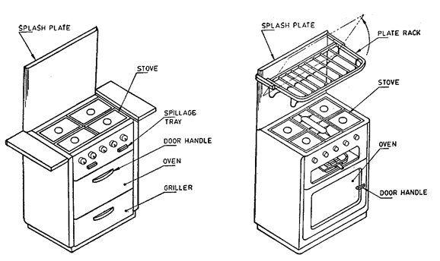

Figure 1 — Types of cooking ranges, nomenclature

## **5.8 Burner pan support**

**5.8.1** The design of the burner pan supports shall be such that it is practicable to support a pan of 100 mm diameter, over at least one top burner without the use of loose rings, and such that a 125 mm diameter vessel remains stable over each burner. Prongs of the support shall have a suitable taper to accommodate round bottom pans.

**5.8.2** Loose pan supports when supplied, shall be so designed that it is not possible to place them firmly in other than proper position.

## **5.8 Spillage collection**

**5.8.1** A tray or other receptacle shall be provided to collect spillage from pans over any top burner and shall be capable of holding at least 300 ml.

**5.8.2** Spillage tray shall be easily cleanable

## **5.9 Grill design**

Cooking range with a high-level grill, or independent wall fixing griller, which may give rise to high temperature above them, shall be tested to ensure that the appliances do not constitute a fire hazard when installed.

## **5.10 Cooking range doors**

**5.10.1** Drop doors shall be such that when opened fully, they shall lie and remain essentially in horizontal position.

**5.10.2** All side-hinged oven doors shall open through at least 100 º.

**5.10.3** The doors and hinges shall show no sign of crack or distortion when tested according to 5.10.3.1 and 5.10.3.2.

**5.10.3.1** For door opening downwards:

a) A load of 200 N (20 kgf) shall be applied uniformly on a 30 cm2 area for 5 minutes at one corner of the door, the other being solidly supported (see Figure 3 (a), and

b) A uniform load of 200 N (20 kgf) shall be applied over a strip of 10 cm width running centrally for 5 minutes (see Figure 3 (b).

**5.10.3.2** For door opening sideways, a load of 200 N (20 kgf) shall be applied uniformly for 5 minutes over the top edge of the doors (see Figure 3 (c).

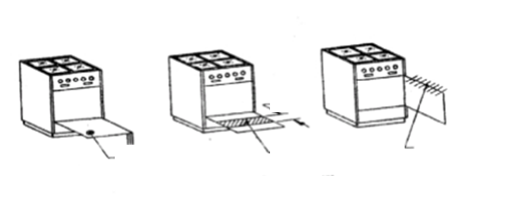

**Figure 3 (a) -20 kgf Figure 3 (b)- 20 kgf Figure 3 (c)- 20 kgf**

## **5.11 Gas inlet connections**

The position of the gas inlet shall allow connection to a gas supply on either side of the appliance with the appliance fitted tight against a back wall. Ample clearance shall be provided to afford easy manipulation of standard tools when connecting the appliance to the supply line.

## **5.12 Insulation**

**5.12.1** Where insulation is employed, it shall neither be exposed to air nor to flue products and it shall be uniformly and tightly packed to provide even protection and to prevent shifting.

**5.12.2** Granular insulation shall not be used unless adequately protected against setting during transportation or normal use.

## **5.13 Thermostat**

**5.13.1** Thermostat shall be easy to operate at all temperatures normally attained in use.

**5.13.2** The minimum gas flow through any thermostat by-pass shall be controlled by an orifice easily removable for cleaning. The fixed minimum by-pass shall be sufficient to maintain stable flames on the main burner at 2.452 kN/m2 (25 gf/cm2) gas inlet pressure.

**5.13.3** If the thermostat includes a device for controlling the pilot gas rate, it shall be easily removable for cleaning.

**5.13.4** All thermostats shall have a suitable filter in the line before the gas valve.

**5.13.5** The numbers of letters indicating the various thermostat settings shall be plainly and durably marked.

## **5.14 Gas system soundness**

There shall be no leakage in the whole gas system.

## **5.15 Strength of appliance**

**5.15.1** The appliance shall support, without breakage or apparent damage for a period of 15 minutes, a load of 1 kN (100 kgf) uniformly applied at the top. After the load has been supported for a period of 15 minutes, it shall be removed and the base and frame examined for any indication of breakage or deformation.

**5.15.2** The materials used and the construction and assembly of the body of the appliance shall be such that the application of a diagonal force of 1.5 kN (150 kgf approximately) applied from front to rear, and a diagonal force 1.25 kN (125 kgf approximately) from side to side as given in Annex A, shall not result in a temporary deflection exceeding 3 mm in the direction and plane of the horizontal component of the diagonal force. Compliance with this requirement shall be determined by the test.

## **5.16 Plate rack**

**5.16.1** Any plate rack if provided shall allow the safe racking of plates from 19 cm to 27 cm diameter. The plate rack shall be secure when normally loaded with plates.

**5.16.2** The distance between the lowest part of the plate rack and the stove shall be not less than 33 cm.

**5.16.3** If the cooking range is fitted as close as possible to a back wall and the plate rack is of the fold up type, it shall neither hit the wall behind the cooker when in the raised position, or shall it fall forward from the position.

# **6 Performance**

## **6.1 Gas consumption**

**6.1.1** It shall be possible to reduce the consumption rate of the burner to the extent given below by providing a fixed simmer orifice in the gas tap.

a) For burners up to 60 L/h gas rate, 33 % of the rated capacity, and

b) For burners above 60 L/h gas rate, 21 L/h or 25 % of the rated capacity, whichever is higher.

**6.1.2** Burners with a gas rate of up to 20 L/h at 30 gf/cm2 gas inlet pressure and appliances incorporating piezo-electric ignition shall, however, be exempted from 6.1.1.

**6.1.3** when the gas consumption of a burner is reduced to simmer, the flame shall not extinguish, blow off, strike back or form soot when tested with commercial butane gas at 2.942 kN/m3 (30 gf/cm2) gas inlet pressure.

## **6.2 Ignition and flame stability**

**6.2.1** There shall be easy and safe access for lighting and relighting each burner by a match stick and it shall be easy to see that the burner is alight. Where the burner or burners are lighted by automatic ignition (battery of flint-operated) by a pilot flame, it shall be not possible for gas to be admitted to the main burner without being smoothly ignited by the pilot flame. Each shall be at room temperature at the start of each test and shall be tested in turn.

**6.2.2** If the flame is applied to any of the burner ports when the gas is flowing, flame travel shall be complete. This applies for all pressure from 2.452 kN/m2 to 3.432 kN/m2 (25-35 gf/cm2) taps being fully open. Burners consisting of two separate tubes, each requiring separate lighting are acceptable on ovens.

**6.2.3** When the cooker burner is ignited from a pilot flame, ignition shall be smooth at pressures from 2.452 kN/m2 to 3.432 kN/m2 (25-35 gf/cm2) with the burner tap turned full ‘ON’ and ignition shall be effected without undue delay after turning ‘ON’ the taps.

**6.2.4** Where flame failure devices are used, these shall open fully from cold in not more than 90 s and shall close from the fully heated condition within 90 seconds.

## **6.3 Noise control**

The ignition of the burner flames, their operation and turning ‘OFF’ shall not give rise to undue or excessive noises during all the operation tests.

## **6.4 Flash back**

**6.4.1** A vessel, having diameter suitable to cover the pan supports, dully filled in with water, shall be placed on the burner under test. The tap of the burner shall be turned on and the gas shall be allowed to flow through the burner at full rate, with taps fully opened and gas lighted. After half an hour the flame shall be immediately reduced to simmer and then brought back to full size. The operation shall be repeated five times. No flash back shall occur during the test. This applies for all pressure from 2.452 kN/m2 to 3.432 kN/m2 (25-35 gf/cm2).

**6.4.2** The test described in 6.6.1 need not be performed on burners having a rating of less than 550 kcaL/h. This test is applicable to boiling burners only and does not apply to grillers.

**6.4.3** There shall be no flash back when griller is switched ‘OFF’ after it has remained lit in full ‘ON’ position for a period of 30 min at a nominal pressure of 25 gf/cm.

## **6.5 Formation of soot**

A vessel, 200 mm in diameter, full of water, shall be placed on the burner and the burner lighted at full ‘ON’ position of the tap for one hour. After the test, no soot shall be deposited on the burner and on the bottom of the vessel. This applies for all pressures from 2.452 kN/m2 to 3.432 kN/m2 (25-35 gf/cm2).

## **6.6 Resistance to draught**

**6.6.1** There shall be no extinction of the flames on any of the burners operating at maximum consumption when the appliance is placed in a general (not localized) current of air with a velocity of 2 m/s, as measured with a rotating vane anemometer. The location of the appliance relative to neighbouring walls and the direction of the draught shall be varied to correspond to likely conditions of appliance installation. This applies for all pressure from 2.452 kN/m2 to 3.432 kN/m2 (25-35 gf/cm2).

**6.6.2** Flames of the oven burner at full ‘ON’ shall not extinguish, where the door is opened or closed abruptly. Oven burner on the bypass rate, if fitted with a thermostat or adjusted to give an oven temperature of 120 ºC above room temperature, if no thermostat is fitted, shall not be extinguished when the door is opened and closed with reasonable care.

**6.6.3** Griller burners shall be tested over the consumption range of 50 % to 100 % full ‘ON’ rate with the grill pan in position.

## **6.7 Thermostats**

**6.7.1** The thermostat shall be such that the temperature in the centre of the oven with a gas inlet pressure of 3.432 kN/m2 (35 gf/cm2) is not more than 8 ºC in excess of the temperature obtained with a gas inlet pressure of 2.942 kN/m2 (30 gf/cm2) for any setting of thermostat. This requirement shall be tested by method given in B1.1 in Annex B.

**6.7.2** The thermostat shall be such that the two temperatures obtainable in an oven for each setting, that is, that obtained by moving from a higher to the required setting and that obtained by moving from a lower to the required setting, do not differ by more than 6 ºC. The requirement shall be tested by method given in B1.2 in Annex B.

**6.7.3** The burners of cooking ranges fitted with thermostat shall be stable when after operating in the highest position, to enable the temperature equilibrium to be obtained, the control is turned sharply to its lowest position at a gas inlet pressure of 2.452 kN/m2 (25 gf/cm2). This requirement shall be tested by method given in B1.3 in Annex B.

**6.7.4** It shall be possible to meet the requirements of 6.10 with the oven tap fully opened, by adjustment of the thermostat settings only.

## **6.8 Oven heat distribution**

**6.8.1** It shall be possible to raise the temperature in the middle of the oven to 210 ºC above room temperature in 14 min with the baking tray placed between one-third and one-half the height of the oven measured from the base of the oven, that is, oven floor. The temperature measurement shall be done by means of a thermocouple, placed in the centre of 5 cm blackened copper sphere (see figure 4).

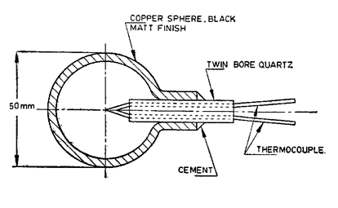

Figure 4 — Blackened copper sphere for oven temperature measurement

**6.8.2** It shall be possible to adjust the gas consumption so that the oven can be kept at a temperature which is not higher than 120 ºC above room temperature with the baking tray placed between one-third and one-half the height of the oven measured from the base. If the oven is provided with a fixed low position, this test shall be satisfied with the tap on the low setting. The temperature measurement shall be determined by blackened copper sphere method as given in 6.8.1.

**6.8.3** It shall be possible to raise the temperature in the middle of the oven to 260 ºC above room temperature using at the most 100 g of butane (1 090 kcal), the baking tray being placed between one-third and one- half the height of the oven measured by the base. This is applicable only to ovens from 10 dm3 to 55 dm3 capacity.

**6.8.4** The quantity of gas necessary to maintain in the middle of the oven, a temperature of 210 ºC above room temperature for one hour, shall not exceed the values given below, the baking tray being placed between one-third and one-half the height of the oven measured from the base.

**Table 1: Heat distribution with respect to gaseous quantities**



NOTE For oven capacities falling in between the oven capacities shown above, the consumption will be worked by interpolation.

**6.8.5** With a temperature in the centre of the oven maintained at 210 ºC above room temperature (measured above the baking tray in any position) the temperature in any horizontal plane shall not vary by more than 10 % from the average temperature of that plane. This shall be necessary when satisfactory cooking can be established.

**6.8.6** The operation of the oven shall not give rise to any obnoxious fumes.

## **6.9 Victoria sandwich cake baking test for ovens**

Ovens of capacity up to 30 dm3 shall bake two cakes of 18 cm diameter each concurrently; and ovens of capacity 80 to 100 dm3 shall bake two cakes 23-cm diameter each concurrently. The details of the test are laid down in Annex C.

## **6.10 Toasting performance on grillers**

When tested as described in Annex D, the total time taken to toast three successive loads, including times of loading and unloading, shall not exceed 11.5 min. For this test, commercial butane gas shall be used.

## **6.11 Combustion**

**6.11.1** When tested according to the method laid down in Annex E, the carbon monoxide/carbon dioxide ratio of the exhaust gases of any burner, operating at any consumption at which the burner is stable at gas inlet pressure from 2.452 kN/m2 to 3.432 kN/m2 (25-35 gf/cm2), shall not exceed 0.02.

**6.11.2** The ratio shall also not be exceeded either with the pan supports reversed or put in any other possible position or with a large skirted vessel placed over any burner. The carbon dioxide and carbon monoxide content of the product of combustion shall be determined by the methods capable respectively of an accuracy of 0.05 % and 0.001 % of the volume of the sample.

## **6.12 Surface temperature**

**6.12.1** Under normal working conditions, the temperature, at any point on the surface of the range (other than working surface) likely to be accidentally touched, shall not exceed 120 ºC. The working surfaces are pan supports, stove tops, internal oven surface, grillers, griller frets, and griller trays. Various points to check the surface temperatures are shown in Figure 5 on a conventional type cooking range.

**6.12.2** Surfaces intended to be handled during the operation of the range shall not attain temperatures likely to cause discomfort in use after 2 hours of continuous operation.

# **7 General**

## **7.1 Instructions**

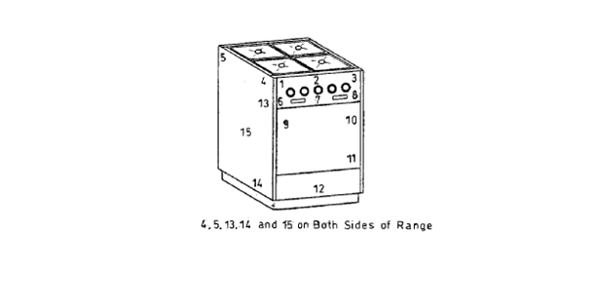

Figure 5 — Points for determination of surface temperature of cooking range

The appliance shall be accompanied by an instruction card giving the following information:

a) Brief instructions for installation and regulation which includes piping and setting of terminals, if any;

b) Rating of the burners in kilocalories per hour (with commercial butane),

c) Instructions for the correct operation of the appliance, and

d) Country of origin.

## **7.2 Marking**

Each appliance shall be legibly and indelibly marked with the following:

a) Manufacturer’s name, initials or registered trademark,

b) Total heat input (with commercial butane),

c) Rating of the burners in kilocalories per hour (with commercial butane),

d) Any special instructions for safe use of the appliance,

e) For use with LPG at 2.942 kN/m2 (30 gf/cm2 approx.),

f) Country of origin, and

g) A temperature chart corresponding to the thermostat setting, if thermostat is provided.

h) The cooking ranges may also be marked with a certification mark.

## **7.3 Packaging**

The cooking ranges shall be packaged as per instruction of the purchaser and safety requirements as such.

Annex A   
(normative)  
  
Method for testing strength of appliance (deflection test)

A.1 Principle

a) Application of a diagonal force to the uppermost member of the front or back of the body proper or body frame, relative to the base, and

b) Application of a diagonal force to the lowermost member of the front or back of the body proper or body frame, relative to the base.

A.2 Procedure

**A2.1** The legs (or base, or both, if removable) and any ornamental finishing strips shall be removed and the body of the range firmly supported on wooden beams resting on the floor or some equally stable foundation.

**A2.2** Rigid angle iron beams shall be placed on diagonally opposite edges of the body proper or body frame in such a manner that the upper beam is along the edge of the uppermost member of the body and the lower beam is on the edge of the base of the cooker diagonally opposite the upper beam and parallel to it. The arrangement is shown in Figure A.1. In cases where the design of the cooker makes it difficult to apply the test exactly as prescribed herein the arrangement of the apparatus shall be left to the discretion of the testing agency.

**A2.3** Each end of the upper beam shall be connected to the corresponding end of the lower beam by a draw bar in series with a spring scale graduated in not greater than 1-kg interval.

**A2.4** The tension on each draw bar shall be increased until the readings of the two scales are equal and their sum is equal to the diagonal force to be applied.

**A2.5** Deflection readings shall be made with two dial gauges graduated to 0.02 mm located respectively on the extreme ends of the uppermost edge of the open body opposite and in the same horizontal plane as the horizontal component of the applied diagonal force.

**A2.6** The temporary deflection shall be considered as the average of the readings of the two instruments in each case and it shall in no case exceed 3 mm.

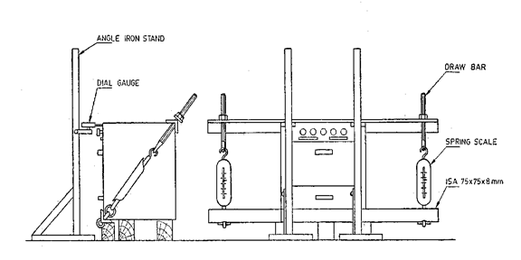

Figure A.1— Apparatus for determining strength of cooking range bodies showing set- up for testing end- frames

Annex B   
(normative)  
  
Method for testing the requirements of thermostats

B.1 Procedure

**B.1.1** The appliance under examination shall be fed with butane gas at a normal working pressure of 2.942 kN/m2 (30 gf/cm2 approx.). At several settings between the lowest on the scale and the highest normally used the effect on the static temperature of an increase in gas pressure of gf/cm2 at the inlet of the appliance shall be noted by means of a thermocouple placed in the centre of 5 cm blackened copper sphere. Temperature shall be recorded after the equilibrium reaches.

**B.1.2** Settings of the thermostat at the bottom, middle and top of the normal working range selected and at each of these settings, after equilibrium conditions have been established and recorded, the thermostat shall be turned down several settings and then up to the original setting. Equilibrium shall be allowed to become established again and the temperature recorded as before by means of a thermocouple placed in the centre of a 5-cm blackened copper sphere. For each settings of the thermostat, two equilibrium temperatures of the oven shall be recorded; one in which the oven has reached its temperature from a lower temperature, and the other in which the oven has reached its temperature from a higher temperature.

**B.1.3** Butane gas at 2.452 kN/m2 (25 gf/cm2) inlet pressure shall be used and oven left full ‘ON’ to enable temperature equilibrium to establish. The thermostat setting shall be the highest possible. Then the control knob shall be turned sharply to its lowest position and the flames examined. The flame shall not extinguish by this process.

Annex C   
(normative)  
  
Victoria sandwich cake baking test for ovens

C.1 Ingredients

**C.1.1** The following ingredients shall be sufficient to make one cake of 23 cm or two cakes of 18 cm diameter:

* Flour 120 g
* Baking powder 10 g
* Butter 120 g
* Sugar 120 g
* Eggs 2
* One table spoonful of water
* a pinch of salt.

C.2 Method

The sugar and butter shall be creamed with a wooden spoon to the consistency of whipped cream and each egg shall be beaten in separately. Baking powder and salt shall be folded in the sifted flour using a metal spoon and water added to it. When two cakes are to be made, the mixture shall be equally divided between two tins and shall be placed on separate shelves in the oven. Baking shall be carried out according to the recommendations of the manufacturer of the oven. One tin shall be allowed to be removed first from the oven and the other tin moved into its place but no other adjustments shall be permitted. The location and orientation of the cakes in the oven shall be noted. The cakes, after removal from the oven, shall be left for cooling on a rack.

C.3 Assessment of results

**C.3.1** The results of the test shall be assessed as given below:

|  |  |  |
| --- | --- | --- |
| Size of cake  cm diameter | Time for cooking  minutes | Colour of cake |
| 18 | 30 | Brown |
| 23 | 35 | Brown |

**C3.2** The cakes shall rise symmetrically and a slightly domed shape shall be permitted.

**C.3.3** Ideally there shall be no variation of colours between the top undersides when considered together but a reasonable departure from this ideal shall be permissible

Annex D   
(normative)  
  
Toasting performance for griller

D.1 Procedure

**D.1.1** Good quality bread, one-day old, shall be cut into slices 12 mm thick and crusts shall be removed to not less than 6 mm from each edge.

**D.1.2** The grill shall be arranged in the recommended position and completely covered with slices of bread; if parts of slices are to be used, they shall be placed at the centre rather than at the outside of the grid. Three such loads shall be prepared and the meter read. The first load shall be placed centrally under the grill. The gas shall be lighted and a stopwatch started. The pan shall be withdrawn as soon as any part of the load is well browned, but before burning commences.

**D.1.3** During the next 25 s the slices shall be turned over on the grill grid, ensuring that the outer edges are placed over the edges of the grid. Any loss of area due to shrinkage shall be accounted for by spaces between the slices.

**D.1.4** The grill pan shall be reinstated at the end of 25 s and the other side toasted. After a 15-s interval a load shall be changed and a second load shall be toasted in the same way, then a third load. At the end of the third load the gas shall be turned ‘OFF’, the watch stopped and the meter read.

**D.1.5** The area is square centimetres over which the bread is browned (it usually approximates to a circle or ractangle) shall be determined. This shall be done for both sides of all three loads keeping the outer edges of the bread always to the edges of the grid.

**D.1.6** Toasted area — Except for small appliances of grill grid area less than 325 cm2 and table appliances, the toasted area shall be not less than 200 cm2. There shall be no marked inequality of browning on the surface of the toast.

D.2 Gas consumption

D.2.1 When tested as indicated in D1, the gas consumption shall not exceed the value given by the following formula:

*P = 0.9A + 315*

where

*P* is the permitted consumption of gas in kilocalories, and

*A* is the toasted area in square centimetres.

Annex E   
(normative)  
  
Method for determination of carbon monoxide/carbondioxide ratio

E1. PROCEDURE

The ranges shall be set up and a collecting hood suitable for the burners under examination shall be obtained. The hood shall be so designed that while not interfering in any way with the normal combustion of the burner, it collects a fairly high proportion of the products of combustion. Also, it shall be such that the sample collected represents the whole of the combustion gases and not those from one particular point. A suitable collecting hood for boiling burners is shown in figure E.1. For grillers and ovens in general, a special sampling hood is shown in figure E.2. When using this hood, the damper provided shall be set or additional flue pipe added, so that spillage of the flue gases around the skirt is just prevented. With the sampling hood in position over the

burner under investigation test gas at inlet pressure of 25 gf/cm2 shall be admitted and the burner operated for a few minutes before sampling commences. The reason for this being that during the first few minutes the burner is warming up and the proportion of carbon monoxide may be high. However, this is not dangerous provided the burner works satisfactorily after heating up.

For oven, the sampling problem may be plain open-ended tube, or may take the form of a tube with closed end and with perforations along its length near the closed end, the total cross-sectional area of the perforations being less than the cross-sectional area of the tube. The probe is offered with the open end or the perforations pointing towards the flue, just outside the plane of the outlet so as to avoid restriction of the flue area.

With the thermostat, if any, at its highest mark, the gas is turned on and promptly lit. after 15 seconds the oven door is shut, sampling is immediately begun and completed in 10 minutes

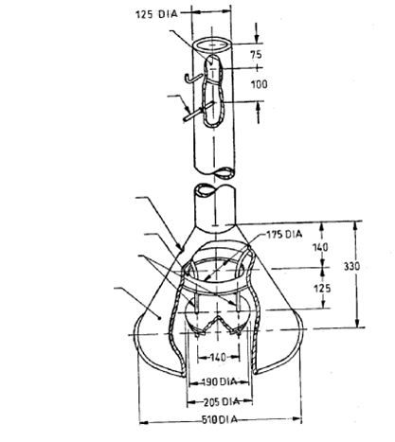

Figure E.1— Hood for boiling burner

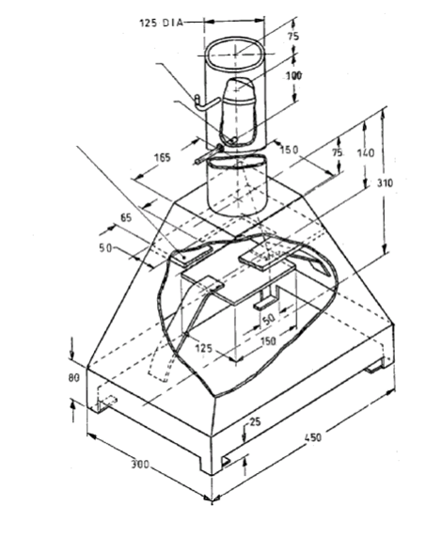

Figure E.2— Hood for grillers and ovens

Bibliography

[1] KS 1226:1996, Specification for domestic cooking ranges for use with liquefied petroleum gases

[2] IS 4760:2002 Domestic cooking ranges including grillers, for use with LPG.

[3] BS 2491: 1963 Specification for domestic cooking appliances for use with liquefied petroleum gases.