WORKING DRAFT EAST AFRICAN STANDARD
Eaves gutters and fittings made of PVC-U — Requirements and test methods

EAST AFRICAN COMMUNITY

`Copyright notice
This EAC document is copyright-protected by EAC. While the reproduction of this document by participants in the EAC standards development process is permitted without prior permission from EAC, neither this document nor any extract from it may be reproduced, stored or transmitted in any form for any other purpose without prior written permission from EAC.
Requests for permission to reproduce this document for the purpose of selling it should be addressed as shown below or to EAC’s member body in the country of the requester:
© East African Community 2024 — All rights reserved
East African Community
P.O. Box 1096,
Arusha
Tanzania
Tel: + 255 27 2162100
Fax: + 255 27 2162190
E-mail: eac@eachq.org
Web: www.eac-quality.net
Reproduction for sales purposes may be subject to royalty payments or a licensing agreement. Violators may be prosecuted.

Foreword
Development of the East African Standards has been necessitated by the need for harmonizing requirements governing quality of products and services in the East African Community. It is envisaged that through harmonized standardization, trade barriers that are encountered when goods and services are exchanged within the Community will be removed.
The Community has established an East African Standards Committee (EASC) mandated to develop and issue East African Standards (EAS). The Committee is composed of representatives of the National Standards Bodies in Partner States, together with the representatives from the public and private sector organizations in the community.
East African Standards are developed through Technical Committees that are representative of key stakeholders including government, academia, consumer groups, private sector and other interested parties. Draft East African Standards are circulated to stakeholders through the National Standards Bodies in the Partner States. The comments received are discussed and incorporated before finalization of standards, in accordance with the principles and procedures for development of East African Standards.
East African Standards are subject to review, to keep pace with technological advances. Users of the East African Standards are therefore expected to ensure that they always have the latest versions of the standards they are implementing.
The committee responsible for this document is Technical Committee EASC/TC 047, Plastic pipes, fittings, valves, piping systems and ducting systems.
Attention is drawn to the possibility that some of the elements of this document may be subject of patent rights. EAC shall not be held responsible for identifying any or all such patent rights

Eaves gutters and fittings made of PVC-U —Requirements and test methods
1 Scope

This draft East African Standard specifies requirements and test methods of eaves gutters and fittings made from unplasticized poly (vinyl chloride) (PVC-U) and intended to be used for rainwater drainage.

2 Normative references

The following referenced documents are indispensable for the application of this document. For dated references, only the edition cited applies. For undated references, the latest edition of the referenced document (including any amendments) applies.

EN 513, Unplasticized polyvinyl chloride (PVC-U) profiles for the fabrication of windows and doors — Determination of the resistance to artificial weathering

ISO 6259-2 Thermoplastics pipes — Determination of tensile properties — Part 2: Pipes made of unplasticized poly (vinyl chloride) (PVC-U), oriented unplasticized poly(vinyl chloride) (PVC-O), chlorinated poly(vinyl chloride) (PVC-C) and high-impact poly(vinyl chloride) (PVC-HI)

ISO 23711 Elastomeric seals — Requirements for materials for pipe joint seals used in water and drainage applications — Thermoplastic elastomers

ISO 2507-1, Thermoplastics pipes and fittings — Vicat softening temperature—Part 1: General test method
ISO 2507-2, Thermoplastics pipes and fittings — Vicat softening temperature—Part 2: Test conditions for unplasticized poly vinyl chloride (PVC-U) or chlorinated poly(vinyl chloride) (PVC-C) pipes and fittings and for high impact resistance poly(vinyl chloride) (PVC-HI) pipes

ISO 2505, Thermoplastics pipes — Longitudinal reversion — Test method and parameters
ISO 580 Plastics piping and ducting systems — Injection-moulded thermoplastics fittings — Methods for visually assessing the effects of heating
ISO 13229 Thermoplastics piping systems for non-pressure applications — Unplasticized poly(vinyl chloride) (PVC-U) pipes and fittings — Determination of the viscosity number and K-value

EN 1905, Plastics piping systems — Unplasticized poly(vinyl chloride) (PVC-U) pipes, fittings and material — Method for assessment of the PVC content based on total chlorine content

EN 10204, Metallic products — Types of inspection documents

ISO 105-A02 Textiles — Tests for colour fastness Part A02: Grey scale for assessing change in colour

ISO 527-2, Plastics — Determination of tensile properties — Part 2: Test conditions for moulding and extrusion plastics

ISO 1183-3, Plastics — Methods for determining the density of non-cellular plastics — Gas pyknometer method

ISO 9001 Quality management systems — Requirements
ISO 4892-2, Plastics — Methods of exposure to laboratory light sources Part 2: Xenon-arc lamps

ISO 4892-3, Plastics — Methods of exposure to laboratory light sources Part 3: Fluorescent UV lamps
ISO 8256, Plastics — Determination of tensile impact strength

3 Terms and definitions

For the purposes of this standard, the following terms and definitions apply.

3.1
eaves gutter
gutter situated outside the building and supported by brackets

3.2
down-pipe
pipe fitted to a gutter to lead rainwater from the gutter to the drainage system or sewer

3.3
union-clip (gutter-union)
fitting for joining two gutters and supported only by those gutters

3.4
joint bracket (union-bracket)
fitting for joining two gutters which is supported by the building structure

3.5
gutter adaptor
fitting for joining two different shaped gutters

3.6
angle
fitting for joining two gutters installed in two different directions

3.7
stop end
fitting for stopping the flow, fixed at the end of a gutter or an outlet

3.8
outlet
fitting for draining off the rainwater from the gutter into the down-pipe

3.9
commercial length
length of a gutter or a down-pipe which was produced in a factory

4 Materials

4.1 Raw material

The raw material shall be PVC-U with additives that are needed to facilitate the manufacture of gutters and fittings components conforming to the requirements of this document

When calculated on the basis of a known formulation or in case of dispute or not known formulation, determined in accordance with EN 1905 the PVC content shall be at least 80 % by mass for profiles and 85 % by mass for injection-moulded fittings.

4.2 Utilization of non virgin material

Requirements for the utilization of non-virgin materials are given in Annex A.

5 General characteristics of profiles — Appearance

When viewed without magnification the, internal and external surfaces of gutters shall be smooth, clean and free from scoring, cavities, and other surface defects. The ends of gutters shall be cut cleanly and square to the axis of the profile.

6 Geometrical characteristics of profiles

6.1 Width

Gutters shall be designated by their upper opening width (size) (See examples of cross section areas in Annex E). The manufacturer shall declare the usable area of the cross-section of the gutter at its designed top opening width for the calculation of flow capacity. This usable area shall be either marked on the gutter or given in commercial documents.

6.2 Length

The commercial length of a gutter shall have a positive tolerance when measured at 20 °C.

7 Physical and mechanical characteristics of profiles

The requirements for the physical and mechanical characteristics and the conditions for the respective test methods shall conform to those given in Table 1.

NOTE Any conflicting parameters and requirements given in the test method standards referred to do not apply here.

Table 1 — Physical and mechanical characteristics of profiles

Sl No | Characteristics | Requirement | Test parameters |  | Test method
i) | Hammer impact strength (type test) | No break or crack visible without magnification | Temperature | (0 ±1) °C | Annex B
ii) | Tensile strength (type test) | ≥ 42 N/mm² | Speed specimen type | 5 mm/min type 2, 3 or 5 a conforming to ISO 527-2 | ISO 6259-2
iii) | Elongation at break (type test) | ≥ 100 % | Speed specimen type | 5 mm/min type 2, 3 or 5ª conforming to ISO 527-2 | ISO 6259-2
iv) | Tensile impact strength (type test) | ≥ 500 kJ/m² | Specimen type temperature | type 2, 3 or 5ª conforming to ISO 8256 (23 ± 2) °C | ISO 8256
v) | Heat reversion(type and production control test) | ≤ 3% | Test temperature  Time | (100± 2) °C  (30 ±2) min | ISO 2505
vi) | Vicat softening temperature (type test) | ≥ 75°C | Conforming to ISO 2507-2 |  | ISO 2507-1
NOTE: ª In case of dispute, test specimen 5 shall be used.

8 Characteristics of fittings

8.1 General

The following types of fittings shall conform to the requirements given in 8.2, 8.3 and Clause 9: union clip, joint-bracket, gutter adaptor, angle, stop-end, outlet and expansion piece.

8.2 Appearance

When viewed without magnification the internal and external surfaces of fittings shall be smooth, clean and free from scoring, cavities, and other surface defects.

8.3 Shape and dimensions

The fittings shall be compatible with the shape and the dimensions of the profile or the gutter. The outlets shall be compatible with down-pipes and fittings.

8.4 Physical characteristics of fittings

The requirements for the physical characteristics and the conditions for the respective test methods shall conform to those given in Table 2.

NOTE Any conflicting parameters and requirements given in the test method standards referred to do not apply.

Table 2 — Physical characteristics of fittings

Sl No | Characteristics | Requirement | Test parameters |  | Test method
i) | Effect of heating ^{a)} (production control test) | ^{c)} and ^{d)} | Temperature  Time | (150 ± 2) °C  (15 ± 2) min. | Method A of ISO 580 in air
ii) | Heat reversion ^{b)} (type test) | No visible deformation without magnification | Temperature  Time | (65 ±2) °C  (30 ± 2) min. | Annex C
iii) | Vicat softening temperature  (type test) | ≥ 75°C | Conforming to ISO 2507-2 |  | ISO 2507-1
^{a)} Without seal and only for injection-moulded fittings.
^{b)} For fittings produced by processes other than injection moulding.
^{c)} i) Within a radius of 15 times the wall thickness around the injection point, the depth of cracks, delamination or blisters shall not exceed 50 % of the wall thickness at that point.

ii) Within a distance of 10 times the wall thickness from the diaphragm zone, the depth of cracks, delamination or blisters shall not exceed 50 % of the wall thickness at that point.

iii) Within a distance of 10 times the wall thickness from the ring gate, the length of cracks shall not exceed 50 % of the wall thickness at that point.

iv) The weld line shall not have opened more than 50 % of the wall thickness at the line.

v) In all other parts of the surface the depth of cracks and delaminations shall not exceed 30 % of the wall thickness at that point.

Blisters shall not exceed a length 10 times of the wall thickness.

^{d)} After cutting through the fitting, the cut surfaces shall show no foreign particles, when viewed without magnification.

10 Gutter sealing rings

10.1 The gutter seals shall have no detrimental effect on the properties of gutters and fittings and shall enable the test assembly to conform to Table 3.

10.2 Materials for sealing rings shall conform to ISO 23711
11 Solvent cements

The adhesive shall be solvent cement and shall be as specified by the manufacturer of profiles and/or fittings.
The adhesive shall have no detrimental effects on the properties of the profiles and of the fittings and shall not cause the test assembly to fail to conform to Table 3.

12 Designation

Eaves gutters and fittings shall be designated by:

a) description of the product, e.g. gutter, stop end, outlet;
b) number of this East African Standard identity block comprising: width of the gutter or, in case of a fitting, the width of the appropriate gutter, in millimetres; material symbol (PVC-U).

EXAMPLE

Designation of an eaves gutter of PVC-U with a width of 150 mm:
Eaves gutter EAS ---- - 150 - PVC-U

13 Marking

13.1 The marking shall be printed or formed directly on the gutter or, if applicable, on the fitting in such a way that it does not initiate cracks or other types of failure and that with normal storage, weathering and processing, and the permissible method of installation and use, legibility shall be durably maintained. Alternatively for fittings, the marking may be on a permanently attached label. If printing is used, the colour of the printed information shall differ from the basic colouring of the product.

The marking shall be easily readable without magnification.

13.2 The marking shall include at least the following details:

a) name, which may be abbreviated, or trade-mark of the manufacturer;

b) upper opening width, in millimetres ;
c) quality mark, if a certification scheme is set up;
d) number of this East African Standard.

14 Fitness for purpose of gutter systems

Gutter systems shall conform to the requirements given in Table 3 when tested in accordance with the test methods and associated conditions given there.

Table 3 — Requirements for gutter systems

Characteristics | Requirement | Test parameters |  |  | Test method
Artificial ageing ^{b)}  (type test) |  | Radiation energy  Cycling and  temperature  regime |  | 2.6 GJ/m²  Method 1 of  EN 513 | Method A of  ISO 4892-2  (Xenon Test)  Artificial weathering
 |  | Or ^{a)}
 |  | Exposure time  Cycle:  — Irradiation  — Condensation |  | 1600 h UVA 351 lamp  6 h at (50 ±2) °C  2 h at (50 ±2) °C | ISO 4892-3  (QUV Test)
 | Colour:  The change of colour shall not exceed stage 3 of the grey scale according to  ISO 105-A02 |  |  |  | ISO 105-A02
 | Tensile impact strength:  50 % of the value before  ageing (see Table 1) | Sample type  Test temperature | According to Table 1  (23 ±2) °C |  | Method A or  ISO 8256
Water tightness  (type test) | No leakage | See Annex D | Annex D |  | Water tightness  (type test)
^{a)} In case of dispute, the method EN ISO 4892-2 (Xenon test) shall be used.

^{b)} This test is a type test for each formulation and colour. It can be used for other products (e.g. for pipes and fittings conforming to EN 12200-1).

15 Production control

Eaves gutters shall be controlled by the manufacturer during their production process at their place of production. This control based on the appropriate sampling rules shall demonstrate the compliance of the products with the requirements of this standard.

Annex A
(normative)

Utilization of non-virgin material

A.1 Material definitions

A.1.1 Virgin material

Material in a form such as granules or powder that has not been subjected to use or processing other than that required for its manufacture and to which no reprocessable or recyclable material has been added.

A.1.2 Own reprocessable material

Material prepared from rejected unused profiles or fittings, including trimmings from the production of profiles or fittings, that will be reprocessed in a manufacturer's plant after having been previously processed by the same manufacturer by a process such as moulding or extrusion, and for which the complete formulation is known.

A.1.3 External reprocessable material

Material comprising either one of the following forms:

a) material from rejected unused profiles or fittings or trimmings therefrom, that will be reprocessed and that were originally processed by another manufacturer;

b) material from the production of unused PVC-U products other than profiles and fittings, regardless of where they are manufactured.

A.1.4 Recyclable material

Material comprising either of the following forms:

a) material from used profiles or fittings which have been cleaned and crushed or ground;

b) material from used PVC-U products other than profiles or fittings which have been cleaned and crushed or ground.

A.2 Reprocessable and recyclable material

NOTE For the purposes of this paragraph the term profiles means extruded profiles and any parts of a fabricated fitting which is made from an extruded profile. The term fitting means injection-moulded fittings and injection-moulded parts of a fabricated fitting.

A.2.1 Own reprocessable material

The use of clean own reprocessable material with agreed specification for the production of profiles and fittings is permitted without limitations.
If fitting material is used for the production of profiles it shall be considered as recyclable material.

A.2.2 External reprocessable and recyclable materials with agreed specification

A.2.2.1 Material from PVC-U profiles and fittings

External reprocessable and recyclable material with an agreed specification from PVC-U profiles and fittings that are available in relevant quantities and intervals of time is permitted to be added to virgin or own reprocessable material or a mixture of those two materials for the production of profiles and fittings provided that all of the following conditions are met.
- A specification for each material shall be agreed between the supplier of external reprocessable or recyclable material and the profile manufacturer plus, if applicable, a certification body. It shall at least cover the characteristics given in Table A.1. When determined in accordance with the test method given in Table A.1, the actual values for these characteristics shall conform to the agreed value, and the permitted deviations shall conform to those given in Table A.1. The quality plan of the supplier of external reprocessable or recyclable material should conform to ISO 9001.

NOTE For the purposes of A.2.2.1, the manufacturer is responsible for claiming and ensuring that the quality plan conforms to or is no less stringent than the relevant requirements of ISO 9001: it is not essential for the manufacturer to be approved and registered for operation in accordance with ISO 9001.

Table A.1 —
Maximum permitted deviations for agreed characteristics

Characteristic | Permitted deviations | Test method
PVC-content ^{a)} | ± 4 % absolute by mass | EN 1905
K-value ª | ± 3 units | ISO 13229
Density ª | ± 20 kg/m³ | ISO 1183-3
Vicat softening temperature (VST) ª | ± 2 °c | ISO 2507-1
Particle size ^{b)} | Requirements and test method shall be agreed and stated in  the specification
Type of stabilizer ^{a b} | Requirements and test method shall be agreed and stated in  the specification
Impurities ^{b} | Based on the source of material and the recycling process a  relevant test method and requirements shall be agreed and  stated in the specification. Both the test method and the requirements shall be published
^{a)} If the source of the material are pipes and fittings produced under a KEBS recognized quality mark or a KEBS quality mark, it is not required to test this material's characteristics if the requirement covered by the quality mark conforms to the requirement given in this Table.

^{b)} The relevant requirements and test method are depending on the recycling process and on the end product.

b) Each delivery shall be covered by a certificate according to 3.1.B of EN 10204:1991, showing conformity to the agreed specification.

c) The maximum quantity of external reprocessable and recyclable material that is intended to be added shall be specified by the profile or fitting manufacturer.

d) The quantity of external reprocessable and recyclable material that is actually added in each production series shall be recorded by the profile or fitting manufacturer.

e) The PVC-content of the end product shall conform to the requirements specified in 4.1.

f) Type testing shall be carried out on the end product with the maximum specified amount of and with each form of external reprocessable or recyclable material with an agreed specification. Approved results shall be taken as proving conformity also of components containing lower levels of additions of external reprocessable or recyclable material.
A.2.2.2 Material from other PVC-U products than profiles and fittings

External reprocessable and recyclable material with an agreed specification from PVC-U bottles or window frames that are available in relevant quantities and intervals of time is permitted to be added to virgin or own reprocessable material or a mixture of those two materials for the production of profiles and fittings provided that all of the following conditions are met.
- The material shall conform to all of the conditions given in a) to f) of A.2.2.1, inclusive, and to all of the additional characteristics and requirements given in Table A.2.

Table A.2 — Requirements for external reprocessable and recyclable material from other PVC-U products than profiles and fittings

Characteristic | Requirements | Test method
PVC-content | 80 % | EN 1905
K-value | 56 ≤ K-value≥70 | ISO 13229
Density | 1390 kg/m³ ≤ density ≥ 1500 kg/m³ | ISO 1183-3
Vicat softening  temperature (V5T) | 62°C | ISO 2507-1
Impurities | ≤ 1500 ppm for particle size≥1000 pm  ≤ 1500 ppm for 1000 pm < particle size < 1400 pm | ^{a)}
Particle size | > 1000 pm: max 15 %  < 1400 pm: 100 %
Application source of  the material | one source: bottles or window frames
NOTE If the source of the material is unused products for which the complete formulation is known and is such that all the requirements given in this table are fulfilled the material does not have to be tested and does not have to meet the requirements for particle size

^{a)} Based on the source of material and the recycling process a relevant test method and requirements shall be agreed and stated in the specification. Both the test method and the requirements shall be published

b) The material shall be clean and dry.

c) The maximum allowed amount of reprocessable and recyclable materials shall depend on the difference in K-value of the virgin material and the reprocessable and recyclable material as follows:

i) if the difference in K-value, when determined in accordance with ISO 13229, is ≤4 units, then up to 20 % by mass may be added;

ii) if the difference in K-value is > 4 units, or not determined, then up to 5 % by mass may be added.

d) The quantity of external reprocessable and recyclable materials that is actually added in each production series shall be recorded by the profile and fitting manufacturer.

A.2.3 External reprocessable and recyclable material not covered by an agreed specification

A.2.3.1 Material from PVC-U profiles and fittings

External reprocessable and recyclable material not covered by an agreed specification from PVC-U profiles and fittings that are available in random quantities and intervals of time is permitted to be added to virgin or own reprocessable material or a mixture of those two materials for the production of profiles provided that all of the following conditions are met.
a) When this material is used the production shall be considered as at least one batch and shall be tested accordingly.

b) The material shall be clean and dry.

c) The maximum allowed amount of external reprocessable and recyclable materials that may be added shall depend on the difference in K-value of the virgin material and the external reprocessable and recyclable material as follows:

i) if the difference in K-value, when determined in accordance with ISO 13229, is ≤ 4 units, then up to 10 % by mass may be added;

ii) if the difference in K-value is >4 units, or not determined, then up to 5 % by mass may be added.

d) The quantity of external reprocessable and recyclable materials that is actually added in each production series shall be recorded by the profile manufacturer.

A.2.3.2 Material from other PVC-U products than profiles and fittings

External reprocessable and recyclable material not covered by an agreed specification from other PVC-U products than profiles and fittings shall not be used for the production of profiles and fittings conforming to this document.

Annex B
(normative)

Impact test
The following impact test shall be carried out on each of three test pieces each not less than 900 mm in length.

The test piece shall be conditioned in ice water for 1 h or in a refrigerator at 0±1°C for 4 h. The test piece shall be mounted in two brackets (700±2))mm apart on a rigid support in such a way that the normal water line of its cross section is vertical, as shown in Figure B.1.

The pendulum shall be dropped on the test piece within 15 s of removal of the test piece from the iced-water or refrigerator.

Dimensions in millimetres

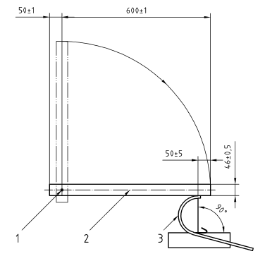
-
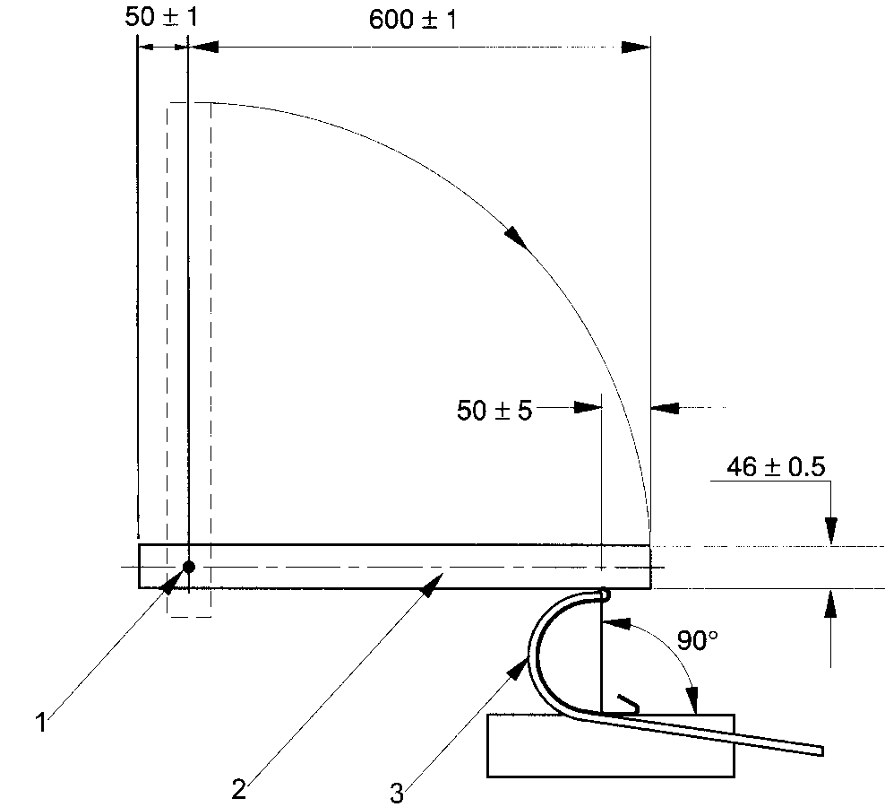

Key
1 Axis

2 Pendulum made of round steel
3 Gutter

Figure B.1 — Arrangement for impact test

Annex C
(normative)

Heat reversion test for fittings

The following test shall be carried out on three test pieces each comprising a complete fitting. Each test piece shall be placed in an oven, in a horizontal position, free to expand, and maintained at (65 ± 2) °C for (30 ± 2) min.

After the test pieces have cooled to room temperature, they shall be examined visually for any signs of deformation and surfaces defects that may have occurred.

Annex D
(normative)

Water tightness test

An assembly of a gutter system shall be arranged as shown in Figure D.1 and the slope shall be 3 mm/m. The distance between the centre lines of two successive brackets shall be 500 mm or as recommended by the manufacturer.

The following test cycle shall be carried out five times consecutively:

—  hot water at (50 ± 2) °C shall be circulated for 15 min and

— cold water at (15 ± 2) °C shall be circulated for 10 min.

each at a flow rate of 0.3 l/s (18 l/min).

The gutter shall be partially blocked by an obstruction of half of the height of the gutter near the outlet to hold back the flow of the water. It shall have a drainage opening at the bottom to allow a flow of not more than 0.3 l/s.

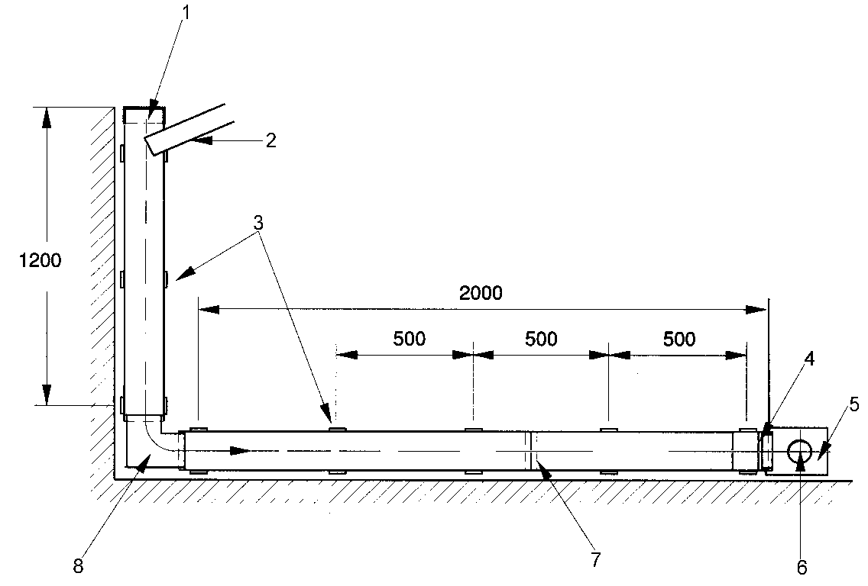

Key
1 Stop end
2 Water feed
3 Brackets
4 Obstruction
5 Stop end
6 Outlet
7 Union clip or joint-bracket
8 Angle

Figure D.1 — Arrangement for water tightness test (horizontal projection)

Annex E
(informative)

Cross section areas

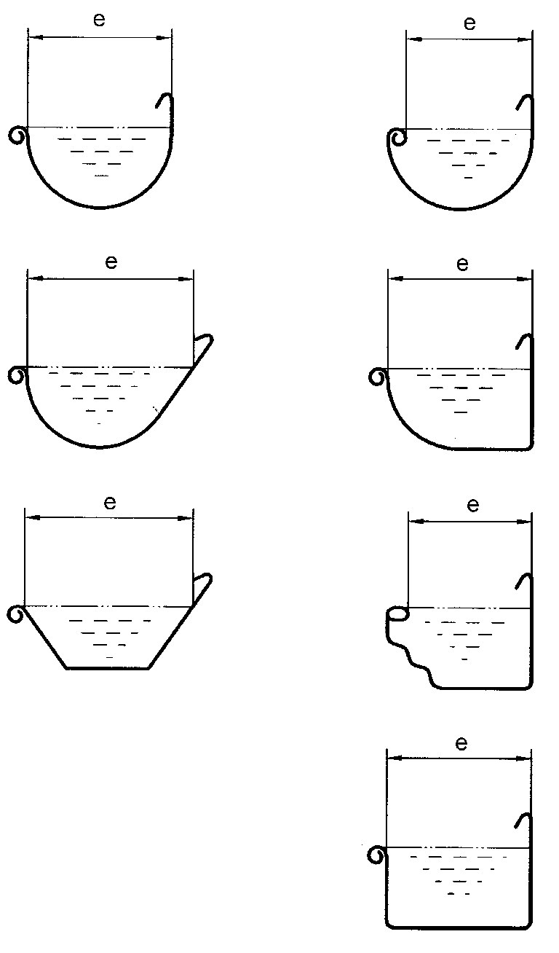

Bibliography

2. KS 2198:2012 Eaves gutters and fittings made of PVC-U — Definitions, requirements and testing
3. BS EN 607: 2004 Eaves gutter and fittings made of PVC-U — Definition, Requirements and Testing.

