DRAFT EAST AFRICAN STANDARD

Solid waste management of healthcare waste ─Specification

EAST AFRICAN COMMUNITY

Copyright notice
This EAC document is copyright-protected by EAC. While the reproduction of this document by participants in the EAC standards development process is permitted without prior permission from EAC, neither this document nor any extract from it may be reproduced, stored or transmitted in any form for any other purpose without prior written permission from EAC.
Requests for permission to reproduce this document for the purpose of selling it should be addressed as shown below or to EAC’s member body in the country of the requester:
© East African Community 2025 — All rights reserved
East African Community
P.O. Box 1096,
Arusha
Tanzania
Tel: + 255 27 2162100
Fax: + 255 27 2162190
E-mail: eac@eachq.org
Web: www.eac-quality.net
Reproduction for sales purposes may be subject to royalty payments or a licensing agreement. Violators may be prosecuted.
Contents Page
Foreword iv
1 Scope 1
2 Normative references 1
3 Terms and definitions 1
4 Requirements 2
4.1 General 2
4.2 Generation of health care waste 3
4.3 Segregation of health care waste 3
4.4 Storage of health care waste 4
4.5 Transportation of healthcare waste 5
4.5.1 On-site transportation 5
4.5.2 Off-site transportation 5
4.6 Treatment of health care waste 5
4.7 Non incineration technology (Autoclaving) 5
4.8 Incineration technology. 6
4.9 Disposal of health care wastes 6
4.9.1 Placenta pit 6
4.9.2 Ash pit 6
Annex A (normative) Specifications for PPEs 7
Annex B (normative) Specifications for vehicles for transporting healthcare wastes 9
Annex C (normative) Minimum specifications for waste bins and receptacles 10
Annex D (normative) Colour coding for different health care waste categories 12
Bibliography 13

Foreword
Development of the East African Standards has been necessitated by the need for harmonizing requirements governing quality of products and services in the East African Community. It is envisaged that through harmonized standardization, trade barriers that are encountered when goods and services are exchanged within the Community will be removed.
The Community has established an East African Standards Committee (EASC) mandated to develop and issue East African Standards (EAS). The Committee is composed of representatives of the National Standards Bodies in Partner States, together with the representatives from the public and private sector organizations in the community.
East African Standards are developed through Technical Committees that are representative of key stakeholders including government, academia, consumer groups, private sector and other interested parties. Draft East African Standards are circulated to stakeholders through the National Standards Bodies in the Partner States. The comments received are discussed and incorporated before finalization of standards, in accordance with the principles and procedures for development of East African Standards.
East African Standards are subject to review, to keep pace with technological advances. Users of the East African Standards are therefore expected to ensure that they always have the latest versions of the standards they are implementing.
The committee responsible for this document is Technical Committee EASC/TC 031, Waste management.
Attention is drawn to the possibility that some of the elements of this document may be subject of patent rights. EAC shall not be held responsible for identifying any or all such patent rights.

Solid waste management of healthcare waste ─Specification

1 Scope
This Draft East African Standard specifies requirements for management of health care wastes from generation, segregation, storage, transportation, treatment by incineration and autoclaving to final disposal.
It applies to wastes arising from activities such as medical, dental, veterinary practice, pathology and pharmaceutical laboratories, health care and home based care services, medical emergency services, blood banks, mortuaries, saloons, tattooing and body piercing establishments.

2 Normative references
The following documents are referred to in the text in such a way that some or all of their content constitutes requirements of this document. For dated references, only the edition cited applies. For undated references, the latest edition of the referenced document (including any amendments) applies.
EAS 491, Specification for incineration plants for hospital waste
EAS 492, Method of test and calculation for performance of hospital waste incinerators

3 Terms and definitions
For the purposes of this document, the following terms and definitions apply.
ISO and IEC maintain terminological databases for use in standardization at the following addresses:
— ISO Online browsing platform: available at http://www.iso.org/obp
— IEC Electropedia: available at http://www.electropedia.org/

3.1
healthcare facility
hospital, health centers, dispensary, clinic, nursing home, health post, and other health related facility
3.2 Healthcare waste
waste generated from healthcare facilities, research centres, saloons and veterinary centres; including infectious waste, pathological waste, sharps, pharmaceutical waste, genotoxic/cytotoxic waste, radioactive waste, coagulated blood waste and expired medicines, drugs and cosmetics.
3.3 Home based care
An authorized health care system where medical services are provided in patients home instead of a designated health care facility.

3.4 genotoxic/cytotoxic
Waste containing drugs or chemicals that are carcinogenic, mutagenic, or teratogenic requiring specialized treatment and disposal.

3.5
infectious waste
any waste that contains pathogen in sufficient quantity to pose a serious threat to public health, such as cultures from laboratories, waste from surgeries and autopsies on patients with infectious diseases, waste from patients in isolation wards or undergoing hemodialysis and waste associated with infected animals
3.6
non-infectious waste
waste of similar in nature to domestic and office waste like kitchen waste, food remains, office papers and packaging materials and any other items that can be scavenged
3.7
pharmaceutical waste
expired, unused, spilt and contaminated pharmaceutical products, prescribed and proprietary drugs, vaccines and sera that are no longer required, and, due to their chemical or biological nature, need to be carefully disposed of
3.8
saloon
includes a barber shop, hair dressing saloon, beauty salon, pedicure, massage center and any other premises used for the related purposes
3.9
sanitary landfill
engineered method system of disposing of solid waste on land in a manner that protects the environment; by spreading the waste in thin layers, compacting it to the smallest practical volume, covering it with soil by the end of each working day, constructing barriers to infiltration, and evacuating the gases produced
3.10
sharps
objects or devices having sharp points or protuberances or cutting edges capable of piercing the skin or having potential to cause harm
3.11
waste treatment
any method, technique or process for altering the biological, chemical or physical characteristics of waste to reduce the hazards it presents and facilitate, or reduce the costs of, disposal. The basic treatment objectives include volume reduction, disinfection, neutralization or other change of composition to reduce hazards.

3.12
waste disposal
intentional burial, deposit, discharge, dumping, placing or release of any waste material into or on any air, land or water. Disposal is undertaken without the intention of retrieval.

3.13 licensed practitioner
This is public health/environmental health/occupational health and safety officer registered and licensed by the relevant national authorities to manage healthcare waste.

4 Requirements
4.1 General
The healthcare waste that are generated within a facility shall always follow an appropriate and well-identified stream from their point of generation until their final disposal. This stream is composed of several steps that include generation, segregation collection and on-site transportation, on-site storage, off-site transportation (optional), treatment and disposal of the health care waste.
Table 1─ Illustration of Health care waste management system
STEP | LOCATION | HEALTHCARE WASTE STREAM | KEY POINTS
0  1  2  3 | In healthcare facility | Waste minimization  Generation  Segregation at source  Collection+on-site transport  On-site Storage  On-site treatment/disposal  Off-site Transport  Off-site treatment/disposal | Purchasing Policy, Stock Management; recycling of certain type of waste
0  1  2  3 | In healthcare facility |  | One of the most important steps to reduce risks and amount of hazardous waste
0  1  2  3 | In healthcare facility |  | Protective Equipment; Sealed containers; Specific easy to wash trolleys
4  5 | In healthcare facility
4  5 | In healthcare  facility |  | Lockable, easy to clean storage room limited storage time of 24-48 hours
4  5 | In healthcare  facility |  | Adequate storage room: Limited time of max 48hours
6  7 | Outside of  Healthcare facility |  | Appropriate and licensed vehicle  Healthcare facility consignment note; indicating the source and final destination
6  7 | Outside of  Healthcare facility |  | The treatment facility shall be managed by a licensed practitioner with competent personnel

4.2 Generation of health care waste
The quantity of health care waste generated shall always be minimized and precautions must be taken during their handling. There shall be efficient stock purchasing policy, stock management policy, and recycling of certain types of wastes.

4.3 Segregation of health care waste
4.3.1 Waste segregation shall always take place at the source, that is at the ward bedside, Operation Theatre, Medical Analysis Laboratory, or any other room or ward in the hospital where the waste is generated and by the staff who generate it.
4.3.2 Waste segregation shall be safe and guaranty the absence of infectious health care waste in the domestic waste flow.
4.3.3 Waste segregation shall be regularly monitored to ensure that the procedures are respected.
4.3.4 Standard color coded waste bins and liners shall be used for waste segregation.

4.3.5 Standard colours recommended are Red for highly infectious wastes, Yellow for infectious wastes, Black or Blue for non-infectious wastes, Brown Chemical and pharmaceutical waste, purple for genotoxic/cytotoxic as shown in Annex D.
4.3.6 Store each segregated waste in the receptacle corresponding to its coded color.
4.3.7 Color coded waste bins with appropriate bin liners, needle cutters, sharps containers, or other waste storage container shall be placed within reach of staff, at most within 1 m at every functional unit.
4.3.8 Standard safety boxes shall be provided and used for storage of sharps waste.
4.3.9 Safety box shall not be filled beyond 75 % of its capacity.
4.3.10 Health care waste shall not be sorted after it has been placed in the bin or container.
4.3.11 Mixed waste shall be treated according to the nature of hazardous waste (e.g. infectious waste) that it contains.
4.3.12 Instructions shall be displayed against each waste bins on proper waste storage in every functional unit
4.3.13 Labels shall be provided on each waste bin to direct users on proper waste storage.
4.3.14 All waste bags or containers shall be clearly labelled with their origin, date, contents, and the appropriate hazard symbol. Labelling shall be in accordance with the international waste labelling symbols.

4.4 Collection and Storage of health care waste
4.4.1 All waste collected in healthcare facility shall be stored in storage bay prior to disposal.
4.4.2 Storage bay shall be located within the health care facility at a distance accessible by all departments/ units.
4.4.3 Storage bay shall not create nuisance or health hazard in a work environment.
4.4.4 Pathways to the bay shall be accessible and paved to ease transportation
4.4.5 The site of the storage bay shall not be waterlogged.
4.4.6 Storage bay shall be located close to the treatment or disposal site
4.4.7 Appropriate color-coded containers shall be used to store waste until it is transported for final treatment or disposal on or off-site.
4.4.8 Each category of waste shall be stored separately.
4.4.9 Bags and containers shall be leak proof.
4.4.10 Size of the storage bay shall depend on amount of waste generated in health care facility
4.4.11 Storage bay shall have impervious floor and walls.
4.4.12 Storage bay shall have adequate ventilation.

4.4.13 Walls of the storage bay shall be smoothly plastered and painted with light-colored, wash-and-wear paint, to ease cleaning.
4.4.14 Storage bay shall have a lockable door
4.4.15 The structure must be provided with different rooms for storage of highly infectious waste, Infectious waste, sharps, recyclable materials.
4.4.16 The storage bay shall be fenced.
4.4.17 Storage bay shall have a durable roofing material
4.4.18 Storage bay shall have proper drainage system.
4.4.19 Radioactive Waste storage shall follow atomic energy regulations.
4.4.20 Storage bays shall maintain frequency of removal depending on the volume and nature of the waste.
4.4.21 Cleaning equipment, PPEs, waste bags and containers shall be located conveniently close to the storage area. The storage bay shall be kept clean at all times.
4.4.22 A separate storage room/compartment for different categories of waste shall be provided.
4.4.23 Pathological waste shall not be stored and must be disposed of immediately.
4.4.24 Pathological waste is to be segregated and transported offsite or incinerated without onsite storage as per the planed disposal (see clause 4.9).
NOTE Treatment and disposal shall be done immediately

4.5 Transportation of healthcare waste

4.5.1 On-site transportation
4.5.1.1 Different types of waste shall be transported separately in designated trolleys or wheelbarrows.
4.5.1.2 Trolleys and wheeled bins shall be cleaned and disinfected by the recommended disinfectants at the end of each working day.
4.5.1.3 Consignment forms for hazardous waste shall be correctly and thoroughly filled in and safely kept.
4.5.1.4 The pathways for transportation shall be paved to facilitate easy transportation.

4.5.2 Off-site transportation
Vehicles used to transport healthcare wastes shall fulfill the following design criteria:

- the vehicle shall have separate compartments for empty plastic bags, protective clothing, cleaning equipment, tools, and disinfectant, and shall have special kits for spill management;
- the hazard sign shall be displayed on the vehicle or container;
- the vehicle shall be marked with the name and address of the waste carrier company and an emergency telephone number;
- be fitted with loading and offloading equipment;
- use refrigerated containers/vehicles if the storage time exceeds the recommended limits or if transportation times are long; and
- the vehicle shall be licensed by relevant authority to carry health care wastes.

4.6 Treatment of health care waste
4.6.1 Health care waste shall be treated before disposal.
4.6.2 Onsite treatment shall be done within the health care facility.
4.6.3 Offsite treatment of health care wastes shall be done at registered treatment facility.
4.6.4 Health care facility management shall evaluate safety, effectiveness and environmental soundness of the treatment methods.
4.6.5 Appropriate PPE shall be used when operating a treatment facility.
4.6.6 The treatment facility shall be operated by competent personnel.

4.7 Non incineration technology (Autoclaving/Microwaving)
4.7.1 When operating a, non-burn treatment technology health care waste shall be subjected to sterilization standards as specified by the manufacturer (i.e. temperature, pressure and time)
4.7.2 The entire load of health care waste must be treated again if the standards are not met.
4.7.3 Each autoclave shall have graphic or computer recording devices which will automatically and continuously monitor & record dates, time of day, load identification number and operating parameters throughout the entire length of the autoclave cycle.
4.7.4 Validation test (Biological test) shall be conducted after autoclaving.
4.7.5 Check autoclave if clean, gasket intact and previous shift has not reported any problems.
4.7.6 Perform scheduled routine test (for example, pressure test).
4.7.7 Weigh and record waste for processing
4.7.8 Tag each waste bag with autoclave tape, with the date of processing written on it.
4.7.9 Place waste in autoclave, along with chemical integrator, self-contained biological indicator.
4.7.10 When waste is cool enough to handle, remove from autoclave and place in the appropriate storage area for disposal.
4.7.11 Record treatment parameters, test results and any other relevant data.

4.8 Incineration technology.
4.8.1 An incinerator shall have two chambers: Primary and secondary chambers.
4.8.2 It shall be capable of destructing waste into ashes by 95%.
4.8.3 Fuel burners shall be used.
4.8.4 Emission shall conform to national and international standards
4.8.5 Design, selection and efficiency of incinerators shall conform to EAS 491 and EAS 492

4.9 Disposal of health care wastes

4.9.1 Placenta pit
4.9.1.1 Shall be located within the health care facility compound.
4.9.1.2 Shall not be located in water logged area.
4.9.1.3 Shall be fenced
4.9.1.4 Pathways to the placenta pit shall be paved for accessibility.
4.9.1.5 Provide running water nearby the placenta pit and a soap for hand washing.

4.9.2 Ash pit
4.9.2.1 An appropriate site for the pit shall be selected on site or offsite.
4.9.2.2 The site shall be as close to the incinerator as possible, in a secure, non-public area that cannot be accessed by animals.
4.9.2.3 The pit shall be reinforced to prevent collapse and paved to prevent seepage.
4.9.2.4 When the pit is full, it shall be covered with soil by 50 cm from the top and sealed permanently.
4.9.2.5 The ash shall be cool enough to handle safely.

Annex A
(normative)
Specifications for PPEs
Item | Description and specification
Utility hand gloves | Glove design
Utility hand gloves | Hand-specific, designed for dexterity and comfort in addition to protection.
Utility hand gloves | Texture in palm area shall provide grip and cleaning sensation to enable safety during janitorial activities.
Utility hand gloves | Cuff design
Utility hand gloves | Straight cuff for maximum protection from contaminated liquids. Cuff shall reach at least 75 mm from the upper arm surface when the elbow is flexed at 90°.
Utility hand gloves | Palm thickness Minimum of 0.5 mm/20 mil.\ Provide good resistance to snags, puncture, abrasion and cuts
Utility hand gloves | Sizes
Utility hand gloves | Up to 7.5” (19.00 cm - x-small
Utility hand gloves | 7.5 – 8” (20.25 cm) – small
Utility hand gloves | 8 – 8.5 (21.50 cm) – medium
Utility hand gloves | 8.5 – 9” (23.00 cm) – large
Utility hand gloves | Over 9.0” (23.00 cm) – x-large
Safety gloves (puncture and cut protection gloves) | Protect against threats from nails, wire, glass fragments, metal shards, wood splinters, and all types of needles.
Safety gloves (puncture and cut protection gloves) | Recommended for incinerator and waste bay operators.
Heavy duty safety boot | Hide: Long-lasting, heat-resistant hard-wearing, lightweight, flexible, rust and corrosion resist Offers heel protection, comfort with odor-reducing, moisture-wicking properties.
Heavy duty safety boot | Design specifications
Heavy duty safety boot | Toe impact protection: Toe impact energy up to 90joules.
Heavy duty safety boot | Siding: Sole construction.
Heavy duty safety boot | Sole puncture protection: Minimum protection of 1 200 newtons.
Heavy duty safety boot | Slip-resistant sole: Deep tread with coefficient of friction >0.
Gum boots | Molded polyvinyl or other plastic to ensure that it is waterproof, Resistant to blood, fluids and easy to disinfect for maximum protection and hygiene.
Gum boots | Anti-skid tread prevents slipping.
Gum boots | Supposed to be used during health care waste collection and transportation.
Apron | Made of 20 mil virgin vinyl with electronically heat-sealed grommets.
Apron | Extra-long nylon string ties included to secure apron in a variety of ways.
Apron | Waterproof and chemical-proof standard.
Safety goggles | Design: Glasses with side protection or goggle.
Safety goggles | Lens: Impact-and heat-resistant, molded, and 2.2 mm thick with ant-fog coating.
Safety goggles | Heat resistant: Self-extinguishing foam and heat-resistant materials.
Safety goggles | Ventilation: At minimum, four indirect ventilation slots.
Safety goggles | Fit: Wide contact between goggle and face.
Safety goggles | Visibility: Unobstructed peripheral vision.
Safety goggles | Strap: Adjustable support strap.
Masks | Shall have exhalation valve that reduces heat and humidity, providing a comfortable breathing environment for the wearer while ensuring that the required level of respiratory protection and filtration performance is maintained under all conditions of use.
Masks | The RPFN952 has a low-profile design with dual fixed straps, adjustable comfortable fit. Folds flat for easy storage.
Masks | Sizes: One size.
Head gear | Hard enough to protect the operators head from mechanical injuries and any possible splash from liquid waste and chemicals.
Annex B
(normative)
Specifications for vehicles for transporting healthcare wastes
Item | Description
An example of a vehicle for transportation of sharps | Body capacity: 2.0 - 4.5 tons.
An example of a vehicle for transportation of sharps | Anti-rust paint.
An example of a vehicle for transportation of sharps | Easy to clean.
An example of a vehicle for transportation of sharps | Incorporate weighing device anti-corrosion steel.
An example of a vehicle for transportation of bio-hazardous waste | Capacity 1.5 – 2 tons.
 | To carry radioactive waste full packed on special
 | containers /bins.
 | Anti-rust paint.
 | Easy to clean.
 | Incorporate weighing device.
 | Anti-corrosion Steel.
An example of a vehicle for transportation of normal waste (Non-hazardous waste) | Body capacity: 4.5 – 20 (m³).
 | Anti-rust paint garbage compactor trucks with a range of loading capacities.
 | Anti-corrosion steel or high-tensile steel.
An example of a vehicle for transportation of liquid waste | Suction pumps with capacity of 3 - 5 hp.
An example of a vehicle for transportation of liquid waste | Suction horse with non- collapsible mechanism.
An example of a vehicle for transportation of liquid waste | Anti-corrosion Steel.
Annex C
(normative)
Minimum specifications for waste bins and receptacles
Item | Description and specification
Medium sized waste bin | Capacity: 30 – 45 L.
Medium sized waste bin | With handle, lid, foot-pedal operated.
Medium sized waste bin | Plastic receptacle features: Easy-clean.
Medium sized waste bin | Plastic shell and lid.
Medium sized waste bin | Large step-on foot pedal operated lid.
Medium sized waste bin | Bio-hazard labels included.
Medium sized waste bin | Weight 4 kg. (single box), and box dimensions 16” x 16” x 27”
Large sized waste bin | Capacity: 50 – 70 L.
Large sized waste bin | With handle, lid, foot-pedal operated, and wheeled.
Wheeled waste bin | Capacity: 70 – 120 L.
Wheeled waste bin | Designed for mechanical handling.
Wheeled waste bin | Rubber-tire wheels.
Wheeled waste bin | Manufactured from high-density polyethylene with UV stabilizer.
Wheeled waste bin | Easy to push or pull.
Wheeled waste bin | Appropriately color coded and properly marked/labeled the type of waste contained therein.
Wheeled waste bin | With smooth surfaces, leak proof, made of plastic.
Wheeled waste bin | Easy to load and unload.
Mobile bag stand | Triple-stand waste separator for the central separation of waste for recycling at wards, offices, kitchen, etc.
Mobile bag stand | Allows workers easy access to bins for segregation at source.
Mobile bag stand | For 80 litre bags.
Mobile bag stand | Dimensions; 1180 x 460 x 920.
Mobile bag stand | Thickness: Metal frame (galvanic zincing) with plastic lid.
Bedside segregation trolley | Designed to hold bins required by a particular ward or workstation.
Bedside segregation trolley | Allows waste segregation at the bedside or other patient treatment site.
Bedside segregation trolley | Made of non-corrosive materials.
Bedside segregation trolley | Washable.
Bedside segregation trolley | Consist of rubber tyres with brakes.
Bin Trolley (infectious waste) | Capacity to carry 50 – 100 kg.
Bin Trolley (infectious waste) | Waste collecting trolley, infectious waste.
Bin Trolley (infectious waste) | With a ground clearance of not less than 200 mm.
Bin Trolley (infectious waste) | Manufactured in a robust and stable way.
Indoor wheeled trolley | Waste collecting trolley for infectious waste.
Indoor wheeled trolley | With a ground clearance of not less than 200 mm.
Indoor wheeled trolley | Manufactured in a robust and stable way.
Indoor wheeled trolley | Must be designed to hold at least 2-3 bins with capacity of 70 – 120 L.
Indoor wheeled trolley | Easy to clean.

Annex D
(normative)
Colour coding for different health care waste categories
Colour coding |  | Healthcare waste categories | Healthcare waste
Red |  | Highly infectious | Anatomical waste, blood, body fluids, pathological waste, culture materials, stocks, petri dishes, waste from isolation ward or camp.
Yellow |  | Infectious wastes and sharps wastes-safety boxes. | Used gloves, dressing materials, specimen containers, infusion packages, catheters, urinal bags.  Used syringes and needles, surgical blades, scalpels, needles, scalpels, prickers, blades, broken glass (for example, pipettes, ampoules, vials).
Yellow |  | Pathological Waste | Body parts e.g., limbs, amputated tissues  Organs removed during surgery or autopsy  Human tissues such as skin, muscle, fat, or biopsy samples
Blue | Black | Non-infectious | Paper, packaging materials, plastic bottles, food remains, boxes, cartons.
Purple |  | Genotoxic / Cytotoxic Waste | Genotoxic/cytotoxic waste includes medicines, consumables, equipment, and cleanup materials contaminated with chemotherapy or cytostatic drugs
Brown |  | Chemical Waste | Chemical cleaners and disinfectants e.g., chlorine solutions, solvents  Solvents used in laboratory procedures e.g., xylene, acetone, ethanol

Annex E
(normative)
Healthcare Waste labelling symbols

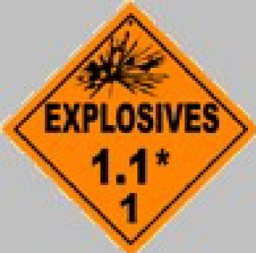  Potentially explosive | 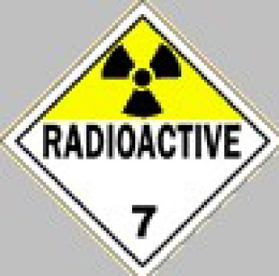  Radioactive | 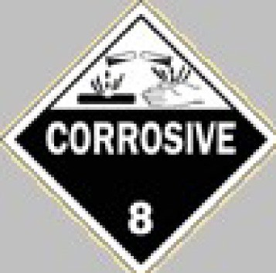  Potentially corrosive waste
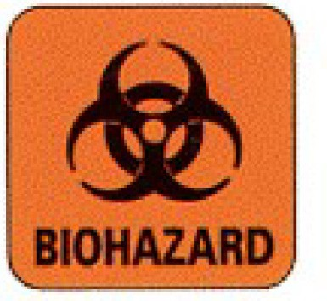  Label for infectious waste | 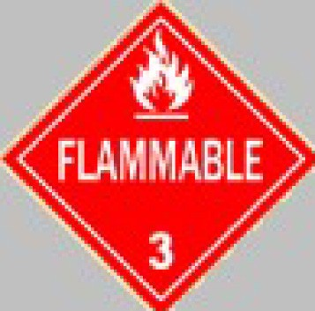  Waste containing flammable materials | 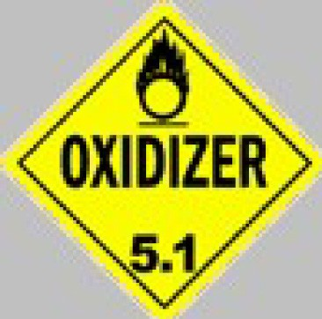  Label for waste containing oxidizing chemicals
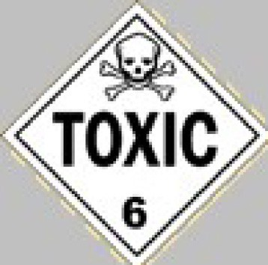  Waste containing toxic mate- rials | 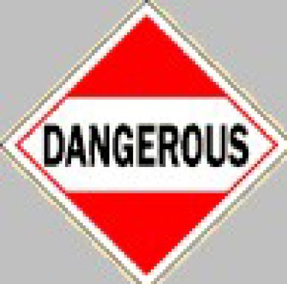  Highly infectious/sharps waste
Bibliography
WHO 2014 Handbook for safe management of waste
WHO 2017 SUMMARY WHO/FWC/WSH/17.05.

