DRAFT EAST AFRICAN STANDARD

Waste tyres management —Specification

EAST AFRICAN COMMUNITY

Copyright notice
This EAC document is copyright-protected by EAC. While the reproduction of this document by participants in the EAC standards development process is permitted without prior permission from EAC, neither this document nor any extract from it may be reproduced, stored or transmitted in any form for any other purpose without prior written permission from EAC.
Requests for permission to reproduce this document for the purpose of selling it should be addressed as shown below or to EAC’s member body in the country of the requester:
© East African Community 2025 — All rights reserved
East African Community
P.O. Box 1096,
Arusha
Tanzania
Tel: + 255 27 2162100
Fax: + 255 27 2162190
E-mail: eac@eachq.org
Web: www.eac-quality.net
Reproduction for sales purposes may be subject to royalty payments or a licensing agreement. Violators may be prosecuted.
Contents Page
Foreword iv
1 Scope 1
2 Normative references 1
3 Terms and definitions 1
4 Requirements 2
4.1 Waste tyres generation 2
4.2 Waste tyres collection and transportation 2
4.3 Storage of segregated waste tyres 2
4.3.1 General 2
4.3.2 Waste tyres storage 2
4.4 Storage of segregated waste tyres 2
4.4.1 General 2
4.4.2 Waste tyres storage 2
4.4.3 Internal waste tyre storage 3
4.4.4 External waste tyre storage 3
4.5 Utilization and disposal of waste tyres 3
5 Record keeping 4
Annex A (informative) Indoor waste tyres storage 5
Annex B (informative) Outdoor waste tyres storage 6
Bibliography 7

Foreword
Development of the East African Standards has been necessitated by the need for harmonizing requirements governing quality of products and services in the East African Community. It is envisaged that through harmonized standardization, trade barriers that are encountered when goods and services are exchanged within the Community will be removed.
The Community has established an East African Standards Committee (EASC) mandated to develop and issue East African Standards (EAS). The Committee is composed of representatives of the National Standards Bodies in Partner States, together with the representatives from the public and private sector organizations in the community.
East African Standards are developed through Technical Committees that are representative of key stakeholders including government, academia, consumer groups, private sector and other interested parties. Draft East African Standards are circulated to stakeholders through the National Standards Bodies in the Partner States. The comments received are discussed and incorporated before finalization of standards, in accordance with the principles and procedures for development of East African Standards.
East African Standards are subject to review, to keep pace with technological advances. Users of the East African Standards are therefore expected to ensure that they always have the latest versions of the standards they are implementing.
The committee responsible for this document is Technical Committee EASC/TC 031, Waste management.
Attention is drawn to the possibility that some of the elements of this document may be subject of patent rights. EAC shall not be held responsible for identifying any or all such patent rights.

Waste tyres management —Specification

1 Scope
This Draft East African Standard specify requirements for generation, collection, transportation, storage, utilization and disposal of waste tyres.
It covers waste tyres arising from individual and institutional level.

2 Normative references
The following documents are referred to in the text in such a way that some or all of their content constitutes requirements of this document. For dated references, only the edition cited applies. For undated references, the latest edition of the referenced document (including any amendments) applies
ISO 24161, Waste collection and transportation management — Vocabulary

3 Terms and definitions
For the purposes of this document, terms and definitions found in ISO 24161:2022 Waste collection and transportation management—Vocabulary and the following terms and definitions apply.

3.1
used tyres

tyre that has been removed from service but may still be suitable for reuse, retreading, reconditioning, or other approved applications

3.2
waste tyres disposal
final stage in waste tyres management system
3.3
waste tyres transportation
conveyance of waste tyres, either treated, partly treated or untreated from a location to another location in an environmentally sound manner through specially designed and covered transport system so as to prevent the foul odour, littering and unsightly conditions
3.4
waste tyres storage
means to store segregated waste tyres at household/community level separately

4 Requirements

4.1 Waste tyres generation
The quantity of waste tyres generated vary from one place to another depending on population growth and rapid industrialization that is taking place in that area. The point of waste tyre generation varies from individuals, garages/service stations, warehouses, factories and institutions. Waste generator shall ensure the waste tyres are segregated at source from other waste.

4.2 Waste tyres collection and transportation
Waste tyres shall be collected from the point of generation or designated storage /Collection centre only by registered individuals or companies and shall be transported exclusively to registered waste tyre facilities for reuse, recycling, or final disposal.

4.3 Storage of segregated waste tyres

4.3.1 General
Storing waste tyres at the source of their generation until they are collected is the first essential step of waste tyres management. Used tyres shall be stored in a manner that minimises risks to the environment and human health.

4.3.2 Waste tyres storage
Waste tyres shall be stored in a secure environment such as warehouse, distribution centres, or retail facility that is not easily accessible by the general public. They should be stored in a way that minimizes the risk of harm occurring by reducing amenity effects and risks of fire or contaminant leaching.

4.4.1 General
Storing waste tyres at the source of their generation until they are collected is the first essential step of waste tyres management. Used tyres shall be stored in a manner that minimises risks to the environment and human health.

4.4.2 Waste tyres storage
Waste tyres shall be stored in a secure environment such as warehouse, distribution centres, or retail facility that is not easily accessible by the general public. They should be stored in a way that minimizes the risk of harm occurring by reducing amenity effects and risks of fire or contaminant leaching.
Waste tyres storage area or facility shall not be sited on wetlands, flood plains, ravines, canyons, on steeply graded surfaces or anywhere else where they may pose a significant environmental or fire risk
Waste tyres shall be stored in one of the following methods:
- Bundled waste tyres – a number of waste tyres shall be strapped together in bundles and stacked either within a system or on their sides.
- Pallet system – the system shall contain a number of waste tyres which includes stringers for material handling equipment.
- Horizontal system – a system (e.g. pallets, shelving, and racks) where waste tyres are stacked upright along a horizontal length exceeding 1.5 m.
- Laced storage (outdoor storage only) – Waste tyres shall be stacked in overlapping system to create a woven or laced arrangement.

4.4.3 Internal waste tyre storage
4.4.3.1 General
Waste tyres shall be stored in a secure environment such as warehouse, distribution centres, or retail facility that is not easily accessible by the general public. They should be stored in a way that minimizes the risk of harm occurring by reducing amenity effects and risks of fire or contaminant leaching.
The site shall be flat with a concrete or hard packed clay surface that is designed to capture and contain water runoff.
Waste tyres stored indoor shall be stored in the manner prescribed in the subsections below:

- Waste tyre facilities with a storage floor area of less than 46 m² in which tyres shall be stored in accordance with the following:
The pile shall not exceed 15m width in any direction and 7m height while maintaining a spacing between the pile and the wall at 1.5m

- Waste tyre facilities with an indoor storage greater than 46 m² in which tyres shall be stored in accordance with the following:
i) Shall maintain aisles with access to exits and fire access doors in accordance with the following requirements:
-The aisles shall be a minimum of 2.4 m wide.
- The required aisle width shall be maintained from floor to top of the pile
ii) Shall maintain dimensions of the waste tyre piles not exceeding 15 m width in any direction and 9 m in height.
iii) Shall be equipped with fire extinguishing system, smoke and heat vents
- Waste tyres stored adjacent to or along one wall shall not extend more than 7.5 m from such wall.
- Waste tyres shall not be stored in exits or enclosures for stairways or ramps, or in boiler rooms, mechanical rooms, or electrical equipment rooms.
- Waste tyre piles shall not be stored within 0.6 m from the ceiling of a building.
NOTE Illustrative diagram is provided as Annex A.

4.4.4 External waste tyre storage
The external waste tyre storage site (i.e. open yard) shall be level, clear of rubbish and combustible materials, and enclosed by fences or walls constructed of non-combustible materials. The fence or wall shall be of sufficient height (not less than 2 m) to keep unauthorized persons from entering.
Individual waste tyre stacks shall not exceed 3.7 m in height, 60 m2 in area. A maximum of four individual waste tyre stacks can be grouped together to form a stack. A minimum clear separation of 2.5 m at the base shall be maintained between each stack. Waste tyre stacks shall be at least 2.5 m from all non-combustible boundaries and buildings and 5 m from combustible boundaries.

4.5 Utilization and disposal of waste tyres
Waste tyres can be reconditioned and continue to be utilized. Tyre wastes shall be disposed of in a landfill once all the recycle resources have been eliminated. To dispose tyres the following steps may be used:
- Conversion of the waste tyre into a valuable product in an environmentally sound manner that reduces its size and recovers the recyclable materials.
- The recycling materials such as large chunks of rubber or polymer shall be sent to recycling facilities.
- Waste tyres can be used as a source of energy.

5 Record keeping
5.1 A waste tyre facility operator shall create and maintain records documenting the quantity of waste tyres received, stored and transferred from the site. The records may include log entries describing the methods of receipt and removal of the waste tyres, the number of waste tyres received and removed, the name of the person employed to deliver or remove the waste tyres and manifest forms.
5.2 A waste tyre facility shall retain waste tyre records for five (5) years at the facility location. On request, a waste tyre facility shall provide the records to a competent authority.

Annex A
(Normative)
Indoor waste tyres storage

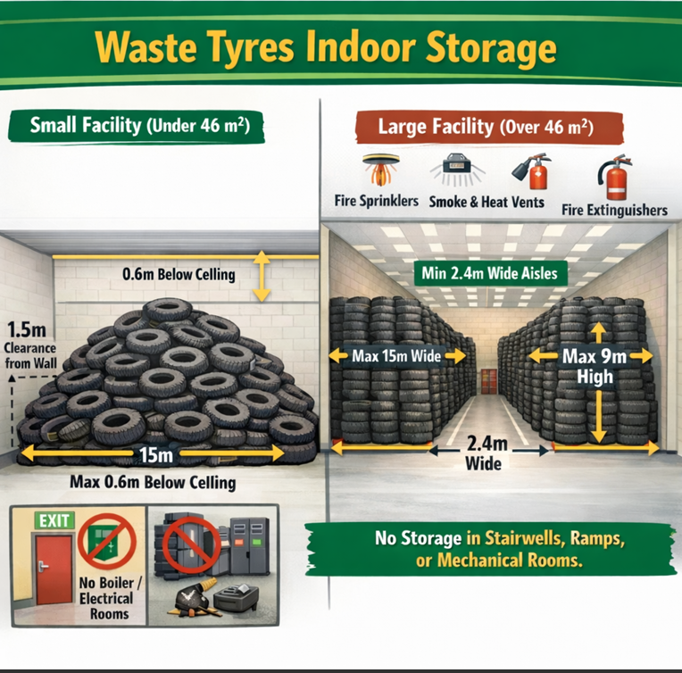

Annex B
(informative)
Outdoor waste tyres storage
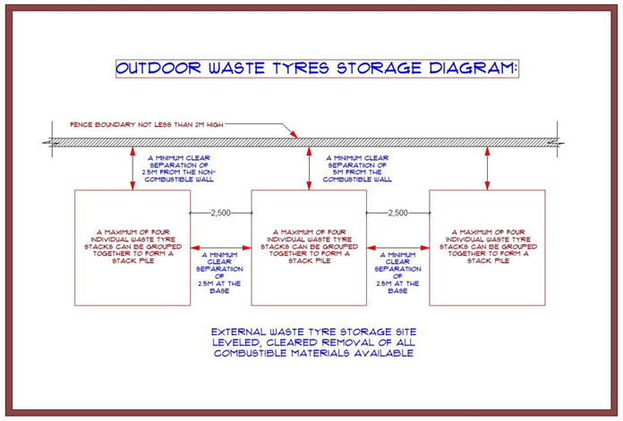

(Annex C)
(Informative)

Potential risk of waste tyres mismanagement
B.1 Risk due to uncontrolled open-air burning
Uncontrolled open-air burning is not an environmentally sound or acceptable management practice. Such practices can release potentially hazardous levels of carbon monoxide and mono – and polyromantic hydrocarbon in the smoke plume.
After open-air burning, organic compounds, like pyrolytic oils, rest in the soil and can cause environmental damage to the flora and fauna.
B.2 Risk due to uncontrolled stockpiling or landfilling
Under certain specifically defined climatic conditions waste tyre dumps or stockpiles can become the breeding grounds for insects, such as mosquitoes, which are capable of transmitting diseases to humans. This is of particular concern in tropical or sub-tropical regions

